**Energy Transition Pathways for the 2030 Agenda**

**SDG 7 Roadmap for Indonesia**

*Developed using National Expert SDG 7 Tool for Energy Planning (NEXSTEP)*

June 2020

|  |  |  |  |  |
| --- | --- | --- | --- | --- |
| DEN |  |  |  |  |

**Table of Contents**

1. Executive summary 1

A. Highlights of the roadmap 1

B. Achieving Indonesia’s SDG 7 and NDC targets by 2030 1

Universal access to electricity 3

Universal access to clean cooking 3

Renewable energy 3

Energy efficiency 4

Nationally determined contributions 4

C. Important policy directions 5

2. Introduction 8

2.1. Background 8

2.2. SDG 7 targets and indicators 8

2.3. Nationally Determined Contributions 9

3. NEXSTEP methodology 10

3.1. Key methodological steps 10

(a) Energy and emissions modelling 10

(b) Economic analysis module 10

(c) Scenario and policy analysis 10

3.2. Scenario definitions 11

(a) The BAU scenario: 11

(b) Current policies scenario: 11

(c) SDG 7 scenario: 11

3.3. Economic analysis 12

3.4. Basics of economic analysis 12

3.5. Cost parameters 12

4. Overview of the Indonesia’s energy sector 13

4.1. Current situation 13

4.2. National energy profile 13

4.3. National energy policies and targets 14

4.4. National energy resources 15

4.5. National energy balance 16

4.6. Energy Demand Outlook 17

4.6.1. Business as usual scenario 17

4.6.2. Current policy scenario 18

(a) Industry sector 18

(b) Transport 18

(c) Residential 19

(d) Commercial 19

(e) Other 19

4.7. Electric Power Generation Outlook 19

4.7.1. Business as usual scenario 19

4.7.2. Current policy scenario 19

4.8. Energy Supply Outlook 20

4.8.1. Business as usual scenario 20

4.8.2. Current policy scenario 20

4.9. Energy Sector Emissions Outlook 21

4.9.1. Business as usual scenario 21

4.9.2. Current policy scenario 22

5. SDG scenario – achieving SDG 7 by 2030 23

5.1. SDG 7 targets 23

5.1.1. SDG 7.1.1. Access to electricity 23

4.1.2. SDG 7.1.2. Access to clean fuels and technologies for cooking 23

4.1.3. SDG 7.2. Renewable energy 24

5.1.4. SDG 7.3. Energy efficiency 25

5.1.5. NDC unconditional target 26

5.2. Power generation in the context of SDG 7 27

5.3. Policy actions for achieving SDG 7 29

5.3.1. Decentralized renewable energy for rural electrification 29

5.3.2. Promoting electric cooking stoves to achieve cost-effective universal access to clean cooking 29

5.3.3. Energy efficiency improvement offers significant cost-saving 31

5.3.4. Multi-sectoral approach needed to achieve the renewable energy target 32

5.3.5. Investment in the power sector is needed for the energy transition 32

5.3.6. Net benefits in the power sector 34

5.3.7. Renewables are cheaper than fossil fuel 34

6. Energy transition pathways with increased ambitions 37

6.1. Scenario ranking 38

6.2. Raising ambition – enhancing the NDC target and achieving SDG 7 40

6.3. No new investment in coal-based power generation 41

6.3.4. Carbon capture and storage for coal-fired power plants in Indonesia 42

6.4. Putting a price on carbon will help to reduce investment gap 43

6.5. Phasing out the fossil fuel subsidy will level the playing field for renewables 43

6.6. Green financing 44

6.7. A holistic approach to reducing the investment gap 45

6.8. Improving energy efficiency beyond the SDG 7 target 46

Residential sector energy savings: 57 Million BOE 46

Industrial sector energy savings : 45 Million BOE 46

Transport sector energy savings: 115 Million BOE 47

Commercial sector energy savings: 0.3 Million BOE 47

6.9. Marginal abatement cost curve 49

7. Rebuilding better in the recovery from COVID-19 with the SDG 7 roadmap 50

7.1. Accelerating access to clean and modern energy services 50

7.2. Reducing financial risks by reshaping the power sector 51

7.3. Savings from the energy sector will help to build other sectors 52

7.4. Restructuring fiscal measures to invest where it is needed the most 52

8. Revisiting existing policies 54

9. Conclusion 56

References 58

Annexes 60

I. National Expert SDG 7 Tool for Energy Planning Methodology 60

II. Key assumptions 62

GDP Growth 62

Population growth 62

Household size 62

Commercial floor space 63

Demand 63

Industry: 63

Transportation: 63

Residential: 63

Commercial: 64

Other sector: 64

Transformation 64

III. Economic analysis data 64

IV. Power generation, by scenario 66

V. Summary of scenarios 68

BAU 68

Scenario description 68

SDG 7.1.1 Universal access to electricity 68

SDG 7.1.2. Universal access to clean cooking 68

SDG 7.2. Renewable energy 68

SDG 7.3. Energy efficiency 68

NDC unconditional target 68

Investment required: IDR 1,464 trillion (US$ 103 billion) 69

Total net benefits from the power sector 69

Coal lock-in 69

Fossil fuel subsidy 69

Energy balance 69

Current policy scenario 69

Scenario description 69

SDG 7.1.1. Universal access to electricity 69

SDG 7.1.2. Universal access to clean cooking 69

SDG 7.2. Renewable energy 69

SDG 7.3 Energy efficiency 70

NDC Unconditional target 70

Investment required: IDR 1,733 trillion (US$ 122 billion) 70

Total net benefits from the power sector 70

Coal lock-in 70

Fossil fuel subsidy 70

Energy balance 70

SDG scenario 70

Scenario description 70

SDG 7.1.1. Universal access to electricity 71

SDG 7.1.2. Universal access to clean cooking 71

SDG 7.2. Renewable energy 71

SDG 7.3. Energy Efficiency 71

NDC unconditional target 72

Investment required: IDR 2,499 trillion (US$ 176 billion) 72

Total net benefits from the power sector 72

Fossil fuel subsidy 72

Coal lock-in 72

Energy balance 72

Ambitious scenario 72

Conditional NDC with high energy efficiency 73

Scenario description 73

SDG 7.1.1. Universal access to electricity 73

SDG 7.1.2. Universal access to clean cooking 73

SDG 7.2. Renewable energy 73

SDG 7.3. Energy efficiency 73

NDC conditional target 74

Investment required: IDR 2,271 trillion (US$ 160 billion) 74

Total net benefits from the power sector 75

Coal lock-in 75

Energy balance 75

Reduced fossil fuel subsidy with low carbon price 75

Scenario description 75

SDG 7.1.1. Universal access to electricity 75

SDG 7.1.2. Universal access to clean cooking 75

SDG 7.2. Renewable energy 76

SDG 7.3. Energy efficiency 76

NDC conditional target 77

Investment required: IDR 2,555 (US$ 180 billion) 77

Total net benefits from the power sector 77

Coal lock-in 77

Fossil fuel subsidy reform 77

Price on carbon 77

Energy balance 78

Reduced fossil fuel subsidy with high carbon price 78

Scenario description 78

SDG 7.1.1. Universal access to electricity 78

SDG 7.1.2. Universal access to clean cooking 78

SDG 7.2. Renewable energy 78

SDG 7.3. Energy efficiency 78

NDC conditional target 79

Investment required: IDR 3,010 trillion (US$ 212 billion). 80

Total net benefits from the power sector 80

Coal lock-in 80

Fossil Fuel subsidy reform 80

Price on carbon 80

Energy balance 80

Enhancing NDC with reduced coal and fossil fuel subsidy 80

Scenario description 80

SDG 7.1.1. Universal access to electricity 81

SDG 7.1.2. Universal access to clean cooking 81

SDG 7.2. Renewable energy 81

SDG 7.3. Energy efficiency 81

Enhancing NDC 82

Investment required: IDR 3,309 trillion (US$ 232 billion) 82

Total net benefits from the power sector 82

Coal lock-in 83

Fossil fuel subsidy reform 83

Energy Balance 83

Enhancing NDC with phasing out NG and fossil fuel subsidy 83

Scenario description 83

SDG 7.1.1. Universal access to electricity 83

SDG 7.1.2. Universal access to clean cooking 83

SDG 7.2. Renewable energy 84

SDG 7.3. Energy efficiency 84

Enhancing NDC 85

Investment required: IDR 3,309 trillion (US$ 233 billion). 85

Total net benefits from the power sector 85

Fossil lock-in 85

Fossil fuel subsidy reform 86

Energy Balance 86

Enhancing NDC by decarbonizing power sector 86

Scenario description 86

SDG 7.1.1. Universal access to electricity 86

SDG 7.1.2. Universal access to clean cooking 86

SDG 7.2. Renewable energy 87

SDG 7.3. Energy efficiency 87

Enhancing NDC 88

Investment required: IDR 4,232 trillion (US$ 298 billion). 88

Total net benefits from the power sector 88

Fossil lock-in 88

Fossil fuel subsidy reform 88

Energy Balance 89

No new investment in coal-fired power plants 89

Scenario description 89

SDG 7.1.1. Universal access to electricity 89

SDG 7.1.2. Universal access to clean cooking 89

SDG 7.2. Renewable energy 89

SDG 7.3. Energy Efficiency 90

Investment required: IDR 2,868 trillion (US$ 202 billion). 90

Total net benefits from the power sector 90

Fossil fuel subsidy 90

Coal lock-in 90

Energy balance 90

VI. Limitations of NEXSTEP 91

VII. Stock-Turnover Analysis 92

Stock-turnover analysis 92

VIII. Indonesia energy balance 2018 95

IX. Indonesia RUPTL 2019 – 2028 Planned Capacity Addition 96

**List of boxes**

Box 1. Indonesia’s biofuel policy………………………………………………………………………………………..24

Box 2. Choice of the carbon price……………………………………………………………………………………....37

Box 3. Enhancing Nationally Determined Contributions …………………………………………………………....40

Box 4. Coal power plants represent an enormous financial risk to shareholders and investors…………………41

**List of figures**

Figure ES 1. Indonesian access to clean cooking 2

Figure ES 2. Indonesia energy efficiency target 3

Figure ES 3. Comparison of emissions by scenarios, 2000-2030 4

Figure ES 4. Forecast of Indonesia’s SDG7 and NDC targets by 2030 …...……….………………………………6

Figure 1. Different components of the NEXSTEP methodology 10

Figure 2. Indonesia’s RUPTL 2019-2028 planned capacity expansion 13

Figure 3. Total Primary Energy Supply, 2018 16

Figure 4. Total Final Energy Consumption, 2018 16

Figure 5 Indonesia’s energy demand outlook, 2020 - 2030 17

Figure 6 Indonesia installed capacity expansion, 2020 - 2030 19

Figure 7 Indonesia primary energy supply, by fuel share 20

Figure 8 Indonesia energy sector emissions outlook, 2020 -2030 21

Figure 9. Projection of TFEC, by scenario and sector, 2020 - 2030 22

Figure 10. Fuel mix for clean cooking, by scenario, 2030 23

Figure 11. Renewable energy in TFEC, 2030 23

Figure 12. Energy efficiency savings in the SDG scenario 25

Figure 13. Emissions by scenario, 2030 26

Figure 14. Electricity demand, by sector, 2030 – all scenarios 26

Figure 15. Renewable power generation, 2030 27

Figure 16 Installed electric power generation capacity, 2030 27

Figure 17. Investment cost of energy transition in the power sector in different scenarios 32

Figure 18. Additional annual investment for different targets in the SDG scenario 33

Figure 19. Net benefits from the power sector 34

Figure 20. LCOE of different power plant technologies in Indonesia 35

Figure 21. Investment gap – enhancing NDC with reduced coal and fossil fuel subsidy 45

Figure 22. Energy efficiency measures 47

Figure 23. Marginal abatement cost curve of selected technologies 48

Figure 24 Power generation technology mix for different scenarios 65

Figure 25. Sankey diagram showing energy flow in 2030 under the SDG scenario 86

**List of tables**

Table 1. Important factors, targets and assumptions used in modelling 14

Table 2. Renewable energy resource utilization 15

Table 3. Annualized cost of cooking technologies 28

Table 4. Criteria with assigned weights for MCDA 36

Table 5. Scenario ranking based on MCDA 37

Table 6. Indonesia fossil fuel subsidy reform 41

Table 7. Evaluation of Indonesia’s current energy policies………………………………………………………….

**Annexes**

Table 8. Targets and indicators for SDG 7 55

Table 9 Energy sector emissions in 2030 56

Table 10.. GDP growth 56

Table 11. Indonesia population statistics 57

Table 12. Household size 57

Table 13. Commercial floor space 57

Table 14. Transport passenger-km 58

Table 15. Residential urbanization 58

Table 16. Indonesia steam power plants 58

Table 17. Economic analysis parameters 59

Table 18. Fuel price for power plant technologies 59

Table 19. Capacity Factor for power plant technologies 59

Table 20. Indonesia Technology Cost Data 60

Table 21. Power generation technology mix for different scenarios……………………………………………….

Table 22. Sustainable Development Goal scenario matrix 64

Table 23. Estimate of stock count in Indonesia 79

Table 24. Stock-turnover analysis results…………………………………………………………………………….

**Abbreviations and acronyms**

ADB Asian Development Bank

BAU business-as-usual

BUR Biennial Update Report

BOE barrels of oil equivalent

CBA cost benefit analysis

CCGT combined cycle gas turbine

CCS carbon capture and storage

CFBC circulating fluidized bed combustion

CPS current policy scenario

CSP concentrated solar power

CTF clean technology fund

EE S&L Energy Efficiency Labelling Program

EL7 Energy Law No. 30/2007

ESCAP Economic and Social Commission for Asia and the Pacific

ETS Emission Trading System

EV electric vehicle

GHG greenhouse gas

GOI Government of Indonesia

ICS improved cooking stove

IGCC Integrated Gasification Combined Cycle

IDR Indonesian rupiah

IRENA International Renewable Energy Agency

ILUC indirect land-use change

IPCC Intergovernmental Panel on Climate Change

IRR Internal Rate of Return

KEN National Energy Policy

LCOE Levelized Cost of Electricity

LEAP Long-range Energy Alternatives Planning

MBOE million barrels of oil equivalent

MCDA Multi-Criteria Decision Analysis

MEPS Minimum Energy Performance Standards

MJ megajoule

MT million tons

MTF Multi-Tier Framework

NDC nationally determined contributions

NEXSTEP National Expert SDG Tool for Energy Planning

PA Paris Agreement

PLN Perusahaan Listrik Negara

PP power plant

RAN-GRK National Action Plan for Reducing Greenhouse Gas Emissions

RIKEN National Master Plan for Energy Conservation

RPJMN Medium-Term Development Plan

RPJPN Long-Term Development Plan

RUEN National Energy General Plan

RUPTL PLN’s Electricity Supply Business Plan

SDG Sustainable Development Goal

TES thermal energy storage

TFEC total final energy consumption

TSCF trillion standard cubic feet

TPES total primary energy supply

UNDP United Nations Development Programme

# Executive summary

Transitioning the energy sector to achieve the 2030 Agenda for Sustainable Development and the objectives of the Paris Agreement presents a complex and difficult task for policymakers. It needs to ensure sustained economic growth as well as respond to increasing energy demand, reduce emissions and, more importantly, consider and capitalize on the interlinkages between Sustainable Development Goal 7 (SDG 7) and other SDGs. In this connection, the United Nations Economic and Social Commission for Asia and the Pacific (ESCAP) has developed the National Expert SDG Tool for Energy Planning ([NEXSTEP](https://www.unescap.org/our-work/energy/nexstep)). This tool enables policymakers to make informed policy decisions to support the achievement of the SDG 7 targets as well as emission reduction targets (NDCs). The initiative has been undertaken in response to the Ministerial Declaration of the Second Asian and Pacific Energy Forum (April 2018, Bangkok) and Commission Resolution 74/9, which endorsed its outcomes. NEXSTEP also garnered the support of the Committee on Energy in its Second Session, with recommendations to expand the number of countries being supported by this tool.

The key objective of this SDG 7 roadmap is to assist the Government of Indonesia develop enabling policy measures to achieve the targets of SDG 7. This roadmap contains a matrix of technological options and enabling policy measures for the Government to consider. It presents several scenarios that have been developed using national data, considering existing energy policies and strategies, and reflecting on other development plans. These scenarios are expected to enable the Government to make an informed decision to develop and implement a set of policies to achieve SDG 7 by 2030, together with NDC.

## Highlights of the roadmap

Indonesia’s progress towards achieving the SDG 7 targets is promising, but the current pace will not be enough. Without a concerted effort and an enabling policy framework, Indonesia is unlikely to achieve all SDG 7 targets by 2030. The current level of progress in providing access to clean cooking fuels will need to shift from LPG cook stoves and focus on the promotion of electric cooking stoves, in order to connect the remaining 52 million people with clean cooking technology and fuel by 2030. The current plan for a 1 per cent annual improvement in final energy intensity will need to be boosted to 1.53 per cent in order to the achieve primary energy intensity target of 2.39 MJ/US$ by 2030.

The existing trend indicates that the country will fail to achieve its 2025 renewable energy target as well as the emission reduction target pledged under the Paris Agreement. The share of renewable energy will need to increase to 22 per cent of total final energy consumption, which is a 6 per cent increase from the current rate, to enable Indonesia to achieve its NDC target for the energy sector together with the SDG 7 targets.

A deeper analysis indicates that commissioning new coal-fired power plants beyond 2020 is not feasible, from both the economic and environmental perspectives. A faster transition towards cleaner energy sources, especially renewables, will help Indonesia to meet its national energy security of supply and its NDC target. The lifecycle cost of renewables-based power generation is already cheaper than coal-fired energy; however, removal of fossil fuel subsidies from power generation and putting a price on carbon would further attract private investments in renewables.

## Achieving Indonesia’s SDG 7 and NDC targets by 2030

### Universal access to electricity

Indonesia is on track to achieve universal access to electricity by 2020. Achieving universal access to electricity is a priority for Government of Indonesia, The National Energy Policy (KEN) states that Indonesia should approach “near 100 per cent” access by 2020. Access to electricity is modelled based on the rural electrification plan of the Perusahaan Listrik Negara (PLN); NEXSTEP identifies off-grid renewables as the cost-effective approach to supplying electricity to the remaining population without access.

### Universal access to clean cooking

Indonesia aims to provide 4.7 million city gas connections and 1.1 million biogas digesters for households by 2025 under the National Energy General Plan (RUEN). Promotion of clean cooking cookstoves at current annual rate of improvement of 8.7 percent from 2010 to 2018, will achieve SDG7 target by 2021. The increase is remarkable when compared to global average improvement of less than 1 per cent during the same period 2010 – 2018 (Tracking SDG7 Report, 2020).

However, NEXSTEP analysis indicates if Indonesia continues to promote LPG cookstoves as the primary clean cooking technology the following issues are possible: increased reliance on LPG imports, increased vulnerability to global oil prices, increased fossil fuel subsidy burden and renewable energy in TFEC decrease.

**Figure ES 1. Indonesian access to clean cooking**

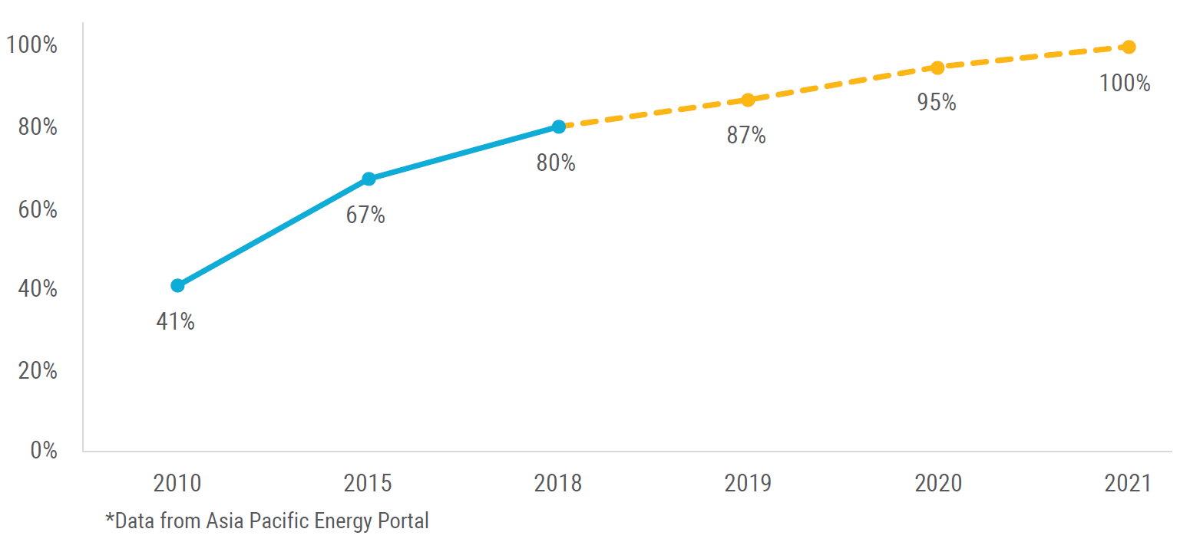

### Renewable energy

The NEXSTEP analysis indicates that the current policies will fall short of Indonesia’s 2025 renewable energy target of 23 per cent and will only reach 17.7 per cent of the Total Primary Energy Supply (TPES) or 16.4 per cent of Total Final Energy Consumption (TFEC) by 2030. The SDG 7 goal and NDC unconditional target together would need a 22 per cent renewable energy share in TFEC by 2030. The increase will require a high penetration of renewable energy in the power sector as well as an increase in renewable energy in the transport sector. Looking further, new coal-fired power plants beyond 2020 are seen to be an uneconomic option, as the lifecycle cost of renewable-based power generation is cheaper than the fossil fuel counterpart. Moreover, investors will face high-risk premiums in investing in fossil fuel-based power plants. Stopping new investment in coal-fired power plants will require renewables to grow to 24 per cent by 2030.

### Energy efficiency

The current trend of energy intensity reduction indicates that Indonesia will need to revise its targeted annual 1 per cent reduction of final energy intensity to 1.53 per cent of primary energy intensity (figure ES 2) to achieve the SDG 7 target of 2.39 MJ/US$ by 2030, a drop from 2.87 MJ/US$ in 2018.

**Figure ES 2. Indonesia energy efficiency target**

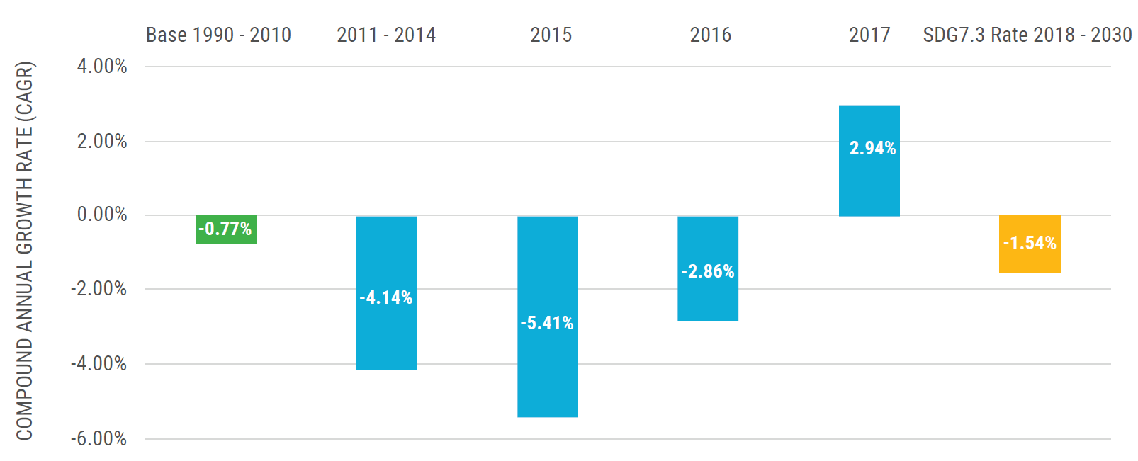

There are ample opportunities for Indonesia to achieve this target as well as implement a higher rate of improvement. These include, for example, a minimum energy efficiency standard (MEPS), rapid deployment of electric vehicles and improvement of energy efficiency of industrial processes. These opportunities are discussed in later sections of this report.

### Nationally determined contributions

In the current policy scenario, Indonesia will fail to achieve the unconditional NDC target of 11 per cent emissions reduction from the energy sector. Emissions will reach 825 MtCO2-e by 2030, compared to 880 MtCO2-e in the business as usual (BAU) scenario, falling short of reducing emissions by 11 per cent target by 42 MtCO2-e. Increasing Indonesia’s contribution to the Paris Agreement and to align the NDC target to the global 1.5-degree pathway, requires emissions to drop to 722 MtCO2-e (figure ES 3). This calls for urgent action to reduce new investment in coal-fired power plants from 2020 onwards and invest more in renewable energy.

**Figure ES 3. Comparison of emissions by scenarios, 2000-2030**

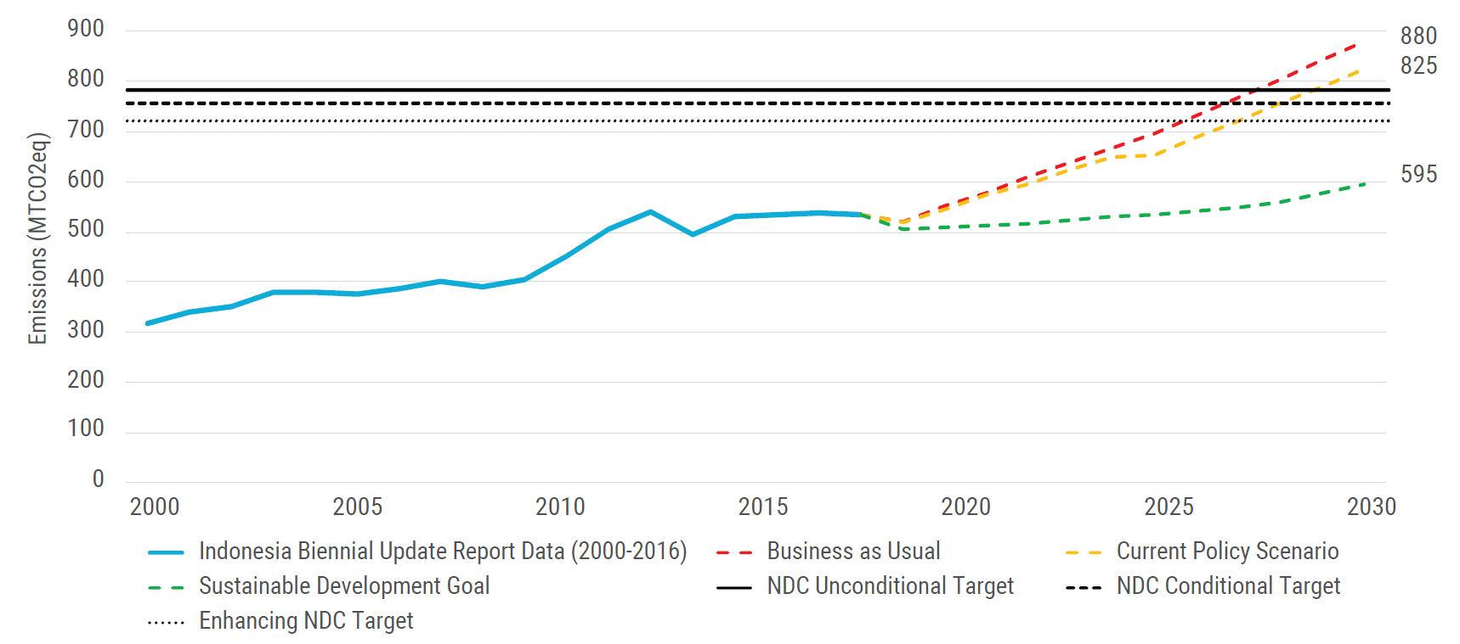

## Important policy directions

The key policy recommendations to help Indonesia accelerate the energy transition to achieve SDG 7 and NDC targets include:

(a)Efforts to achieve universal access to clean cooking needs to increase by three-fold. Electric cooking stove is the recommended technology option to achieve this target for Indonesia. This option should be prioritized for the areas where the electricity system experience surplus electricity supply e.g., the JAMALI (Java-Madura-Bali) system. Implementation of this program will cost the Government of Indonesia a total of Indonesian rupiah (IDR) 9.77 trillion (US$ 688 million)[1] to achieve universal access to clean fuels and technologies for cooking;

(b) Improving energy efficiency beyond the current target of 1 per cent energy intensity reduction offers a cost-effective way to reduce energy expenditure and achieve the SDG 7 target.Low- to no-cost measures, such asefficient lighting, Minimum Energy Performance Standards (MEPS), switching to electric transport, improving fuel economy standards and improvement of industrial processes have a solid business case with quick returns on investment;

(c)Indonesia has the potential to contribute more to achieving the Paris Agreement by enhancing its NDC targets to align it with the 1.5°C compatible pathways. A rapid decline in national greenhouse gas emissions by 45 per cent, compared to 2010 levels, can be achieved by 2030. This will require the energy sector to reduce its emissions by 18 per cent, compared with BAU;

(d)Investments in new coal-fired power generation are no longer cost-effective compared with renewables and should be stopped to avoid emissions lock-in.Least-cost optimization analysis suggests that lifecycle costs of renewables, such as hydropower, geothermal, solar and biomass, are cheaper than coal-fired technologies. The underlying financial risks of investment in coal-based power plants should not be ignored;

(e)Financing the low-carbon transition through carbon pricing, removing fossil fuel subsidies and the issuance of green bonds should be encouraged.Indonesia has already proved itself a leader in reducing fossil fuel subsidies. Further measures to eliminate remaining subsidies, particularly those for power generation, would save an annual fiscal cost of IDR 101.32 trillion (US$ 7.13 billion) and level the playing field for renewables. Placing a price on carbon will internalise the externality cost of fossil fuel-based power generation and establish a market mechanism to reduce GHG emissions. The introduction of green financing, such as through green bonds, would alleviate the burden of large capital investments needed for the 2030 energy transition.

**Figure ES 4. Forecast of Indonesia’s SDG 7 and NDC targets by 2030**

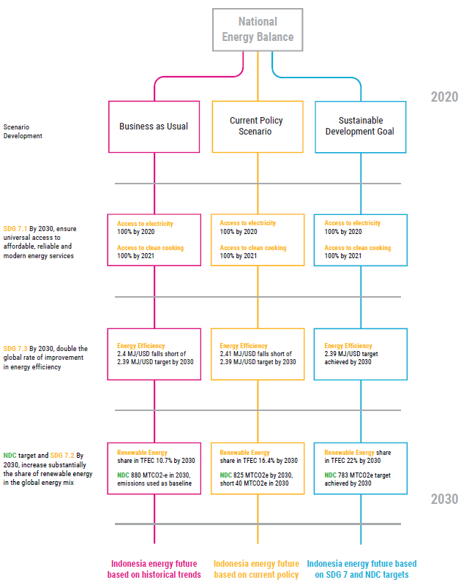

# Introduction

## Background

Transitioning the energy sector to achieve the 2030 Agenda for Sustainable Development and the objectives of the Paris Agreement presents a complex and difficult task for policymakers. It needs to ensure sustained economic growth, respond to increasing energy demand, reduce emissions and, more importantly, consider and capitalize on the interlinkages between Sustainable Development Goal 7 (SDG 7) and other SDGs. In this connection, the United Nations Economic and Social Commission for Asia and the Pacific (ESCAP) has developed the National Expert SDG Tool for Energy Planning (NEXSTEP). This tool enables policymakers to make informed policy decisions to support the achievement of the SDG 7 targets as well as emission reduction targets (NDCs). The initiative has been undertaken in response to the Ministerial Declaration of the Second Asian and Pacific Energy Forum (April 2018, Bangkok) and Commission Resolution 74/9, which endorsed its outcomes. NEXSTEP also garnered the support of the Committee on Energy in its Second Session, with recommendations to expand the number of countries being supported by this tool.

## SDG 7 targets and indicators

SDG 7 aims to ensure access to affordable, reliable, sustainable and modern energy for all. It has three key targets, which are outlined below.

• Target 7.1. “By 2030, ensure universal access to affordable, reliable and modern energy services.” Two indicators are used to measure this target: (a) the proportion of the population with access to electricity; and (b) the proportion of the population with primary reliance on clean cooking fuels and technology.

• Target 7.2. “By 2030, increase substantially the share of renewable energy in the global energy mix”. This is measured by the renewable energy share in total final energy consumption (TFEC). It is calculated by dividing the consumption of energy from all renewable sources by total energy consumption. Renewable energy consumption includes consumption of energy derived from hydropower, solid biofuels (including traditional use), wind, solar, liquid biofuels, biogas, geothermal, marine and waste. Due to the inherent complexity of accurately estimating traditional use of biomass, NEXSTEP focuses entirely on modern renewables (excluding traditional use of biomass) for meeting this target.

• Target 7.3. “By 2030, double the global rate of improvement in energy efficiency”, as measured by the energy intensity of the economy. This is the ratio of the total primary energy supply (TPES) and GDP. Energy intensity is an indication of how much energy is used to produce one unit of economic output. As defined by the IEA, TPES is made up of production plus net imports minus international marine and aviation bunkers plus stock changes. For comparison purposes, GDP is measured in constant terms at 2011 PPP.

## Nationally Determined Contributions

Nationally Determined Contributions (NDCs) represent pledges by each country to reduce national emissions and are the stepping-stones to the implementation of the Paris Agreement. Since the energy sector is the largest contributor to greenhouse gas (GHG)[2] emissions in most countries, decarbonizing energy systems should be given high priority. Key approaches to reducing emissions from the energy sector include increasing renewable energy in the generation mix and improving energy efficiency. In its NDC document, Indonesia has pledged to reduce GHG emission by 29 per cent (unconditional) compared to BAU, and 41 per cent (conditional) with international support compared to BAU by 2030. The contribution of the energy sector towards these targets is estimated to be 11 per cent (unconditional) and 14 per cent (conditional).

# NEXSTEP methodology

The main purpose of NEXSTEP is to help design the type and mix of policies that will enable the achievement of the SDG 7 targets and the emission reduction targets (under NDCs) through policy analysis. However, policy analysis cannot be done without (a) modelling energy systems to forecast/backcast energy and emissions, and (b) economic analysis to assess which policies or options would be economically suitable. Based on this, a three-step approach has been proposed. Each step is discussed in the following sections.

## Key methodological steps

### Energy and emissions modelling

NEXSTEP begins with energy systems modelling for developing different scenarios to achieve SDG 7 by identifying potential technical options for each scenario. Each scenario contains important information, including the final energy (electricity and heat) requirement by 2030, possible generation/supply mix, emissions and the size of investment required. The energy and emissions modelling component use the Low Emissions Analysis Platform (LEAP). It is a widely used tool for energy sector modelling and for creating energy and emissions scenarios. Many countries have used LEAP to develop scenarios as a basis for their Intended Nationally Determined Contributions (INDCs). The Least Cost Optimization method is used to calculate the optimal expansion and dispatch of the electric power system. Figure 1 shows the different steps of the methodology.

### Economic analysis module

The energy and emissions modelling section selects the appropriate technologies, and the economic analysis builds on this by selecting the least cost energy supply mix for the country. The economic analysis is used to examine economic performances of individual technical options identified and prioritize least-cost options. As such, it is important to estimate some of the key economic parameters such as net present value, internal rate of return, and payback period. A ranking of selected technologies will help policymakers to identify and select economically effective projects for better allocation of resources. The economic analysis helps present several economic parameters and indicators that would be useful for policymakers in making an informed policy decision.

### Scenario and policy analysis

Using the Multi-Criteria Decision Analysis (MCDA) tool, this prioritized list of scenarios is assessed in terms of their techno-economic for the energy sector, and environmental dimensions to convert to a policy measure. The top-ranked scenario from the MCDA process is essentially the output of NEXSTEP, which is then used to develop policy recommendations.

**Figure 1. Different components of the NEXSTEP methodology**

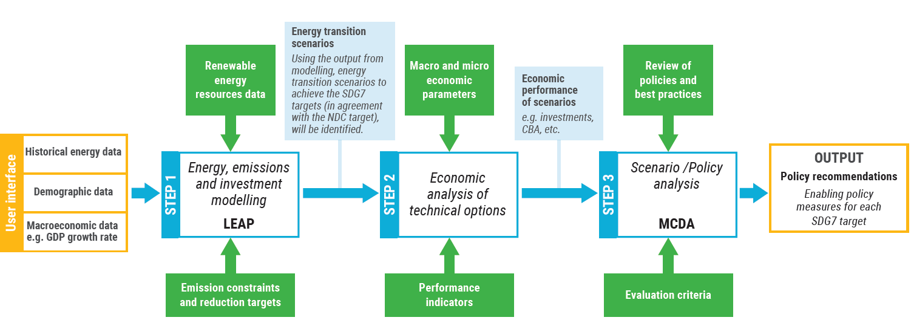

***Note:*** *This tool is unique in the way that no other tools look at developing policy measures to achieve SDG 7. The key feature that makes it outstanding is the backcasting approach for energy and emissions modelling. This is important when it comes to planning for SDG 7, as the targets for the final year (2030) are already given; thus, the tool needs to be able to work its way backward to the current date and identify the best possible pathway.*

## Scenario definitions

The LEAP modelling system is designed for scenario analysis, to enable energy specialists to model energy system evolution based on current energy policies. In the NEXSTEP model for Indonesia, three main scenarios have been modelled: (a) a BAU scenario; (b) current policy scenario (CPS); and (c) Sustainable Development Goal (SDG) scenario.

### The BAU scenario:

This scenario follows historical demand trends, based on simple projections, by using GDP and population growth. It does not consider emission limits or renewable energy targets. For each sector, the final energy demand is met by a fuel mix reflecting the current shares in TFEC, with the trend extrapolated to 2030. Essentially, this scenario aims to indicate what will happen if no enabling policies are implemented or the existing policies fail to achieve their intended outcomes;

### Current policies scenario:

Inherited and modified from the BAU scenario, this scenario considers all policies and plans currently in place. In addition, a target of an 11 per cent decrease of GHG emissions by the energy sector by 2030, compared to the BAU scenario, is set according to the unconditional NDCs of Indonesia. Other policy orientations of the National Energy General Plan (RUEN) are considered, such as the intention of decreasing the dependence on oil and optimizing the use of natural gas;

### SDG 7 scenario:

This scenario and its sub-scenarios aim to achieve the SDG 7 targets, including universal access to electricity and to clean cooking fuel, substantially increasing renewable energy share and doubling the rate of energy efficiency improvement. A least-cost option has been used to provide electricity access to the remaining population. For clean cooking, different technologies (electric cooking stove, LPG cooking stove and improved cooking stove) have been assessed. Energy intensity has been modelled to help achieve the SDG 7 target. Finally, an emission reduction target has been used to estimate the optimum share of renewable energy in TFEC which is considered to be a substantial increase.

## Economic analysis

The economic analysis considers the project’s contribution to the economic performance of the energy sector. The purpose of a cost-benefit analysis (CBA) is to make better informed policy decisions. It is a tool to weigh the benefits against costs and facilitate an efficient distribution of resources in public sector investment.

## Basics of economic analysis

The economic analysis of public sector investment differs from a financial analysis. A financial analysis considers the profitability of an investment project from the investor’s perspective. In an economic analysis the profitability of the investment considers the national welfare, including externalities. A project is financially viable only if all the monetary costs can be recovered in the project lifetime. Project financial viability is not enough in an economic analysis, and contribution to societal welfare should also be identified and quantified. For example, in the case of a coal power plant, the emissions from the combustion process emits particulate matter that is inhaled by the local population, causing health damage and acceleration of climate change. In an economic analysis a monetary value is assigned to the GHG emission to value its GHG emissions abatement.

## Cost parameters

The project cost is the fundamental input in an economic analysis. The overall project cost is calculated using the following:

1. Capital cost – capital infrastructure costs for technologies, which are based on country-specific data to improve the analysis. They include land, building, machinery, equipment and civil works;
2. Operation and maintenance cost – comprising fuel, labour and maintenance costs. Power generation facilities classify operation and maintenance costs as fixed (US$/MW) and variable (US$/MWh) cost;
3. Decommissioning cost – retirement of power plants costs related to environmental remediation, regulatory frameworks and demolition costs;
4. Sunk cost – existing infrastructure investments are not included in the economic analysis, since no additional investment is required for the project;
5. External cost – refers to any additional externalities which place costs on society;
6. GHG abatement – avoided cost of CO2 generation is calculated in monetary value based on carbon price. The 2016 Intergovernmental Panel on Climate Change (IPCC) Guidelines for National Greenhouse Gas Inventories is followed in the calculation of GHG emissions for the economic analysis. The sectoral analysis is based on the Tier 1 approach, which uses fuel combustion from national statistics and default emission factors.

# Overview of the Indonesia’s energy sector

## Current situation

Indonesia is an archipelagic State with more than 18,000 islands and a population of more than 265 million in 2018. The country is ranked as the world's fourth most populous nation and has seen rapid economic growth and development. A growing population, rising household incomes and increasing urbanization will lead to rising energy demand and put constraints on energy supply.

The vision and mission for the country is set under the Long-Term Development Plan (RPJPN) 2005-2025, which aims to establish a country that is developed and self-reliant, just and democratic, and peaceful and united. The RPJPN is divided into ‘five-year Medium-Term Development Plans (RPJMN). The national energy policy approach is defined under the 2007 Energy Law, which is aligned with the RPJPN; this is used to support energy independence for achieving long-term growth.

The Government recently passed Presidential Regulation 22/2017 for implementing the provision of the Energy Law to create the National Energy General Plan (RUEN). The RUEN is supposed to implement the 2014 National Energy Policy (KEN), which aims to achieve energy self-reliance and national energy security. In terms of energy efficiency, the 2007 Energy Law provides for energy efficiency principles, further specified under the Government Regulation No. 70/2009 on Energy Conservation (Asia-Pacific Energy Portal, 2020).

The country has set a target to limit its GHG emissions through the Nationally Determined Contributions in 2015 which suggests an unconditional target of 29 per cent (41 per cent if external support is received) by 2030 compared to BAU.

## National energy profile

Indonesia has made significant progress towards achieving universal access to electricity. The ratio of electrification in Indonesia was 98.3 per cent in 2018. Indonesia is on track to achieve universal access to electricity by 2020.

Access to clean cooking solutions is measured at 80 per cent, based on National Statistics for Indonesia (Neliti, 2020). Indonesia has made remarkable progress towards clean cooking – more than a 10-fold increase from 7 per cent in 2000. This has been possible due to government-funded programmes during 2007-2015, i.e., Zero-Kero and Improved Cook Stove programme that have seen about 50 million households getting access to clean cooking technology. The current policies to reach 4.7 million city gas connections and 1.1 million biogas digesters by 2025 are modelled in the current policy scenario.

The renewable energy share in TFEC is calculated at 11.25 per cent in 2018, which is equivalent to 12 per cent of TPES. Figure2 shows Indonesia’s planned capacity expansion for electricity generation. This is based on the planned capacity expansion from RUPTL 2019-2028 (Ministry of Energy and Mineral Resources, 2020). Coal in power generation has been planned to increase by 27GW by 2028 reaching a share of 42 per cent of total installed capacity in 2028.

**Figure 2. Indonesia’s RUPTL 2019-2028 planned capacity expansion**

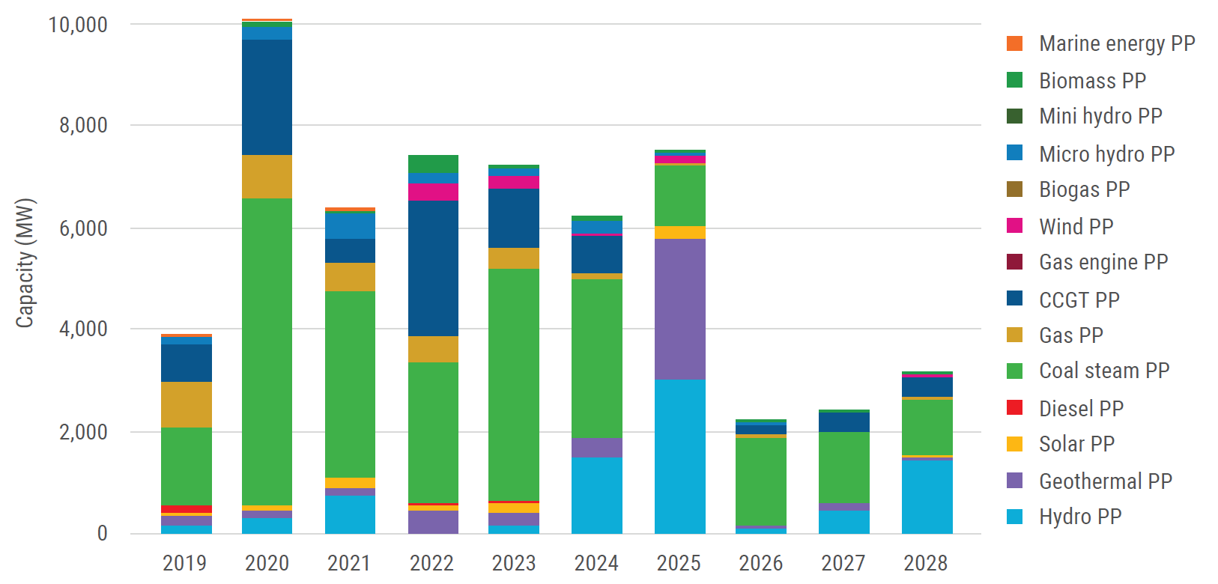

Energy intensity in Indonesia has been declining at an average annual rate of 2.81 per cent since 2010 and reached 2.87 MJ/US$ in 2018. Under the current policy, Indonesia aims to reduce its energy intensity (in terms of final energy) by 1 per cent annually up to 2025. The objective is to achieve energy elasticity[3] of less than 1 in 2025.

## National energy policies and targets

Scenario development has been based on energy policies and assumptions (as summarized in table 1) as well as considering relevant policies (listed below) that are already in place. National Energy Policy (KEN): KEN mandates a renewable energy target of 23 per cent in the primary energy mix by 2025. Indonesia has set a target to improve energy efficiency by 1 per cent in TFEC in order to promote energy saving across all sectors (Ministry of Energy and Mineral Resources, 2018);

1. National Energy General Plan (RUEN): To connect 4.7 million city gas connections and 1.1 million biogas digesters (Ministry of Energy and Mineral Resources, 2018);
2. RUPTL 2019-2028: In the power sector the capacity addition is based on RUPTL 2019-2028 and the remaining two years (2029 and 2030) are forecasted using linear regression (Ministry of Energy and Mineral Resources, 2020);
3. Biofuel Roadmap: Biofuel mandate of 30 per cent biodiesel and 20 per cent bioethanol utilization by 2025 based on Minister of Energy and Mineral Resources Regulation No.12 of 2015 in the transport sector (Ministry of Energy and Mineral Resources, 2018);
4. National Master Plan for Energy Conservation (RIKEN): RIKEN sets a goal of decreasing energy intensity by 1 per cent annually until 2025. In order to reach this goal, energy savings potentials have been identified as follows: industry 15-30 per cent, commercial buildings 25 per cent, transportation 20-35 per cent and households 10-30 per cent;
5. Energy Law No. 30/2007 (EL7) The law recognizes energy security as a critical national issue and requires that more attention to be given to new and renewable energy development and that incentives should be developed for energy providers to do this;
6. National Action Plan for Reducing Greenhouse Gas Emissions (RAN-GRK): RAN-GRK is a follow-up to Indonesia’s commitment to reduce GHG emissions by 29 per cent in 2020 from the BAU level by its own efforts and then reaching 41 per cent reduction with international support, based on Presidential Decree No. 61 of 2011;
7. Green Energy Policy (Ministerial Decree No. 2/2004): The Green Energy Policy identifies Indonesia’s strategy to maximize the utilization of its renewable energy potential and to build public awareness of energy efficiency measures;
8. Nationally Determined Contribution (NDC): The first NDC of 2016 shows the national commitment to reduce GHG Emissions at 29 per cent unconditional and 41 per cent conditional up to 2030.

**Table 1. Important factors, targets and assumptions used in modelling**

|  |  |  |  |
| --- | --- | --- | --- |
| **Parameters** | **Business as usual** | **Current policy scenario** | **Sustainable Development Goal** |
| Economic growth | 5.7% | | |
| Population growth | Statistics Indonesia | | |
| Household size | Assumption used in National Energy General Planning (RUEN) | | |
| Commercial floor space | Assumption used in National Energy General Planning, adjusted with the GDP growth used in a moderate scenario of Medium-term National Development Planning (RPJMN 2020-2024) | | |
| Transport activity | Assumption used in National Energy Planning, adjusted with the GDP growth used in a moderate scenario of Medium-term National Development Planning (RPJMN 2020-2024) | | |
| Residential urbanization | Assumption used in National Energy General Planning | | |
| Biodiesel target | 2025: 20% | 2025: 30% | NA |
| Bioethanol target | 2025: 5% | 2025: 20% | NA |
| Access to electricity | 2020: 100% | 2020: 100% | 2020: 100% |
| Access to clean cooking fuels | Based on 2018 share | 4.7 million city gas connections  1.1 million biogas digesters | 100 per cent access to clean cooking fuels and technologies |
| Energy efficiency | Remains constant | 1 per cent annual improvement in TFEC | 1.53 per cent annual improvement in TFEC |
| Power plants | Based on 2018 share | RUPTL 2019 - 2028 | Based on least cost optimization |

## National energy resources

Indonesia is a resource-rich country and has abundant renewable energy potential. It has coal resources and reserves of 151,399.41 million tons (MT) and 39,890.95 MT, respectively. In 2018, coal production in Indonesia amounted to 557.77 MT of which 356.39 MT were exported, establishing Indonesia as the world’s fourth largest exporter of coal.

Indonesia has proven and potential oil reserves of 3.15 billion barrels and 4.36 billion barrels, respectively. The country has been a net importer of oil since 2004, due to a production decline caused by depletion of mature production wells, the limited development of new production wells and declining investment.

Indonesia’s proven and potential natural gas reserves are estimated at 96.06 trillion standard cubic feet (TSCF) and 39.49 TSCF, respectively. In 2018, natural gas production in Indonesia totalled 2.99 TSCF, making the country the largest exporter of natural gas in South-East Asia.

Renewable energy potential in Indonesia is mentioned in the RUPTL document. The country’s utilization of renewable energy potential is very low (table 2) This indicates that there is significant potential to expand the renewables share.

**Table 2 Renewable energy resource utilization in Indonesia**

|  |  |  |  |
| --- | --- | --- | --- |
| **Renewable Energy** | **Potential** | **Installed capacity** | **Utilization** |
| Geothermal | 29,544 MW | 1,438.5 MW | 4.9 per cent |
| Hydro | 75,091 MW | 4,826.7 MW | 6.4 per cent |
| Mini-micro hydro | 19,385 MW | 197.4 MW | 1.0 per cent |
| Bio-energy | 32,654 MW | 1,671.0 MW | 5.1 per cent |
| Solar | 207,898 MW | 78.5 MW | 0.04 per cent |
| Wind | 60,647 MW | 3.1 MW | 0.01 per cent |
| Ocean energy | 17,989 MW | 0.3 MW | 0.002 per cent |

*Source:* RUPTL document (PLN, 2019).

## National energy balance

The national energy balance of Indonesia 2018, as noted in the *Handbook of Energy and Economic Statistics of Indonesia*, is the starting point of the NEXSTEP analysis. The Total Primary Energy Supply (TPES) is dominated by oil, coal and natural gas, with renewables contributing only 13 per cent in 2018.figure 3) shows TPES of Indonesia is 1,533 million barrels of oil equivalent (MBOE). Indonesia’s TPES by fuel share: Crude oil and products (37 per cent); coal (32 per cent); natural gas and products (19 per cent); and renewables (13 per cent).

**Figure 3. Total Primary Energy Supply, 2018**

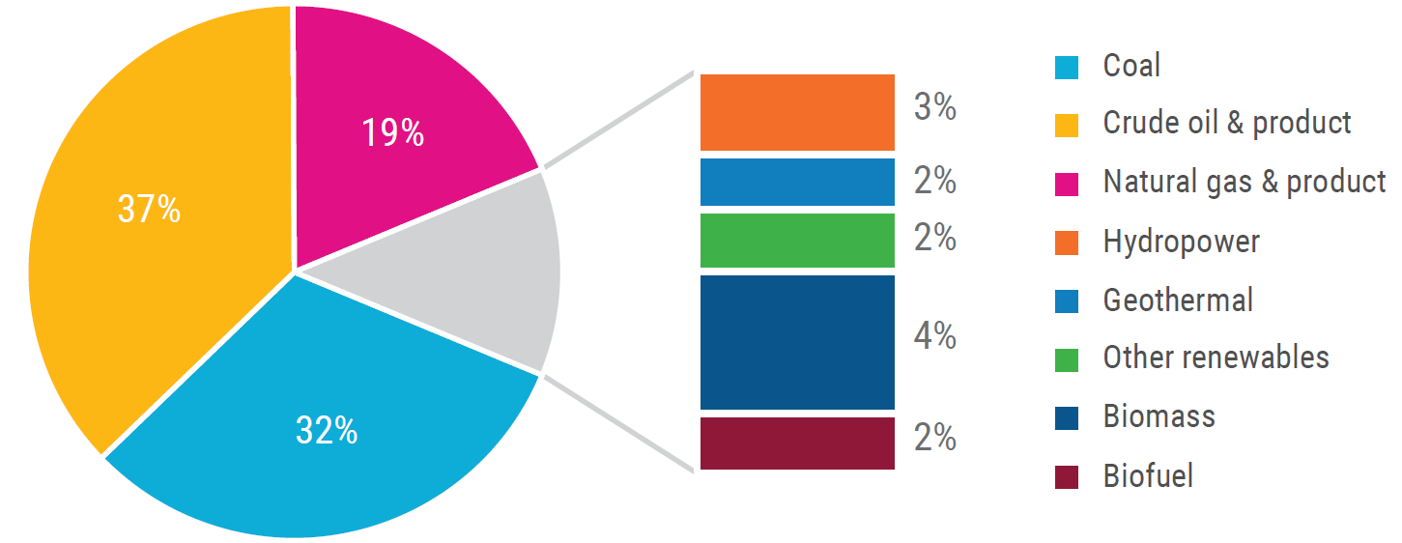

Indonesia is the largest energy consumer in South-East Asia. TFEC in 2018 is reported as 936.33 MBOE (figure 4). TFEC in Indonesia increased by 38 per cent between 2000 and 2016. The largest increase was in the transport sector, which more than doubled during that period. Indonesia’s final energy consumption, by sector, is led by transport (40.8%, 39.2 MBOE), industry (34.7%, 33.4 MBOE), households (15.7%, 15.1 MBOE), commercial (4.5%, 4.3 MBOE) and other sectors (1.7%, 1.6 MBOE).

**Figure 4. Total Final Energy Consumption, 2018**

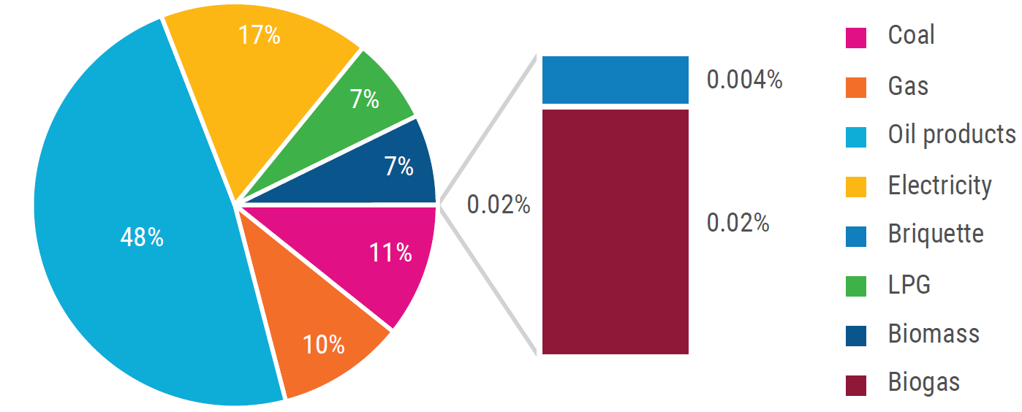

## Energy Demand Outlook

The energy demand is calculated using the activity level and energy intensity in the LEAP model. Indonesia’s energy demand outlook for 2020 - 2030 is influenced by population growth data from Statistics Indonesia (see Annex II: Key assumptions), GDP growth of 5.7 per cent annually and energy elasticity for each sector. The annual average growth rate for the total final energy demand in the BAU and current policy scenarios is 4.5 per cent, whereas the growth rate is reduced to 3.6 per cent in the SDG scenario.

### Business as usual scenario

In the business as usual scenario, TFEC is expected to increase from 1,055 MBOE in 2020 to 1,624 MBOE in 2030. The current fuel mix in the energy system is expected to continue to 2030 in the absence of any major intervention. In 2030, the industry sector will have the largest share of TFEC at 663 MBOE (41 per cent), followed by the transport sector at 584 MBOE (36 per cent), residential at 223 MBOE (14 per cent), commercial at 92 MBOE (6 per cent), other sectors at 25 MBOE (2 per cent) and non-energy use at 36 MBOE (2 per cent).

### Current policy scenario

In the current policy scenario, TFEC is also expected to see similar growth – increasing from 1,054 MBOE in 2020 to 1,620 MBOE in 2030 (Figure 5). The sectoral shares; industry 663 MBOE (41 per cent), transport 583 MBOE (36 per cent), residential sector 221 MBOE (14 per cent), commercial sector 92 MBOE (6 per cent), other sectors 25 MBOE (2 per cent) and non-energy use 36 MBOE (2 per cent). The sectoral overview of energy demand in the current policy scenario is discussed below.

**Figure 5 Indonesia’s****energy demand outlook, 2020 - 2030**

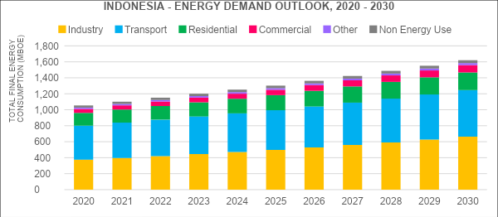

#### Industry sector

Energy demand in the industrial sector will double from 334 MBOE in 2018 to 663 MBOE in 2030. The subsector shares of industrial energy consumption in 2030 will be: fertilizer, chemical, and rubber products, 139.4 MBOE (21 per cent); cement and non-ferro materials, 132.7 MBOE (20 per cent); food and beverages, 119.5 MBOE (18 per cent); textiles and leather, 79.6 MBOE (12 per cent); pulp and paper, 59.1 MBOE (9 per cent); machinery and transportation tools, 59.7 MBOE (9 per cent); iron and steel ,53.1 MBOE (8 per cent); wood and other products, 13.3 MBOE (2 per cent); and other industries, 6.6 MBOE (1 per cent).

#### Transport

The transport sector’s energy demand is projected to increase to 583 MBOE by 2030, compared with 391 MBOE in 2018. In 2030, the subsector share of transport energy demand will be: road transport 482 MBOE (83 per cent); aviation 65 MBOE (11 per cent); marine 31 MBOE (5 per cent); and rail 4 MBOE (1 per cent).

#### Residential

The residential sector’s demand in Indonesia is projected to increase to 221 MBOE by 2030, compared with 151 MBOE in 2018. In 2030, the subsector share of residential energy demand will be urban, 165 MBOE (74 per cent), and rural, 56 MBOE (24 per cent). The residential sector energy demand outlook is influenced by increased urbanization to 63.4 per cent by 2030, compared with 55.3 per cent in 2018, increased ownership of household appliances calculated by stock-turnover analysis and an increase in population to 294 million by 2030.

#### Commercial

The commercial sector energy demand is projected to increase from 43 MBOE in 2018 to 92 MBOE in 2030. The sector is divided into government buildings and private buildings. In 2030, the subsector share of commercial energy demand will be private buildings 79 MBOE (86 per cent) and government buildings 13 MBOE (14 per cent). The commercial sector analysis is based on floor space occupied by the sector and the energy intensity per square metre.

#### Other

The other sector energy demand is projected to increase to 25 MBOE by 2030, compared with 16 MBOE in 2018. The forecast for other sector energy consumption is based on the data from the *Handbook of Energy and Economics*.

## Electric Power Generation Outlook

Indonesia’s installed electric power generation capacity in 2018 was reported as 64,924 MW of which 62,255 MW is on-grid and 2,668 MW is off-grid electric power generation. In 2018, the installed on-grid power plant capacity for Indonesia; Steam PP 31,587 MW, followed by Combined Cycle Gas Turbine (CCGT) PP 11,220 MW, Gas PP 5,348 MW, Diesel PP 4,630 MW, Hydro PP 4,431 MW, Gas Engine PP 2,357 MW, Geothermal PP 1,948 MW, Mini Hydro PP 268 MW, Wind PP 143 MW, Biomass PP 142 MW, Micro Hydro 98 MW, Solar 24 MW and Waste PP 15 MW.

### Business as usual scenario

The business-as-usual scenario essentially forecasts if no-action is taken and the system continues to expand based on the 2018 fuel share till 2030. In 2030, the installed on-grid power generation for Indonesia is forecasted as 135 GW. In 2030, the fossil fuel share will dominate electric supply at 89 per cent, with renewables contributing only 11 per cent of installed capacity.

The installed capacity by technology: Steam PP 68,781 MW, CCGT PP 24,431 MW, Gas PP 11,646 MW, Diesel 10,083 MW, Hydro PP 9,649 MW, Gas Engine PP 5,133 MW, Geothermal PP 4,242 MW, Mini Hydro PP 583 MW, Biomass PP 343 MW, Wind PP 311 MW, Micro Hydro PP 214 MW, Biogas PP 88 MW and Solar PP 53 MW.

### Current policy scenario

The NEXSTEP analysis for Indonesia uses data from the RUPTL 2019 – 2028 to model the current policy scenario for electric power generation outlook. In this scenario, an additional 27 GW coal-based power plant will be added to the power sector by 2028 (Annex IX), making the power generation highly carbon intensive. In 2030, the installed on-grid power generation for Indonesia is forecasted as 135 GW (Figure 6). In 2030, the fossil fuel share will continue to dominate electric supply at 81 per cent and renewables share increases to 19 per cent of the installed capacity.

The installed capacity by technology: Steam PP 67,020 MW, CCGT PP 23,268 MW, Hydro PP 13,858 MW, Gas PP 9,562 MW, Geothermal PP 8,136 MW, Diesel 4,864 MW, Gas Engine PP 2,358 MW, Micro Hydro PP 2,212 MW, Wind PP 1,416 MW, Solar PP 1,288 MW, Biomass PP 1,265 MW, Mini Hydro PP 268 MW, Biogas PP 40 MW and Marine Energy PP 7 MW.

**Figure 6 Indonesia installed capacity expansion, 2020 - 2030**

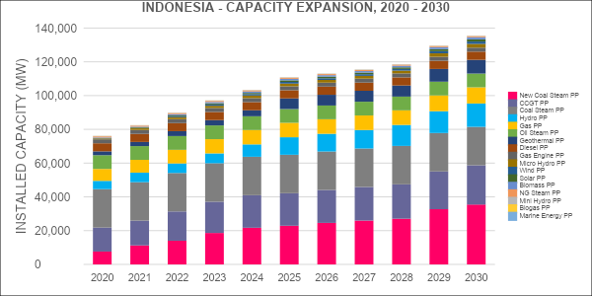

## Energy Supply Outlook

The Energy Supply Outlook for Indonesia in the period 2020 - 2030 is based on national energy resource constraints, which specify the resources available domestically and the resources which need to be imported. In the LEAP model, the national base year reserves for fossil-fuel resources and the annual yield from renewable energy resources in modelled as constraint.

### Business as usual scenario

In the business as usual scenario, the Total Primary Energy Supply (TPES) is forecasted to increase from 1,620 MBOE in 2020 to 2,492 MBOE in 2030. The fuel shares in 2030 is forecasted as: coal 714 MBOE, natural gas 589 MBOE, oil products 559 MBOE, crude oil 341 MBOE, biomass 129 MBOE, hydropower 66 MBOE, biofuel 46 MBOE, electricity 1 MBOE and other renewables 55 MBOE.

### Current policy scenario

In the current policy scenario, the TPES is forecasted to increase from 1,620 MBOE in 2020 to 2,505 MBOE in 2030. The fuel shares in 2030 (Figure 7) is projected as: coal 715 MBOE (29 per cent), natural gas 551 MBOE (22 per cent), oil products 455 MBOE (18 per cent), crude oil 341 MBOE (14 per cent), biomass 122 MBOE (5 per cent), hydropower 106 MBOE (4 per cent), biofuel 67 MBOE (3 per cent), electricity 1 MBOE (0.04 per cent) and other renewables 142 MBOE (6 per cent).

**Figure 7 Indonesia primary energy supply, by fuel share**

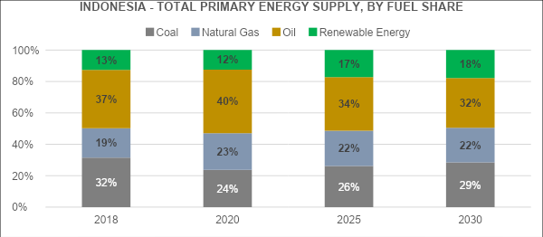

Indonesia’s national energy supply priorities are included in the calculations with domestic demand for coal increasing from 385 MBOE in 2020 to 715 MBOE in 2030 to meet the additional demand in electric power generation and industrial consumption. The national priority of increasing biofuel consumption to reduce oil imports leads to an increase in biofuel consumption from 24 MBOE in 2018 to 67 MBOE in 2030 (if current biodiesel and bioethanol blending targets are fully implemented by 2030).

Indonesia’s national renewable energy target of 23 per cent by 2025 in TPES will not be achieved based on current policies even if they are fully implemented, reaching 17 per cent in 2025 and 18 per cent in 2030. Indonesia’s plan to increase biofuels will increase renewable energy share but at the same time this progress will be lost due to the replacement of traditional biomass stoves by LPG cook stoves. In the SDG scenario discussed in the next chapter, Indonesia will be able to meet renewable energy target achieving 30 per cent by 2025 and 32 per cent by 2030 in TPES.

## Energy Sector Emissions Outlook

The energy sector emissions for Indonesia is calculated based on IPCC Tier 1 emission factors assigned in the LEAP model wherever fuel is being combusted.

### Business as usual scenario

Based on the NDC document submitted to the United Nations Framework Convention on Climate Change the projected emissions in the business as usual scenario for Indonesia in 2030 will be 1,669 MTCO2-e, which is used as aa reference for emission reduction calculations.

The NEXSTEP analysis uses the latest available 2018 data for Indonesia’s energy sector and energy demand growth assumptions to calculate the energy sector emissions in 2030 at 880 MTCO2-e which is nearly half of the original estimate from the Government of Indonesia. The result of NEXSTEP exercise agrees with similar analysis completed in the Indonesia Energy Outlook 2019 which calculates energy sector emissions in 2030 at 912 MTCO2-e for the business as usual scenario. This indicates that the original NDC BAU target of 1,669 MTCO2-e needs to be revised and Government of Indonesia can raise ambitious in reducing energy sector emissions.

### Current policy scenario

Based on the Nationally Determined Contributions (NDC) document submitted to UNFCCC, Indonesia has committed to reducing GHG emissions in the energy sector to 11% unconditionally (without international aid) below the BAU scenario. The emissions in the current policy scenario will reach 825 MtCO2-e by 2030 (Figure 8), compared with 880 MtCO2-e in the BAU scenario, falling short of the NDC target by 42 MtCO2-e.The result of NEXSTEP exercise agrees with similar analysis completed in the Indonesia Energy Outlook 2019 which calculates energy sector emissions in 2030 at 813 MTCO2-e for the PB scenario.

**Figure 8 Indonesia energy sector emissions outlook, 2020 -2030**

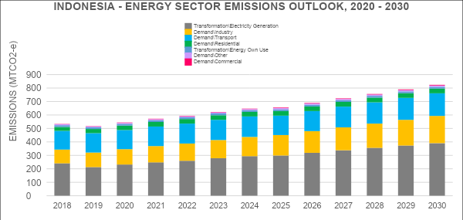

# SDG scenario – achieving SDG 7 by 2030

Access to affordable, reliable, sustainable and modern energy is essential to achieving the 2030 agenda for Sustainable Development and the Paris Agreement on climate change. In the SDG scenario, TFEC increases from 1,032 MBOE in 2020 to 1,462 MBOE in 2030. The reduction in TFEC in this scenario, compared to the other scenarios, is due to the improvement in energy efficiency as per the SDG 7 target. In 2030, the industry sector will have the largest share of TFEC at 636 MBOE (44 per cent), followed by the transport sector at 468 MBOE (32 per cent), residential sector at 204 MBOE (14 per cent), commercial sector at 92 MBOE (6 per cent), other sectors at 25 MBOE (2 per cent) and non-energy use at 36 MBOE (2 per cent). (Figure 9) shows the total final energy consumption by scenario in 2030.

**Figure 9. Projection of TFEC, by scenario and sector, 2020 - 2030**

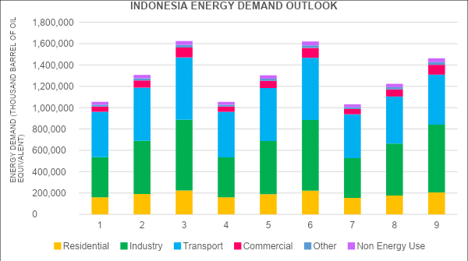

## SDG 7 targets

### SDG 7.1.1. Access to electricity

Indonesia is on track to achieve universal access to electricity by 2020. The electricity demand, in the SDG scenario, will increase from 255 TWh in 2018 to 585 TWh in 2030. This includes the additional demand in the transport sector due to the increased electrification of passenger cars, buses and taxis.

### 4.1.2. SDG 7.1.2. Access to clean fuels and technologies for cooking

The RUEN will connect 4.7 million city gas connections and 1.1 million biogas digesters. In the SDG scenario, the target is achieved by the promotion of electric cooking stoves for additional 15 million households compared to the current policy scenario. Implementation of this programme will cost the Government of Indonesia IDR 9.77 trillion (US$ 688 million) by 2030. Refer to subsection 5.4.2 for an overview of suitable clean cooking technologies for Indonesia. Figure 10shows the technology mix to achieve universal access to clean cooking for different scenarios.

**Figure 10. Fuel mix for clean cooking, by scenario, 2030**

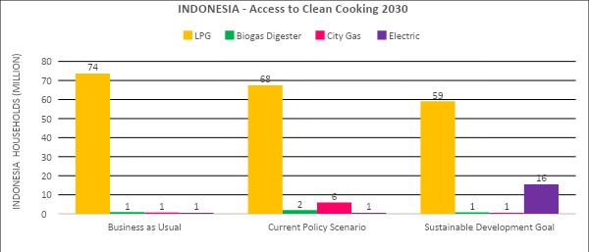

### 4.1.3. SDG 7.2. Renewable energy

SDG 7.2 does not have a quantitative target; however, an increase in renewable energy is required to meet the NDC emissions target. NEXSTEP methodology first estimates the net increase in energy demand in response to universal energy access (both electricity and clean cooking) as well as energy efficiency improvement. It then uses the NDC target for the energy sector to estimate the renewable energy share in TFEC.

**Figure 11. Renewable energy in TFEC, 2030**

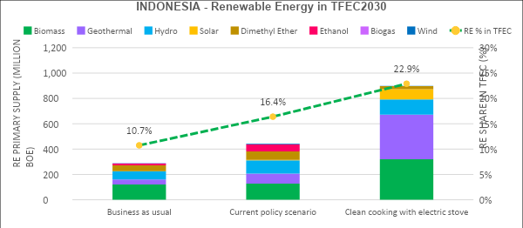

The share of renewable energy in TFEC in 2030 will be 10.7 per cent equivalent to 11.6 per cent of TPES in the business as usual scenario, which is expected to grow to 16.4 per cent in TFEC, equivalent to 17.7 per cent of TPES by 2030 in the current policy scenario (Figure 11). This increase is largely driven by the biofuel mandate and the increase in the renewable energy share in RUPTL 2019-2028. The renewable energy share in TFEC needs to increase to 22.9 per cent, equivalent to 32.6 per cent of TPES in order to reduce emissions and achieve the NDC unconditional target. As indicated in the NEXSTEP methodology above, this is the optimum share of renewable energy that considers the reduction of TFEC due to the improvement in energy efficiency as well as switching from biomass-based cooking stoves to electric cooking stoves. This share of renewable energy also reflects a moderate increase in biofuel (box 1) and uptake of renewable-based power generation technology

|  |
| --- |
| **Box 1. Indonesia’s biofuel policy**  Indonesia has one of the most ambitious biofuel programmes in the world. The biofuel mandate of 30 per cent biodiesel and 20 per cent bioethanol utilization by 2025 is based on Ministry of Energy and Mineral Resources Regulation No.12 of 2015 in the transport sector. However, biofuels have unintended consequences related to deforestation, a negative impact on biodiversity and concern about greenhouse gas emissions.  Indirect land-use change (ILUC) is a major concern among environmental experts. If biofuel crops are produced on uncultivated land it leads to direct land-use change. However, biofuel crops grown on existing cultivated land leads to new land being cleared to grow food crops. If ILUCF is taken into account, GHG saving performance decreases by about 15 per cent for ethanol pathways, and there are no GHG savings for any biodiesel pathway (except biodiesel from waste) (European Parliament, 2015).  Studies have shown expansion of palm oil-based biodiesel has negative impacts related to increases in deforestation and peatland drainage. In Indonesia 23 million hectares of forest were allotted for conversion to palm-oil, but only 2 million hectares were utilized for palm-oil cultivation, with companies gaining profits from timber sales and not fulfilling their cultivation obligations. Air pollution is another concern due to health damage from wildfire haze in forest-clearing activities and peat drainage for palm oil (Gerasimchuk, I. and others, 2013).  Biofuels still have a part to play in the sustainable energy transition. Progress towards second-generation and third-generation biofuels such as algae is key. Investment is required in research and development to reach commercial potential. |

### SDG 7.3. Energy efficiency

The primary energy intensity, a proxy for the measurement of energy efficiency improvement, is estimated to be 2.43 MJ/US$ and falls short of the SDG rate of 2.39 MJ/US$ in 2030. The rate of improvement in primary energy intensity is expected to be 1.4 per cent both in the BAU scenario and the current policy scenario. The required improvement in primary energy intensity is 1.53 per cent in Indonesia and will be achieved in all SDG scenarios (Figure 12).

Energy efficiency measures in the residential, transport, industrial and commercial sectors reduce TFEC by more than 158 MBOE compared to the current policy scenario, with the highest in the transport sector (115 MBOE) followed by the industrial sector (27 MBOE) and residential sector (16 MBOE). Details of the measures in different sectors together with the size of savings are given in the subsection 5.4.3.

**Figure 12. Energy efficiency savings in the SDG scenario**

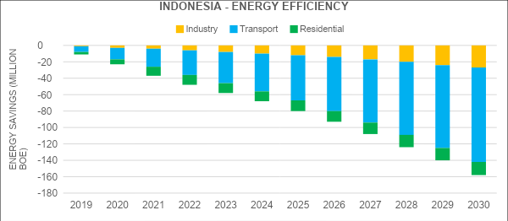

### NDC unconditional target

Emission analysis in this study suggests that the BAU emission in 2030 will be 880 MtCO2-e. This is different to what is reported in the NDC document.[4] This difference is primarily due to the changes in the predicted economic growth of the country. Indonesia has committed to reducing GHG emissions in the energy sector by 11 per cent unconditionally (without international aid), below the BAU level. In response to this target, Indonesia will need to reduce its emissions by 42 MtCO2-e compared to the current policy scenario. Emissions in the current policy scenario will reach 825 MtCO2-e by 2030, compared with 880 MtCO2-e in the BAU scenario. Emissions in the SDG scenario will be 605 MtCO2-e in 2030, which is set to achieve the NDC target (unconditional). (Figure 13) shows emissions in different scenarios.

**Figure 13. Emissions by scenario, 2030**

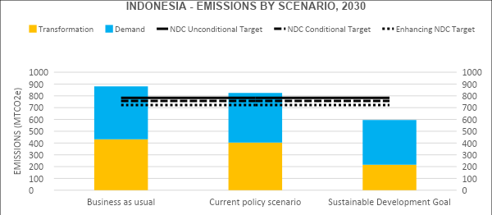

## Power generation in the context of SDG 7

The demand for electricity in 2030 will be 532 TWh, both in the BAU and current policy scenarios (Figure 14). The bulk of the demand will be seen in the residential sector (219 TWh), followed by the industrial sector (186 TWh) and the commercial sector (126 TWh). In the SDG scenario, the demand is expected to increase 585 TWh by 2030, largely due to the increase in electricity demand in the transport sector.

**Figure 14. Electricity demand, by sector, 2030 – all scenarios**

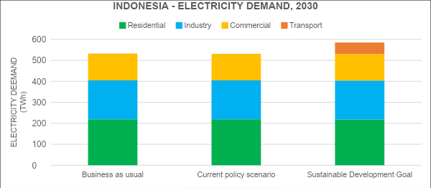

In terms of fuel mix in power generation, coal-fired power will be the dominating source of power generation in the BAU and current policy scenarios. In the SDG scenario, high penetration of renewable energy will be needed to achieve the NDC target and to substantially increase the share of renewable energy in TFEC. (Figure 15) shows the shares of different renewable energy sources in different scenarios in 2030.

**Figure 15. Renewable power generation, 2030**

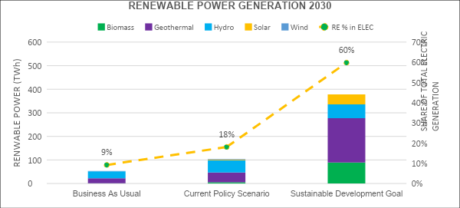

The installed electric power generation capacity for Indonesia is calculated as 136 GW for both the BAU and CPS. In the SDG scenario, the installed capacity increases to 154 GW due to an increase in renewable energy in the power generation mix (Figure 16). However, it is important to note that the SDG scenario is based on least-cost optimization which looks at the life-cycle cost of the power plant including capital, operating and fuel costs during operation based on Indonesia national data.

**Figure 16 Installed electric power generation capacity, 2030**

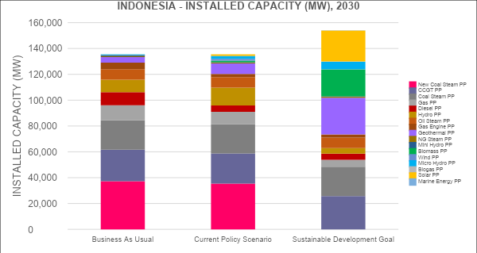

## Policy actions for achieving SDG 7

### 5.3.1. Decentralized renewable energy for rural electrification

***Indonesia is on track to achieve universal access to electricity by 2020. The least-cost electrification programme in Indonesia should be based on renewable off-grid generation. The NEXSTEP analysis compares the cost of connection by three methods – grid extension, mini-grid electrification and off-grid renewable energy systems.***

Grid electrification is executed by the State Electricity Company PLN. Based on the PLN rural electrification plan, the planned connection cost to achieve universal access to electricity is IDR 14.21 million (US$1,000) per household. However, this cost can increase substantially due to dealing with aspects such as remote communities and villages, complex terrain, low population densities, and levels of willingness and ability to pay by low-income households. Based on an Asia Development Bank (ADB) analysis for Sumba, the connection cost per household will be IDR 25 million (US$1,760) (ADB, 2016).

As of 2018, 1.1 million households in Indonesia still lacked access to electricity. The projected cost of achieving universal access is IDR 17.05 trillion (US$1.2 billion), based on low-cost assumption. However, it is important to consider the fact that the cost could increase to IDR 28.85 trillion (US$2.03 billion), based on high-cost assumption. In rural areas with a high cost of supply by rural grid extension programmes, it may be unsustainable for utilities and unaffordable for consumers. Apart from the connection cost, several challenges should be considered that are related to the maintenance cost of distribution network, unreliable supply with several hours of power cuts daily and environmental impact of power lines in protected areas.

Mini-grid electrification based on solar power was analysed as the second option for achieving universal access to electricity, for which the connection cost was calculated at IDR 15.35 million (US$1,080) per household. Mini-grid systems require capital investment in power generation, transformers and distribution lines for households.

Off-grid solar home systems with battery energy storage were selected as the most suitable and cost-effective option for achieving universal access to electricity. The connection cost was calculated at IDR 14.44 million (US$1,016) per household. The average household energy requirement was estimated at 101 kWh per month. The technical option is a 600W solar panel, 700 VA inverter and 4kWh Lithium-ion battery storage. The economic calculation includes capital cost for equipment and installation cost.

The implementation of off-grid solar home systems with battery energy storage electrification programme will cost the Government of Indonesia IDR 16.63 trillion (US$1.17 billion). This cost can be further decreased by sourcing local equipment and, at the same time, creating new job opportunities.

Based on the least-cost electrification option for rural electrification, Indonesia should focus on connecting remote rural populations by off-grid solar home systems with battery storage.

### 5.3.2. Promoting electric cooking stoves to achieve cost-effective universal access to clean cooking

***Universal access to clean cooking solutions should be a top priority in Indonesia and this target should be achieved by promoting electric cooking stoves. Policymakers can achieve additional benefits by utilising surplus electricity generation in some networks of Indonesia, e.g., the JAMALI (Java-Madura-Bali) system.***

The clean cooking technologies are evaluated below.

*(a) Improved cooking stove*

Studies suggest that ICS programmes often have low adoption rates due to the inconvenience of use, preference for traditional cooking stoves, the need for frequent maintenance and repairs etc. ICS programmes initially require strong advocacy to promote adoption, after which they require ongoing follow-up, monitoring, training, maintenance, and repairs in order to ensure continuing usage.

Based on World Health Organization (WHO) guidelines for emission rates for clean cooking, only certain types of ICS technology comply with these requirements, particularly when considering that cooking stove emissions in the field are often higher than they are in the laboratory used for testing. Based on the need for ongoing follow-up, ICS serves better as a temporary option, but is not best suited as a long-term solution.

*(b) Biogas digester*

Biogas digesters have high upfront capital costs – about IDR 14.21 million (US$1,000) for a standard size that is suitable for a four-member family – and require a substantial subsidy due to their longer payback period. The technology is not favoured in rural areas due to the cultural aspects of using animal or human waste for cooking. Additionally, a standard size biogas digester requires 2-4 cows, depending on the size of the cow, to produce enough feedstock for daily gas demand for a household.

*(c) LPG cooking stove*

LPG use in Indonesia is constrained due to distribution challenges in rural areas and the high level of the fossil fuel subsidy. An LPG cooking stove creates lower indoor air pollution compared to ICS and is classified as Level 4 in the World Bank Multi-Tier Framework (MTF).[5] It reduces indoor air pollution by 90 per cent compared with traditional cook stoves. However, as 70 per cent of LPG is imported, promoting LPG utilization will increase import dependency on petroleum fuel in Indonesia.

*(d) Electric cooking stove*

Indonesia has surplus electricity generation and using this surplus generation to promote electric cooking stoves makes sense. The technology is classed as Level 5 in World Bank MTF for Indoor Air Quality Measurement. Electric cooking stoves are more efficient than other cooking stoves, including gas stoves. Electric cooking stoves can generally be divided into two types – solid plate and induction plate. A solid plate cooking stove uses a heating element to pass radiant energy onto the food and reaches about 70 per cent efficiency. An induction plate cooking stove, on the other hand, uses electromagnetic energy to directly heat pots and pans, and can be up to 90 per cent efficient.

*(e) Natural gas stove*

Clean cooking with natural gas is not a viable solution for rural households as it would require building a gas distribution infrastructure, which is extremely difficult for remote locations. Table 3 summarizes the annualized cost of different cooking technologies.

**Table 3. Annualized cost of cooking technologies**

|  |  |
| --- | --- |
| **Technology** | **Annualized cost** |
| ICS | IDR 412,090 (US$29) |
| Electric stove | IDR 838,390 (US$59) |
| LPG stove | IDR 866,810 (US$61) |
| Biogas digester | IDR 1,833,090 (US$129) |

### 5.3.3. Energy efficiency improvement offers significant cost-saving

***Energy efficiency policies across sectors can help achieve substantial energy savings by reducing the need for investment in energy infrastructure, fuel costs and vulnerability to fossil fuel prices. Policymakers should improve the energy efficiency strategy by including well-defined best practice policies, implementation timelines and enforcement.***

Achievement of the SDG 7 target of 2.39 MJ/US$ by 2030, will require 1.53 per cent reduction in energy intensity per year, up to 2030. This equates with reducing TFEC by 158 MBOE by 2030. The NEXSTEP analysis identified the following measures for supporting this reduction cost-effectively:

1. Convert 50 per cent[6] of passenger buses to electric buses by 2030, saving 55 million barrels of oil equivalent (BOE) annually;
2. Improve fuel economy standards by 20 per cent for all heavy-duty vehicles from 2022 onwards, saving 36 million BOE annually;
3. Change the wet process of clinker production in the cement industry to a pre-heated process using pre-calciner kilns, saving 27 million BOE annually;
4. Convert 50 per cent[7] of passenger cars to electric cars by 2030, saving 24 million BOE annually;
5. Introduce MEPS for all new lights from 2022 onwards to reduce CFL 14W to CFL 11W, saving 2 million BOE annually;
6. Introduce MEPS for all new air-conditioners from 2022 onwards, saving 4 million BOE annually;
7. Switch from traditional cooking to clean cooking (electric cooking stove), saving 10 million BOE annually.

Energy efficiency measures in the NEXSTEP model are applied at the end-use level to estimate savings from measures such as Minimum Energy Performance Standards (MEPS), efficient cooking stove adoption, electrification of transport, improving fuel economy standards and industrial energy efficiency measures.

MEPS is a policy instrument used to promote energy efficiency by banning the poor-performing appliances from the market, thereby forcing manufacturers to introduce innovation and consumers to adopt energy efficient appliances. In 1998, the Government of Japan launched “The Top Runner programme” for energy efficiency standards across 21 products. As a result, energy efficiency standards were met or exceeded across all 21 products, with benefits such as cost savings and GHG reduction due to reduced energy consumption. In the NEXSTEP analysis, the implementation of MEPS has been modelled from 2022 onwards to provide policymakers with time to prime the market participants. A stock turnover analysis was completed to model appliance uptake and energy savings from this measure (Annex VII).

The cement industry in Indonesia is of strategic importance to supporting national infrastructure projects, rural development and housing initiatives. In 2018, the cement industry production capacity was 109.9 million tons annually while domestic consumption was 69.6 million tons. This indicates that there is significant over-capacity of about 30 per cent, which can used to increase cement exports. Indonesia’s cement industry is energy-intensive, with energy consumption of 66.9 MBOE, and relied heavily on coal (90 per cent of fuel mix) in 2018. There are significant opportunities for reducing energy consumption in clinker production by replacing the existing wet process with thermal energy intensity of 3.6 GJ/ton with the best available technique of pre-heating, pre-calciner kilns 2.9 GJ/ton.

### 5.3.4. Multi-sectoral approach needed to achieve the renewable energy target

SDG 7 target for renewable energy does not specify any quantitative target – it suggests substantially increasing the share of renewable energy in TFEC by 2030. The NEXSTEP methodology employs an integrated and logical approach to estimating a target that would not only help achieve the SDG 7 targets but also support the achievement of NDC. Based on this approach, NEXSTEP estimates that the share of renewable energy in TFEC would need to be 22.9 per cent in 2030, which is in line with Indonesia’s current 23 per cent target; however, Indonesia’s target is primary energy and not final energy). In terms of TPES, the renewable energy share would need to be 32.6 per cent.

The current trend suggests that Indonesia will fall short of this target and will only reach 16.4 per cent in TFEC under the current policy scenario. Therefore, a significant step up is necessary to bridge the gap. The major increase will need to be in the power sector. In terms of technology mix for renewable energy electric power generation, the share of generation will be geothermal (47 per cent) followed by biomass (27 per cent), hydro (15 per cent) and solar (11 per cent).

### 5.3.5. Investment in the power sector is needed for the energy transition

The total investment required in the power sector to achieve the BAU scenario in Indonesia would be IDR 1,464 trillion (US$103 billion) in the next 10 years, which will be, on average, IDR 146 trillion (US$10 billion) per year. The CP scenario will require IDR 1,734 trillion (US$122 billion) in investment, due to the increase in renewables (Figure 21).

**Figure 17. Investment cost of energy transition in the power sector in different scenarios**

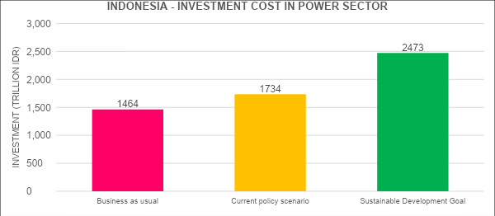

The investment requirements for Indonesia’s SDG scenario is explained: access to electricity requires zero additional funding, and by switching to an off-grid solar home system with battery storage for rural electrification Indonesia can save IDR 0.4 trillion (US$ 30 million) by 2030. Access to clean cooking fuels and technologies requires additional investment of IDR 9.77 trillion (US$ 688 million) by 2030. Renewable energy investments in the power sector would be IDR 2,473 trillion (US$174 billion) by 2030. Achievement of energy efficiency will provide a net financial saving[8] (excluding electric vehicles) of more than IDR 460 trillion (US$32 billion) by 2030 and will help reduce the overall investment needed. In the SDG scenario, the investment requirement would be IDR 203 trillion (US$14 billion) annually i.e., IDR 2,030 trillion (US$140 billion) by 2030, which is annually IDR 28 trillion (US$2 billion) in addition to the investment needed for the current policy scenario.

**Figure 18. Additional annual investment for different targets in the SDG scenario**

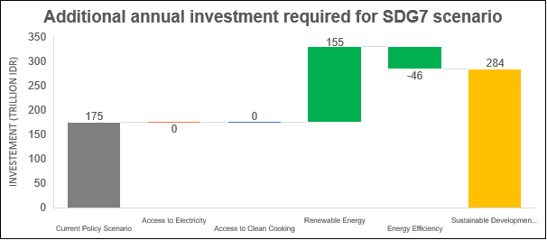

### 5.3.6. Net benefits in the power sector

The net benefits in power generation are calculated by using capital costs, operation and maintenance costs (fixed and variable), fuel costs and externality cost (only when the carbon price is applied). The net cost is calculated by subtracting the cost of generation from the revenue earned by supplying the electricity. The net benefits from the BAU scenario will be IDR 3,055 trillion (US$215 billion) and IDR 3,297 trillion (US$232 billion) in the current policy scenario, by 2030 (Figure 23). The SDG scenario will provide a net benefit of IDR 5,130 trillion (US$361 billion) in the power sector by 2030.

**Figure 19. Net benefits from the power sector**

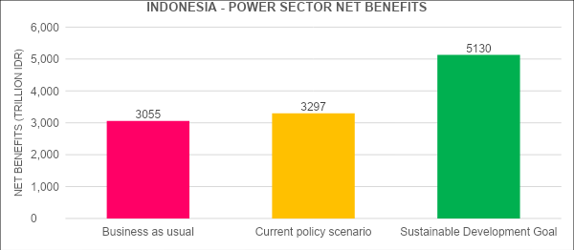

### 5.3.7. Renewables are cheaper than fossil fuel

The Levelized Cost of Electricity (LCOE) is a widely used metric in the energy industry for comparing the economic value of different electricity generation technologies. It calculates the unit cost of electricity (US$/MWh) over the lifetime of the project, including capital, operating and financing costs.

The LCOE method sums up the lifetime costs of an energy system divided by the lifetime energy generation. LCOE is a measure of the cost-competitiveness of different electricity generation technologies. LCOE is measured using the lifecycle cost of a system and therefore balances out the disparity where some technologies have a high capital cost but low operating cost, whereas the other technologies have low capital cost and high operating cost.

NEXSTEP has calculated LCOE for Indonesia (Figure 20) using cost figures published by the Indonesian Government in the Technology Data for Indonesian Power Sector report (National Energy Council (DEN) and Danish Energy Agency, 2017) (some cost figures have been updated to reflect the recent changes in the market price). This makes LCOEs entirely reflective of the national context of Indonesia. The LCOE component analysis highlights renewable electricity generation technologies e.g. solar Photovoltaic (39.40 US$/MWh), geothermal (41.78 US$/MWh), Hydro (50.83 US$/MWh) and onshore wind (52.38 US$/MWh) are cheaper than coal-fired generation technologies today in Indonesia. The results from the LCOE analysis are comparable with analyses done by others; for example, LAZARD LCOE analysis 13.0 gives a range of US$ 32-42 /MWh for utility-scale solar photovoltaic, while the IRENA Renewable Power Generation 2019 LCOE for onshore wind is 53 US$/MWh.

**Figure 20. LCOE of different power plant technologies in Indonesia**

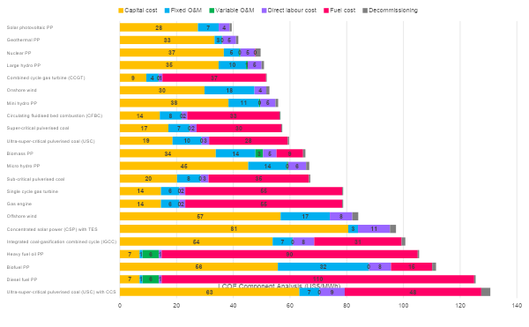

# Energy transition pathways with increased ambitions

***The SDG scenarios have been further analysed to identify the best way forward for Indonesia in transitioning its energy sector to 2030. This analysis shows that there are socio-economic and environmental benefits for Indonesia from raising its ambition beyond just achieving the SDG 7 targets, such as creating cost-effectiveness by further improving its energy efficiency as well as economic benefits from enhancing its NDC target beyond the unconditional and conditional NDC targets.***

Ten different sub-scenarios have been developed under the SDG 7 scenario in order to analyse and compare costs and benefits, and to identify a scenario that is most suited to Indonesia. The sub-scenarios are:

1. Clean cooking with LPG. This scenario looks at achieving SDG 7 targets and the unconditional NDC target. Universal access to electricity is achieved by extending the grid network, and the clean cooking target is achieved by the LPG cooking stove. Energy efficiency is strengthened to achieve SDG 7.3 target, and the optimum share of renewable energy is estimated using the NDC unconditional target as the constraint, together with least cost optimization for the power sector;
2. Clean cooking with improved cooking stove. This scenario is same as the above scenario except that universal access to electricity is achieved by RE-based mini grid and clean cooking target is achieved by improved cooking stove;
3. Clean cooking with electric stoves. This scenario is same as scenario (b) except that universal access to electricity is achieved by off-grid technologies, and the clean cooking target is achieved by using electric cooking stoves;
4. No new investments in coal power plants. This scenario looks at raising ambition beyond SDG 7. Targets for access to electricity and clean cooking fuel are achieved by least-cost options, which are off-grid technologies and electric cooking stoves, respectively. Energy efficiency is strengthened to achieve the SDG 7.3 target, and the optimum share of renewable energy is estimated using the NDC unconditional target as the constraint. Coal is phased out from the power sector, with no new coal power plants after 2020 and the gradual decommissioning of existing ones by 2030;
5. Conditional NDC with high energy efficiency. This scenario looks at raising ambition beyond SDG 7. Targets for access to electricity and clean cooking fuel are achieved by least-cost options, which are off-grid technologies and electric cooking stoves, respectively. Energy efficiency is strengthened further to go beyond the SDG 7.3 target, and the optimum share of renewable energy is estimated using the NDC conditional target as the constraint, together with least cost optimization for the power sector;
6. Reduced fossil fuel subsidy with low carbon price: This scenario looks at raising ambition beyond SDG 7. Energy efficiency is strengthened further to go beyond SDG 7.3 target and the optimum share of renewable energy is estimated using the NDC conditional target as the constraint, together with least-cost optimization for the power sector. The fossil fuel subsidy is removed from the consumer side and a carbon price of IDR 213,450 (US$15) per ton is introduced;
7. Reduced fossil fuel subsidy with high carbon price. This scenario is same as scenario (f), but the carbon price is increased to IDR 426,300 (US$30) per ton;
8. Enhancing NDC with reduced coal-based power generation and fossil fuel subsidy. This scenario is the same as scenario (g), but the fossil fuel subsidy is completely phased out. In addition, coal is phased out from the power sector, with no new coal power plants after 2020 and the gradual decommissioning of the existing ones by 2030;
9. Enhancing NDC with reduced natural gas-based power generation and a fossil fuel subsidy. This scenario is the same as scenario (h), but natural gas, instead of coal, is phased out by 2030;
10. Enhancing NDC by decarbonizing power sector: This scenario is the most ambitious one in which the power sector is completely decarbonized by phasing out all fossil fuel-based power generation by 2030. The other parameters remain the same as scenario (i).

|  |
| --- |
| **Box 2. Choice of the carbon price**  In today’s market, there is no consistency in carbon price, and it is therefore very difficult to choose a carbon price that will suit the national context. In the absence of any carbon price in Indonesia and the Southeast Asia region, an indicative price of US$ 30 per ton has been chosen, with a sensitivity analysis performed by reducing it to 50 per cent (US$ 15 per ton). The *State and Trend of Carbon Pricing 2020* report published by the World Bank (World Bank, 2020) suggests that a minimum carbon price of US$ 40-US$ 80 per ton of is needed by 2020 to cost-effectively reduce emissions in line with the temperature goal of the Paris Agreement. In this study, a slightly lower carbon price has been chosen, based on the country’s socio-economic context. This is an indicative price to demonstrate how a price on carbon would support the proposed transformation of the energy sector. Further in-depth investigation should be performed, involving subject matter experts and stakeholders, to identify the price suitable for Indonesia. |

## Scenario ranking

The SDG scenarios have been evaluated and ranked, using the Multi Criteria Decision Analysis (MCDA) tool, with a set of 12 criteria and weights assigned to each criterion (table 4). While the criteria and weights have been selected based on expert judgement, ideally the process should use a stakeholder consultation. If deemed necessary, this step can be repeated using the NEXSTEP tool in consultation with stakeholders where the participants may want to change weights of each criterion. The following factors have been considered to assume comparative weights across the set of criteria, where the total weight needs to be 100 per cent:

1. Universal access to electricity to be achieved;
2. Universal access to clean cooking fuel to be achieved;
3. Renewable energy share in the total final energy consumption to increase;
4. Energy efficiency improvement should be doubled, and where there is an economic benefit it should be further enhanced;
5. The unconditional NDC target should be achieved. Where possible, the conditional target should be achieved and, if it is economically viable, the NDC target should be further enhanced to align it with the 1.5-degree pathway.
6. Total investment should be kept low, but the net benefit should be high. This was done by assigning both indicators the same weight to ensure that a scenario is chosen on the value-for-money basis;
7. The fossil fuel subsidy should be phased out. Policy reform is required to enable the abolishment of subsidies that encourage wasteful consumption of energy;
8. Carbon pricing should be introduced to encourage investments in clean energy.

**Table 4. Criteria with assigned weights for MCDA**

|  |  |
| --- | --- |
| Criterion | Weight |
| Access to clean cooking fuel | 10% |
| Energy efficiency | 10% |
| Share of renewable energy | 10% |
| Emissions in 2030 | 10% |
| Alignment with PA | 9% |
| Fossil fuel subsidy phased out | 3% |
| Price on carbon | 3% |
| Fossil fuel phase-out | 5% |
| Cost of access to electricity | 5% |
| Cost of access to clean cooking fuel | 5% |
| Investment cost | 15% |
| Net benefit from the power sector | 15% |

Table 5 shows the summary of results obtained through this evaluation process. The scenario recommendation suggests that the SDG scenario, “Enhancing Nationally Determined Contributions with reduced coal and fossil fuel subsidy”, is the highest-ranked energy transition pathway for Indonesia.

**Table 5. Scenario ranking based on MCDA**

|  |  |  |
| --- | --- | --- |
| **Rank** | **Scenarios** | **Weighted score** |
| 1 | Enhancing NDC with reduced coal and fossil fuel subsidy | 72.2 |
| 2 | Enhancing NDC with no new investment in coal-based power plant | **67.0** |
| 3 | Reduced fossil fuel subsidy with low carbon tax | **66.1** |
| 4 | Reduced fossil fuel subsidy with high carbon tax | **65.7** |
| 5 | Enhancing NDC with reduced NG and fossil fuel subsidy | **64.5** |
| 6 | Enhancing NDC by decarbonizing power sector | **63.9** |
| 7 | Conditional NDC with high energy efficiency | **60.3** |
| 8 | Clean cooking with ICS | **59.3** |
| 9 | Clean cooking with electric stoves | **57.1** |
| 10 | Clean cooking with LPG | **50.2** |
| 11 | Current policy | **34.6** |
| 12 | Business-as-usual | **23.6** |

In this scenario, Indonesia has the potential to increase the net benefits from the power sector by investing in renewables and, at the same time, to reduce GHG emissions beyond NDC targets. The retirement of existing coal-fired generation plants should be planned by policymakers. The phase-out of fossil fuel subsidies is another major benefit for Indonesia. By encouraging the use of electric cooking stoves, Indonesia can improve its benefits by targeting poor and vulnerable households compared to the current LPG subsidy programme which is poorly targeted.

## Raising ambition – enhancing the NDC target and achieving SDG 7

This scenario achieves all SDG 7 targets and raises ambitions by enhancing NDC to align with the 1.5-degree pathway. Universal access to electricity is achieved by 2020, based on the electrification of rural households using off-grid renewable technologies. Universal access to clean cooking is achieved by 2030 by promoting the use of electric cooking stoves. The share of renewable energy in the total final energy consumption is increased to 28.6 per cent by expanding the share of renewables in electric power generation to 88 per cent and the rapid electrification at the end-use level. Energy efficiency improvements are projected to be 2.7 per cent, which is beyond the SDG 7 target of 1.53 per cent.

Based on socio-economic and environmental benefits, it is suggested that Indonesia should aspire to achieving emission reductions beyond the NDC target by stopping new investment in coal-fired power generation. Because investment in coal-fired generation is no longer a cheaper option for power generation, the costs of renewables such as solar PV, wind, hydropower and geothermal have dropped significantly.

Energy transition in this scenario would require an additional investment of IDR 1,574 trillion (US$110 billion), compared to the current policy scenario. The additional investment requirement can be eased by abolishing fossil fuel subsidies and reinvesting the IDR 1,012 trillion (US$71.2 billion) saved over the period of 10 years to 2030 into renewables. In addition, introducing carbon pricing of IDR 426,300/tCO2-e (US$30/tCO2-e) will add IDR 327 trillion (US$23 billion) over the 10 years to 2030. The remaining investment gap of IDR 235 trillion (US$16.6 billion) can be covered by introducing green bonds.

|  |
| --- |
| **Box 3. Enhancing Nationally Determined Contributions**  Indonesia can achieve the reduction of GHG emissions beyond NDC targets in the energy sector. Policies to support the decarbonisation of electricity generation will help to achieve Paris Agreement targets and increase renewables.  In its NDC document, Indonesia has pledged to reduce GHG emissions by 29 per cent (unconditional) compared with BAU 41 per cent (conditional) with international support Government of Indonesia, 2020).The contribution of the energy sector towards these targets is 11 per cent (unconditional) and 14 per cent (conditional). Based on key global benchmarks for the Paris Agreement, a 1.5°C compatible pathway shows that a rapid decline in GHG and CO2 emissions by 45 per cent, compared with 2010 levels, will be achieved by 2030 (Climate Analytics, 2019). Indonesia can increase its ambitions and align its NDC with this pathway by reducing energy sector emissions by 18 per cent compared to the BAU.  Enhancing NDCs is possible and achievable in all the SDG scenarios analysed. The reduction in CO2-e emission is due to an integrated framework for achieving SDG 7 and NDC targets. For example, achieving universal access to electricity would increase emissions in BAU. However, in SDG scenarios, decentralized renewable energy-based generation leads to net zero emissions. Another example is in the transport sector, with the replacement of gasoline vehicles with electric vehicles (EVs). Fuel switching from gasoline to electricity leads to an increase in electricity demand. However, EVs have higher fuel efficiencies, and emissions depend on the grid emission factor, which is much lower than burning petroleum in internal combustion engines. Therefore, although EVs are considered to be an energy efficiency measure, they also help to mitigate GHG emissions. |

## No new investment in coal-based power generation

Stopping new investment in coal-fired power generation is essential to meeting the long-term targets of the Paris Agreement. Policymakers should cancel any coal-fired capacity addition and plan the retirement of existing coal-fired power plants. The importance of early action cannot be overstated. A schedule for the planned retirement of existing coal-fired power plants should be defined and forced-retired as quickly as possible.

The 1.5 $℃$ pathway requires countries in South Asia and South-East Asia to meet regional benchmarks of 50 per cent decarbonisation by 2030 and 100 per cent decarbonisation by 2050 (Climate Analytics, 2019). Indonesia’s current planned capacity addition of 27GW in RUPTL 2019-2028 will lead to a lock-in of coal-fired power generation and increase the risk of stranded assets in future due to the impact of climate change.

|  |
| --- |
| **Box 4. Coal power plants represent an enormous financial risk to shareholders and investors**  There are more financial benefits and economic reasons for stopping new investment in coal than some short-term impacts that the coal industry may face during the transition. With the sharp decline of prices during recent years, LCOEs of utility-scale renewables are already cheaper than new coal-based technologies, even without carbon capture and storage (CCS). With the forecast of further cost reductions of renewables up to 2025 (IRENA, 2016), and the potential for increases in the cost of coal, this difference is expected to widen further.  Experts believe that soon there will be a point when it will be more economic to stop a coal-fired power plant and build a new solar PV plant, as the operating cost of a coal plant will outstrip the economic benefits. In Indonesia, based on the Government’s price cap of IDR 994,700 (US$70) per ton of coal, by 2030 it could be cheaper to build new solar PV plants than operating existing coal plants (Carbon Tracker, 2019). However, this inflection point would be seen much earlier if restrictions are put in place to help achieve the 1.50C pathway, e.g., making CCS mandatory for coal plants. This will lead to stranded assets of investors. Stranded assets are those assets that at some time prior to the end of their economic life are no longer able to earn an economic return, i.e., a project fails to meet the required internal rate of return (IRR) of a company or an investor.  Financial institutions are already taking their stance against this perceived risk by ceasing their financial support for coal plant development. Chubb Limited announced in July 2019 that it would no longer underwrite the construction and operation of new coal-fired plants or new risks for companies that generate more than 30 per cent of their revenues from coal mining or energy production from coal (Chubb, 2019). There are more than 100 global financial institutions, e.g., banks, insurers and credit facilities, who have analysed the economic risks of coal-based power plants and have announced their divestment from coal (IEEFA, 2019). |

In the past, investment in coal-fired generation was a cheap and reliable, albeit polluting, method of generating electricity. This is no longer the case as renewables have matured and costs have dropped significantly. It is cheaper today to generate electricity from renewables such as solar, hydropower, geothermal and biomass compared to coal-fired technologies.

### Carbon capture and storage for coal-fired power plants in Indonesia

The Government of Indonesia has considered CCS in the national energy strategy through the pilot project, Merbau Gas Gathering Station, to capture and store 50-100 tCO2 per day. However, the cost-effectiveness of CCS varies widely with geography and project sites. An in-depth feasibility study to identify CCS-readiness should be undertaken prior to the implementation of CCS. Moreover, most renewable energy technologies are now cheaper than coal-based technologies without CCS. The addition of CCS will further increase the difference.

## Putting a price on carbon will help to reduce investment gap

Carbon pricing is recognized around the world as an effective policy tool to facilitate sustainable energy transition. The external cost of carbon emissions such as health damage, climate impacts and social costs paid by society should be shifted towards the producers and consumers responsible for producing pollution-causing goods by directly setting a price on carbon emissions.

There are two main mechanisms for carbon pricing – emission trading schemes (cap and trade) and carbon taxation.

Emission trading systems place a cap on CO2-e emissions and allow participants to trade an allowance of CO2-e emissions under the cap. The mechanism results in a wealth transfer from high-emission to low-emission technology proponents, increasing the attractiveness of low-emission technology investments. Indonesia is currently in the process of developing a domestic Emissions Trading System (ETS) for the power and industry sectors.

Carbon taxes simply put a price on the GHG emissions or on the carbon content of fuels. In the NEXSTEP analysis a carbon price of IDR 426,300 (US$30) per ton, in the current policy scenario, will raise IDR 1,435 trillion (US$101 billion) in the analysis period of 2020-2030. Governments may choose to treat this as a revenue stream or hypothecate these funds to use it as a wealth transfer mechanism.

As of 2019, 55 per cent of 185 parties that submitted the NDC document have stated plans for or are considering the implementation of carbon pricing. According to the World Bank, a minimal price range of IDR 710,500-IDR 1,421,000 (US$50-100)/tCO2-e is required by 2030 to achieve the targets of the Paris Agreement on climate change (World Bank, 2020). Sweden is an example of successful implementation of the carbon pricing mechanism. Introduced in 1991, Sweden’s carbon tax is currently IDR 1,804,670 (US$127)/tCO2-e. Funds raised from this mechanism are used to develop energy efficient technologies such as biomass-based district heating.

In this analysis, a price on carbon has been considered as a mechanism for limiting emissions and levelling the playing field for low-carbon technologies.

## Phasing out the fossil fuel subsidy will level the playing field for renewables

Indonesia needs to reform its fossil fuel subsidy programme. Policymakers should abolish fossil fuel subsidies by the Government of Indonesia to save an annual fiscal cost of IDR 100.9 trillion (US$7.1 billion). The NEXSTEP analysis considers both consumer-side energy subsidies and the generation-side financial support and tax incentives in calculating an annual fiscal cost of fossil fuel subsidies by the Government of Indonesia.

Indonesia plans to provide energy subsidies only to poor and vulnerable households through LPG, kerosene and electricity subsidies. However, in 2017 only 13 million poor and vulnerable households received subsidised 3-kg LPG cylinders compared with 19.8 million rich household beneficiaries. This indicates that the LPG subsidy programme is poorly targeted, with an annual fiscal cost of IDR 41.2 trillion (US$2.9 billion) to the Government (OECD, 2019).

Indonesia also provides a fossil fuel subsidy on the generation side. A coal price cap is set at IDR 994,700 (US$70)/ton for electricity generators and a domestic market obligation at 25 per cent of the total production volume by coal-mining companies. The Government of Indonesia estimates that the total value of the coal price cap to PLN was IDR 14.16 trillion (US$1.7 billion) in 2018. A gas price cap is set at IDR 85,260 (US$6)/MMBtu; the total value of this natural gas price cap is estimated to be IDR 15.63 trillion (US$1.1 billion), based on the market price of IDR 119,364 (US$8.4)/MMBtu. Indirect subsidies such as tax exemptions, loan guarantees and preferential royalty rates were quantified at IDR 9.09 trillion (US$0.64 billion) by the Global Subsidies Initiative in 2015. Table 6 presents an overview of the fossil fuel subsidy reform elements for Indonesia.

**Table 6. Indonesia Fossil Fuel subsidy reform**

|  |  |  |  |  |
| --- | --- | --- | --- | --- |
| **Sector** | **Subsidy** | **Partial (demand)** | **Complete (demand + generation)** | **Reform** |
| Residential | 3-kg LPG subsidy | Transition to electric stoves | Transition to electric stoves | Transition to electric stoves from LPG for poor and vulnerable households |
| Kerosene subsidy | Transition to electric stoves | Transition to electric stoves | Transition to electric stoves |
| Transportation | Diesel subsidy | Removed | Removed | Transition to electric buses and electric taxis |
| Electric power generation | Coal price cap US$70/Ton | Present | Removed | Coal price based on market price |
| Natural gas price cap – US$6/MMBtu | Present | Removed | Natural gas price based on market price |
| Indirect coal generation subsidy | Present | Removed | Tax exemptions, loan guarantees, preferential royalty rates abolished |

## Green financing

Accelerating green financing is critical to achieving the sustainable energy transition. Large capital investments in renewables will be required, but at the same time it will lead to even greater savings compared to fossil fuel-based generation. Policymakers need to work with central banks, regulatory authorities and investors to examine the possibility of developing a green finance policy and establishing a green finance bank or fund to help close the investment gap.

Green bonds mobilize resources from domestic and international capital markets to finance climate solutions. In 2018, Indonesia issued through the Ministry of Finance its first sovereign green bond, raising IDR 17.76 trillion (US$1.25 billion) to finance eligible green projects.

Renewable energy technologies have relatively high financing costs in developing countries, which reflects their unattractive risk/return profile. This is because of their long-time horizon, high initial capital costs, illiquid equipment and project risks. Policymakers can reduce high financing costs using two methods – de-risking and direct incentives. De-risking has two basic forms – policy de-risking instruments that reduce risk and financial de-risking instruments that transfer risk. Direct incentives are direct finance transfers or subsidies to low carbon investments. The United Nations Development Programme’s (UNDP) “De-risking Renewable Energy Investment”[9] is an important guide for policymakers in developing strategies to reduce risks in renewable energy investment.

## A holistic approach to reducing the investment gap

An investment gap analysis was performed using different economic and fiscal measures to identify potential ways to reduce Indonesia’s burden of the additional investment. Different combinations of the three key measures was analysed: the removal of the fossil fuel subsidy; putting a price on carbon emissions; and the issuance of green bonds.

In the scenario “Enhancing NDC with phasing out the coal and fossil fuel subsidy” the investment required will be IDR 3,308 trillion (US$233 billion). (Figure 21) shows that phasing out the fossil fuel subsidy and investing the savings in renewables can fill the bulk of the additional investment gap – about IDR 1,574 trillion (US$110 billion) – compared to the investment of IDR 1,734 trillion (US$122 billion) under the current policy scenario. A price on carbon emissions has the potential to generate about one-fifth of the investment gap. The net benefits will be IDR 3,993 trillion (US$281 billion), an increase of IDR 696 trillion (US$49 billion) compared to current policy scenario.

**Figure 21. Investment gap – enhancing NDC with reduced coal and fossil fuel subsidy**

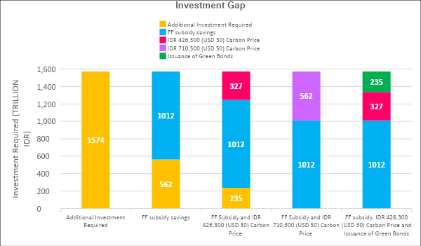

## Improving energy efficiency beyond the SDG 7 target

Indonesia has the technical potential economic benefits to further accelerate energy efficiency beyond the SDG 7.3 target to achieve a reduction of 218 million BOE, compared with 158 million BOE to achieve the SDG 7 target. This will require the following changes and additions to the previous set of measures listed in subsection 4.3.3.

### Residential sector energy savings: 57 Million BOE

1. Introduce MEPS for all new refrigerators from 2022 onwards, saving 10 million BOE annually;
2. Introduce MEPS for all new televisions from 2022 onwards, saving 10 million BOE annually;
3. Introduce MEPS for all new air conditioners from 2022 onwards, saving 8 million BOE annually;
4. Introduce MEPS for all new lights from 2022 onwards in order to reduce CFL 14W to LED 5W, saving 6 million BOE annually;
5. Introduce MEPS for all new washing machines from 2022 onwards, saving 2 million BOE annually;
6. Introduce MEPS for all new electric fans from 2022 onwards, saving 2 million BOE annually;
7. Introduce MEPS for all new water pumps from 2022 onwards, saving 0.4 million BOE annually;
8. Promotion of electric cook stoves for households with traditional biomass cook stoves and households depending on LPG subsidy, saving 20 million BOE annually.

### Industrial sector energy savings : 45 Million BOE

1. Change the wet process of clinker production in the cement industry to a pre-heated process using pre-calciner kilns, saving 27 million BOE annually;
2. Regenerative burners (30 per cent energy saving) for the iron and steel industry, saving 16 million BOE annually;
3. Increasing the share of co-generation/combined heat and power in the pulp and paper industry from 80 per cent to 100 per cent, saving 1 million BOE annually;
4. Benchmarking electricity consumption in cement production, saving 1 million BOE annually;
5. Switching from fixed drive to variable speed drive motors in the iron and steel industry, saving 0.1 million BOE annually.

### Transport sector energy savings: 115 Million BOE

1. Convert 50 per cent[10] of passenger buses to electric buses by 2030, saving 55 million barrels of oil equivalent (BOE) annually;
2. Improve fuel economy standards by 20 per cent for all heavy-duty vehicles from 2022 onwards, saving 36 million BOE annually;
3. Convert 50 per cent[11] of passenger cars to electric cars by 2030, saving 24 million BOE annually;
4. Electrification of 100 per cent passenger taxis by 2030, saving 1 million BOE annually;

### Commercial sector energy savings: 0.3 Million BOE

1. Improving Energy Efficiency Standards in government buildings 10 per cent by 2030; saving 0.3 million BOE annually

The energy savings from different technologies, measures and interventions is compared (Figure 22).

**Figure 22. Energy efficiency measures**

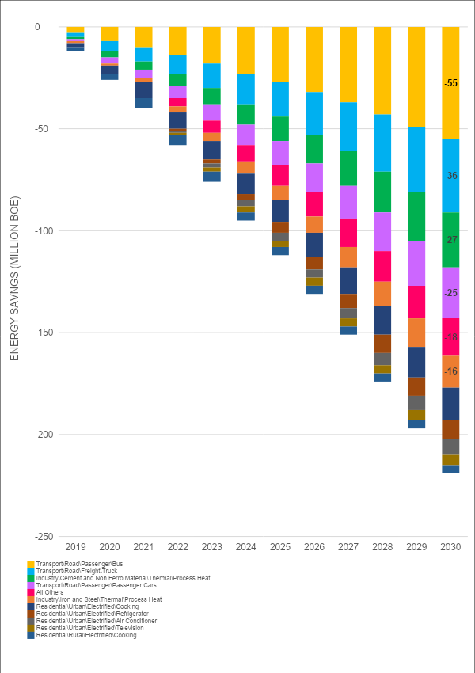*.*

## Marginal abatement cost curve

The marginal abatement cost curve of selected mitigation technologies for Indonesia is shown in (Figure 2). This offers a strong message for policymakers to prioritize GHG mitigation technologies and measures based on their cost-benefit analysis.

**Figure 23. Marginal abatement cost curve of selected technologies**

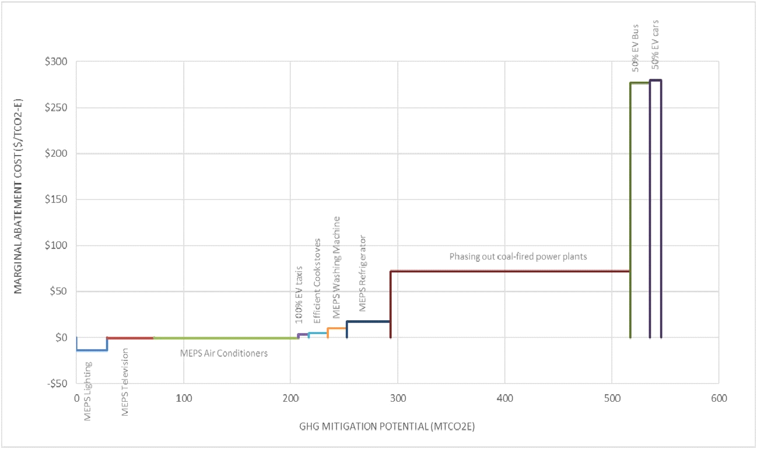

Clearly, stopping new investments in coal-fired power plants beyond 2022 will offer the maximum potential to reduce emissions with a low cost of abatement. While such an avenue may lead to some negative impacts on the coal industry (e.g., loss of jobs), a careful transition plan with a focus on skill-building of the existing labour force to the new industry will need to be adopted to avoid such impacts.

The minimum energy efficiency standard for air-conditioners is a low-hanging fruit with essentially no cost to the Government and with a potential for a very high level of abatement. This reinforces the fact that space cooling is a large area of energy consumption and thus a major source of emissions. A deeper study of the efficient cooling system in Indonesia should be undertaken. Indonesia can leverage this opportunity for further study by tapping into ESCAP’s programme on “Enhancing cooling energy efficiency in Asia-Pacific”.

# Rebuilding better in the recovery from COVID-19 with the SDG 7 roadmap

Energy plays a key role in rebuilding better in the recovery from the COVID-19 pandemic. Energy services are essential to supporting health-care facilities, supplying clean water for essential hygiene, enabling communication and IT, and off-grid renewables refrigeration for vaccine storage. Economic challenges resulting from the pandemic have the potential to force countries in the Asia-Pacific region to focus on short-term fixes to revive GDP growth, potentially undermining long-term sustainable development. In the energy sector, this can result in the decline of investment in clean energy development – slowing progress in renewable energy and energy efficiency, and eventually, impeding national economic growth.

The lockdown measures to contain COVID-19 have led to economic contraction in Indonesia and a significant drop in energy consumption. Demand has fallen for electricity, gas and oil, a situation that is expected to continue for some time. Experts and policymakers are still taking stock of the impacts of COVID-19 on the energy landscape due to the contraction of the economy as well as what it will mean for the ongoing transition to sustainable energy. The ADB suggests that the impacts of COVID-19 can cause Indonesia’s economic growth to drop to 2.5 per cent in 2020, down from 5 percent in 2019, before it recovers to 5 per cent in 2021 (ADB, 2020).

Thus, it has never been more important to design a well-planned energy transition pathway that enables the country’s energy sector to shield itself from the likely impacts of the COVID-19 pandemic and helps in the recovery to build better. The SDG 7 roadmap has identified several key areas that will assist policymakers in strengthening policy measures to help recover from the COVID-19 impacts while maintaining the momentum to achieving the 2030 Agenda for Sustainable Development and the Paris Agreement.

## Accelerating access to clean and modern energy services

Access to clean and modern energy services is essential for helping rural populations to combat challenges related to COVID-19. Relying on traditional and hazardous technologies for lighting and cooking increases their susceptibility to the effects of the virus. It is important to consider how these seismic shifts in the energy sector from COVID-19 affect the most vulnerable people.

Indonesia has about 5 million people who live without electricity and 80 million people without access to clean cooking fuel. One medium-term impact of COVID-19 could be decreased investment in energy access, as national budgets come under strain and priorities shift. Under-investment in this area would have a severe impact on the capacity of rural health centres to support front-line health workers and provide essential services to COVID-19 patients. When a vaccine does become available, it will need cold storage and refrigerated transportation over large areas. The value of decentralised technologies such as solar will therefore be enormous for large-scale immunisation efforts in rural areas of Indonesia.

The Government of Indonesia has already introduced some measures to combat this challenge by announcing free electricity for three months to help 24 million households in the 450VA category, and a 50 per cent discount to 7 million households in the 900VA category (The Jakarta Post, 2020). Access to electricity is crucial for poor and vulnerable households, and social safety net measures are a priority in the country. However, access to clean cooking technologies is a development challenge that is often forgotten. WHO has warned about the severity of health impacts arising from the exposure to traditional use of biofuel for cooking, and is encouraging policymakers to adopt measures to end this challenge. Moreover, scientists are already investigating links between air pollution and higher levels of coronavirus mortality, with preliminary results showing a probable correlation between the two.

The SDG 7 roadmap has analysed and identified technical options for connecting the remaining population to cleaner fuel for cooking and has estimated the cost of the measure. The benefits resulting from this measure, in the form of reduced mortality and health impact, will exceed the needed investment of IDR 9.77 trillion (US$ 688 million).

## Reducing financial risks by reshaping the power sector

Lower electricity demand, if continued over a longer period, may place fossil fuel generators in a difficult economic position of constrained output and dwindling revenues. This could lead to the early closure of some privately-owned fossil-fuel power plants, particularly those approaching end-of-life. Government power utilities may demand larger subsidies for their survival. By contrast, renewable energy power plants face relatively lower economic impacts compared to their fossil fuel counterparts. In many national power systems, renewable outputs are dispatched first to the power market, meaning they can continue to sell their energy unimpeded. As a result, many national grids have seen the penetration of renewable energy shoot up to levels not expected for the next decade – thus providing both a stress test of the system and a glimpse of a high renewables future.

The SDG 7 roadmap has identified the fact that if Indonesia continues to implement the planned coal-fired generation infrastructure in the power sector, there is a risk of a financial burden relative to alternative investments in clean power. The higher operational cost of coal-based power plants, together with the subsidy injection in the coal industry in the form of a price cap, would lead to the risk of stranded assets in the near future. As the bulk of the power generation infrastructure is owned by PLN, the government owned utility, the major economic liability will fall on the Government of Indonesia.

Furthermore, as highlighted in box 4, financial institutions have started ending their financial support in coal plant development by indicating coal-fired power plants as high-risk investments. They have decided to no longer underwrite the construction and operation of new coal-fired plants or new risks for companies that generate more than 30 per cent of their revenues from coal mining or energy production from coal.

As outlined in chapter 5, the NEXSTEP analysis identified ample economic reasons for stopping new investments in coal-fired power generation and filling the gap with more renewables, with the possibility of using natural gas as a transition fuel during the initial years. The levelled cost of electricity for Indonesia (Figure 24) shows that solar PV, geothermal, hydropower etc. are significantly cheaper than the coal-based technologies. In addition, the job creation potential of renewables per unit invested exceeds that of fossil fuel investments, which can make a critical contribution to the post-COVID recovery efforts (International Renewable Energy Agency, 2020).

## Savings from the energy sector will help to build other sectors

The NEXSTEP analysis shows that there are ample opportunities in Indonesia to save energy by improving energy efficiency beyond the current practices as well as further strengthening the national target of energy-intensity reduction. As highlighted in the previous chapters of this report, several cost-effective energy efficiency measures can be implemented in the residential, transport and industrial sectors that will result in net financial gain – with annual energy savings of up to 158 million BOE, equivalent to IDR 46 trillion (US$ 3.24 billion). Savings from this improvement can help investment in other sectors, such as health, social protection and stimulus, which are critical in responding to, and recovering from the COVID-19 pandemic.

An example of low- to no-cost measures is the introduction of minimum energy efficiency standards (MEPS) in producing appliances, e.g., air conditioners, televisions and lights, all of which have no or negative costs. There is also potential for implementing energy efficiency in the transport sector, e.g., by promoting electric vehicles. This has a multitude of other related benefits (in addition to energy saving), including the reduction of expenditure on importing petroleum products, reducing local air pollution as well as the potential for Indonesia to become a manufacturing hub for electric vehicles, which will provide a large number of jobs. At the same time, other options for sustainable transport also need to be explored. These include: (a) avoiding the need to travel through integrated land-use planning and transport demand management; (b) shifting travel to the most efficient or clean mode, e.g., non-motorised or public transport; and (c) improving the environmental performance of transport through technological improvements to make vehicles more energy-efficient and less carbon-intensive. Such measures are very important to solidifying the pathway to recovery from COVID-19 and rebuilding better.

## Restructuring fiscal measures to invest where it is needed the most

Fossil fuel subsidies are often used by Governments to increase the affordability of energy services for the poor. Unfortunately, however, this supports the rich more than its intended target group because it is the rich segment of the population who use much more energy than the poor. The Government of Indonesia has recognised this shortcoming and demonstrated its willingness to curb the overall subsidy by reducing or, in some cases, eliminating such subsidies for petroleum products. However, the annual expenditure on fossil fuel subsidies is still about IDR 100.89 trillion (US$ 7.1 billion), which is very significant and will impede the investment needed in the critical sectors, e.g., health care.

In some cases, subsidies are poorly target and thus leads to unintended consequences. For example, in 2017, only 13 million poor and vulnerable households received subsidized 3-kg LPG cylinders compared with 19.8 million rich household beneficiaries, at an annual fiscal cost of IDR 41.2 trillion (US$ 2.9 billion) to the Government of Indonesia (OECD, 2019). For power generation the subsidy – in the form of a price cap on coal and natural gas, a domestic market obligation of 25 per cent and corporate tax exemptions – equals about IDR 40 trillion (US$ 2.8 billion).

In addition, the fossil fuel industry has been the major source of air pollution, causing severe health impacts, which is likely to increase the vulnerability of people to pandemics like COVID-19. Renewable energy technologies have multiple benefits – including improving health, increasing energy security by utilizing indigenous energy sources, reducing import costs of feedstocks and technologies, and enhancing natural capital. While the cost of renewables has decreased significantly and LCOEs are already cheaper than their fossil fuel counterparts, the importance of putting a price on carbon should not be ruled out. The additional funds generated with such a fiscal instrument can be used to level the playing field for renewables as well as support economic recovery in cases like COVID-19.

The SDG 7 roadmap has identified the potential for financial savings from phasing out fossil fuel subsidies to be equal to as much as IDR 1,620 trillion (US$ 114 billion) by 2030 or about IDR 162 trillion annually. This is a significant financial resource that can support investment in the recovery from COVID-19.

# Revisiting existing policies

Indonesia’s current energy policies have been evaluated based on the outputs from the LEAP model, in order to highlight any inconsistencies or revisions required to achieve the SDG 7 and NDC targets by 2030. These are summarized in table 7.

**Table 7. Evaluation of Indonesia’s current energy policies**

|  |  |  |  |  |  |  |
| --- | --- | --- | --- | --- | --- | --- |
| **No.** | **Policy** | **Policy type** | **Concerning** |  | **Policy evaluation** | **NEXSTEP analysis** |
| 1 | National Energy General Plan (RUEN) (Presidential Regulation No.22, 2017) | Strategic planning | RUEN mandates a reduction in energy intensity by 1% each year during 2015-2025 and a reduction in final energy consumption by 17% and 39%, respectively, in 2025 and 2050. |  | **Strategy.**  RUEN outlines the targets to be achieved in 2025 and 2050. However, this policy fails to outline the path required to achieve the SDG 7 targets. | **Strategy.**  The roadmap document outlines key shortcomings of the RUEN, mainly renewable energy share in TPES, energy efficiency targets and access to clean cooking. |
| 2 | National Master Plan for Energy Conservation (RIKEN) | Regulatory instruments, Codes and standards. Other regulatory instruments | RIKEN sets a goal of decreasing energy intensity by 1% annually until 2025. In order to reach this goal, energy savings potentials have been identified as follows: industry 15-30%; commercial buildings 25%; and households 10-30%. The plan includes fiscal incentives (tax deductions and soft loans) together with other instruments such as training and educational programmes as well as energy audits. Indonesia aims to reach energy savings of 17% in the final consumption of the following sectors by 2025: industrial sector, 17%; transport sector, 20%; commercial sector and households, 15%.  Furthermore, Indonesia is targeting a 1% energy savings in the transformation sector by 2025. |  | **Energy efficiency.**  The energy intensity improvement of 1% annually in the total final energy consumption (TFEC) is not in line with the SDG 7 target, because globally this is measured in terms of total primary energy supply (TPES). | **Energy efficiency.**  NEXSTEP analysis suggests a revised target of 1.53% improvement in primary energy intensity, to achieve SDG 7.3 Energy Efficiency in Indonesia by 2030. It also presents a breakdown of technologies and measures to achieve the target. |
| 3 | National Action Plan for Reducing Greenhouse Gas Emissions (RAN-GRK) and First Nationally Determined Contribution (NDC), Republic of Indonesia | Strategic planning | RAN-GRK is a follow-up to Indonesia’s commitment to reduce GHG emission by 26% in 2020 from the BAU level through its own efforts to reduce 29% (unconditional) and reaching 41% (conditional) reduction with international support.  RAN-GRK was developed to provide a policy framework for the central Government, local governments, the private sector and other key stakeholders in implementing actions related directly and indirectly to GHG emission reduction efforts. It proposes mitigation actions in five priority sectors (agriculture, forestry and peatland, energy and transport, industry, waste management). |  | **NDC targets.**  Indonesia’s NDC target for the energy sector is 11% (unconditional) and 14% (conditional, based on international support), compared with the BAU level. | **NDC targets.**  Indonesia’s NDC target is achievable, and it is possible to enhance the targets by raising ambitions.  An enhanced NDC target of 18% reduction in the energy sector would bring the total contribution to 45% reduction in GHG emissions and align the NDC targets with the 1.5-degree pathway by 2030. |
| 4 | Energy Law No. 30/2007 (EL7) | Strategic planning | The Law recognizes energy security as a critical national issue and requires that more attention should be given to new and renewable energy development, and that incentives should be developed for energy providers to do this. The Law also requires energy to be provided for underdeveloped, remote and rural areas by exploiting local energy potential, and renewable energy. Throughout these developments, there should be prioritization of environmentally-friendly technologies. |  | **Energy security**  EL7 prioritizes energy security by reducing the dependence on import of oil products. The use of biofuels is promoted to reduce imports, emissions in the transport sector and support local industries. Although it is a well-intentioned policy, the environmental concerns of biofuels are a major drawback together with financial viability during low oil prices. | **Energy security**  NEXSTEP analysis suggest that electrification of the transport sector utilizing renewable energy resources such as geothermal, hydropower, solar, wind and biomass in Indonesia is a long-term solution to reduce imports, lower emissions and create new jobs opportunities. |
| 5 | Clean Technology Fund (CTF) | Strategic Planning, Fiscal/Financial Incentives, Economic Instruments, Grants/Subsidy | CTF aims to accelerate Indonesian initiatives to promote energy efficiency and renewable energy, and to help reach the objective of increasing electricity access from 65% of the population to 90% by 2020. The US$ 400 million plan will help to transform Indonesia's use of renewable energy and ultimately support the Government to meet its long-term goal of reducing greenhouse gas emissions by 26% in 2020. |  | **Green financing**  The decarbonization of Indonesia’s energy sector will require substantial investment in access to clean cooking, renewable energy, energy efficiency and electrification of transport. | **Green financing**  An in-depth cost-benefit analysis in NEXSTEP shows that a range of financial instruments and fiscal measures such as fossil fuel subsidies, carbon pricing and green bonds are important in closing the investment gap for the 2030 energy transition. |
| 6 | Green Energy Policy (Ministerial Decree No. 2/2004) | Strategic planning, Regulatory instruments, Information and education, Information provision, Economic instruments, Fiscal/financial incentives | The Green Energy Policy identifies Indonesia’s strategy to maximize the utilization of its renewable energy potential and to build public awareness of energy efficiency measures. The Government provides incentives for the development of the local renewable energy industry in areas such as West and East Nusa Tenggara, Molukken and Papua |  | **Renewable energy**  The Green Energy policy supports the development of renewable energy resources in Indonesia. However, in the current policy scenario the utilization of renewable energy resources is only 7% of the total potential. | **Renewable energy**  NEXSTEP analyses the potential to increase renewables in the energy mix based on the least-cost optimization, emission reduction target and resources constraints. The utilization of renewable energy resources increases to 30% of the total energy potential by 2030. |
| 7 | MEPS and Labelling for Air Conditioning (Ministerial Regulation No.57/2017) | Regulatory Instruments, Codes and Standards, MEPS | MEPS and labelling for the 27,000 BTU/hour air-conditioning type inverter and non-inverter air conditioners came into force in December 2017 and took effect in July 2018. Ratings stars started with 1 star (for air conditioners with a minimum EER of 8.53) up to 4-star ratings for air conditioners with a minimum EER of 10.41 |  | **MEPS**  MEPS for air conditioners is a cost-effective solution to achieve substantial savings in energy consumption and reduce emissions in buildings. | **MEPS**  NEXSTEP analysis suggests the implementation of a mandatory MEPS policy for air conditioners from 2022 onwards.  Energy savings potential of 12.9 TWh in 2030 is possible if a minimum EER of 12.3 is introduced in 2022. |
| 8 | MEPS and Labelling for Air Conditioning (Ministerial Regulation No.07/2015) | Regulatory Instruments, Codes and Standards, Product Standards, MEPS | The minimum energy efficiency requirement of single split wall-mounted type residential air conditioners, -inverter: EER 2.64; -non-inverter: EER 2.50. |  |
| 9 | Sales tax exemption for low cost green cars | Economic instruments, fiscal/financial incentives, Value-Added Tax, tax relief | This is a component regulated in Ministry of Finance Regulation No. 33 // PMK.010 // 2017 concerning types of motorized vehicles subject to Luxury Sales Tax (LST). A sales tax of zero per cent is charged for motorised vehicles that are cheap and environmentally-friendly cars with the following provisions:  1. Internal spark combustion engine with a cylinder capacity of up to 1,200 cc and fuel consumption for at least 20 (twenty) kilometres per litre or other equivalent fuel; or  2. Compression ignition engine (diesel or semi-diesel) with a cylinder capacity up to 1,500 cc and fuel consumption of at least 20 (twenty) kilometres per litre or other equivalent fuel |  | **Sustainable transport**  The low-cost green car incentive is a significant boost towards reducing fuel consumption in the transport sector. However, the policy fails to include long-term energy transition technologies such as electric vehicles and hybrids. | **Sustainable transport**  NEXSTEP suggests that smart policies are essential to incentivize long-term sustainable transport technologies, such as electric vehicles and hybrids. Although implementation of these strategies will incur costs for the Government, the benefit is enormous, including higher energy security, lower emissions and reduction in final energy consumption. |
| 10 | Energy Efficiency Labelling Programme (EE S&L) | Regulatory Instruments, Information and Education, Performance labels, Endorsement label | This program currently covers air conditioning (voluntary), compact fluorescent lightbulbs (mandatory), refrigerators (voluntary) and freezers (voluntary). Programs to cover rice cookers, clothes washers, irons, ballasts, televisions, and fans are under development as of early 2015. |  | **EE S&L**  Indonesia’s current policy for EE S&L programme is still in the initial stages of development with mandatory policies for compact fluorescent lightbulbs (CFL) and voluntary labelling for air conditioners, refrigerators and freezers. | **EE S&L**  A NEXSTEP analysis suggests that a mandatory EE S&L programme should be implemented from 2022, covering all major household appliances such as air conditioners, refrigerators, televisions, washing machines, LED light bulbs, electric fans and water pumps. |
| 11 | Energy efficiency awareness raising | Information and education | In raising awareness and introducing the benefits of energy efficiency, the Indonesian Ministry of Energy and Mineral Resources created key programmes such as the 10% Cut Campaign Programme (10% Cutting Energy Use) which encourages all stakeholders in the energy sector, including government agencies, industry, NGOs, and the public, to reduce energy consumption by up to 10%. |  | **Energy efficiency**  An energy efficiency improvement of 10% in government agencies, industry, NGOs and the public. | **Energy efficiency**  A NEXSTEP analysis models a 10% improvement in government buildings, which is expected to reduce energy consumption by 349,000 BOE in 2030. |
| 12 | Prototyping of electric buses and city cars | Research, development and deployment Applied research | The Indonesian Institute of Sciences (LIPI) has produced various prototypes of electric buses and city cars. The technology centre will become the main location for the design of electric auto components produced by Indonesians. |  | **Electric transport**  The policy supports the development of electric transport in Indonesia. It is a good starting point, but it needs to be expanded to establish Indonesia as a leading electric transport market. | **Electric transport**  Indonesia has the potential to become a major producer of electric vehicles in South-East Asia. A NEXSTEP analysis shows that electric transport policies such as 50% EV passenger cars, 50% electric buses and 100% electric taxis can reduce emissions by 29 MTCO2e- in 2030. |

# Conclusion

Indonesia faces challenges as well as opportunities in its efforts to achieve SDG 7 and to transition its energy sector towards a low carbon future. The SDG 7 roadmap offers an integrated multisectoral plan to build on the existing plans and policies of Indonesia in achieving SDG 7 and NDC targets.

Indonesia is progressing towards SDG 7, but more effort is needed to achieve the full suite of SDG 7 targets. The policy gap analysis suggests several areas where concerted efforts are needed to achieve these targets as well as to enable the achievement of Indonesia’s emissions reduction target under the Paris Agreement. Without well-designed and targeted policy measures, Indonesia will still have a large population that is continuing to cook with harmful fuels and technologies in 2030 and beyond.

In the current policy environment, Indonesia will fail to achieve its national renewable energy target as well as the NDC target unless a more rapid uptake of renewables ensues, mainly in the power sector but also in the industry and transport sectors. While the national energy intensity has been declining for the past decade, Indonesia will need to further strengthen its efforts to achieve the target and capitalise on the net financial gain offered by energy efficiency.

Looking further ahead, Indonesia has significant potential for raising its ambition and contributing more to the Paris Agreement by aligning its NDC target with the global 1.50C pathway. Stopping new investment in coal-based power plants and widening the scope of energy efficiency through multisectoral measures will put Indonesia firmly on this track. Cheaper renewables are highly likely to pose risks to future investments in fossil fuel-based power plants, particularly coal-based generation, leading to stranded assets. Stopping new investment in coal would create an enabling business environment to lower risks and build market confidence. Elimination of fossil fuel subsidies and putting a price on carbon will level the playing field for renewables and help to reduce the investment gap as well as attract private investment and spur innovation.

Finally, the energy transition pathway presented in this SDG 7 roadmap will support rebuilding better after the COVID-19 pandemic. The proposed energy transition presents opportunities to reduce economic risks, both for public and private investment, and identifies areas for financial savings in the energy sector that can support the recovery of other critical sectors, such as the health sector.

# References

ADB (2016). Achieving Universal Energy Access in Indonesia. Manila. Available at <https://www.adb.org/sites/default/files/publication/182314/achieving-electricity-access-ino.pdf.>

______(2020). Indonesia’s Economic Growth to Slow in 2020 on COVID-19 Impact, but Gradual Recovery Expected in 2021. Manila. Available at <https://www.adb.org/news/indonesia-s-economic-growth-slow-2020-covid-19-impact-gradual-recovery-expected-2021.>

Asia-Pacific Energy Portal (2020). Available at <https://asiapacificenergy.org/>.

Climate Analytics (2019). *Decarbonising South and South-East Asia* – Shifting energy supply in South Asia and South-East Asia to non-fossil fuel-based energy systems in line with the Paris Agreement long-term temperature goal and achievement of Sustainable Development Goals. Available at <https://climateanalytics.org/media/decarbonisingasia2019-fullreport-climateanalytics.pdf>.

European Parliament (2015). The Impact of Biofuels on Transport and the Environment, and Their Connection with Agricultural Development in Europe. Brussels. Available at <https://www.europarl.europa.eu/RegData/etudes/STUD/2015/513991/IPOL_STU(2015)513991_EN.pdf>.

Government of Indonesia (2020). Third National Communication to the United Nations Framework Convention on Climate Change. 2020. Jakarta. Available at <https://unfccc.int/sites/default/files/resource/8360571_Indonesia-NC3-2-Third%20National%20Communication%20-%20Indonesia%20-%20editorial%20refinement%2013022018.pdf>.

International Renewable Energy Agency (2020). Post COVID-19 Recovery – An Agenda for Resilience, Development and Equality. Masdar City, Abu Dhabi. Available at <https://www.irena.org/publications/2020/Jun/Post-COVID-Recovery>.

Gerasimchuk, I., R. Bridle, T. Moerenhout, T. Laan, C. Charles and E. Asmelash (2013). *Biofuels – At What Cost? A review of costs and benefits of EU biofuel policies.* Winnipeg, Canada: International Institute for Sustainable Development. Available at <https://www.iisd.org/pdf/2008/indonesia_biofuels.pdf.>

Ministry of Energy and Mineral Resources (2018). *Handbook of Energy & Economic Statistics of Indonesia 2018*. Jakarta. Available at <https://www.esdm.go.id/assets/media/content/content-handbook-of-energy-and-economic-statistics-of-indonesia-2018-final-edition.pdf.>

_______ (2020). RUPTL Electricity Supply Business Plan 2019-2028. Jakarta. Available at <https://gatrik.esdm.go.id//assets/uploads/download_index/files/5b16d-kepmen-esdm-no.-39-k-20-mem-2019-tentang-pengesahan-ruptl-pt-pln-2019-2028.pdf>.

National Energy Council (DEN) and Danish Energy Agency (2017). Technology Data for the Indonesian Power Sector: Catalogue for Generation and Storage of Electricity. Jakarta: Government of Indonesia.

Neliti (2020). Percentage of Households by Province and Type of Cooking Fuel, 2001, 2007-2015. Available at <https://www.neliti.com/publications/51275/percentage-of-households-by-province-and-type-of-cooking-fuel-2001-2007-2015>.

OECD (2019). Indonesia's Effort to Phase Out and Rationalise its Fossil Fuel Subsidies. Paris: Organisation for Economic Co-operation and Development. Available at [https://unfccc.int/sites/default/files/resource/8360571_Indonesia-NC3-2-Third%20National%20 Communication%20-%20 Indonesia%20-%20 editorial%20 refinement%2013022018.pdf.](https://unfccc.int/sites/default/files/resource/8360571_Indonesia-NC3-2-Third%20National%20%20Communication%20-%20%20Indonesia%20-%20%20editorial%20%20refinement%2013022018.pdf.)

PLN (2019): Electricity Supply Business Plan (RUPTL) 2019-2028, Government of Indonesia, available at <https://web.pln.co.id/stakeholder/ruptl.>

Ramstein, C., G. Dominioni, S. Ettehad, L. Lam and M. Quant (2019). State and Trends of Carbon Pricing 2019. Washington, D.C.: World Bank.

SDG7 Tracking Report (2020), Clean Cooking Chapter Available at

<https://trackingsdg7.esmap.org/data/files/download-documents/03-sdg7-chapter2-accesstocleanfuelsandtech4cooking.pdf>

Th*e Jakarta Post* (2020). Jokowi Announces Free Electricity, Discounts for Households Hardest Hit by COVID-19 Impacts, 1 April 2020. Jakarta. Available at <https://www.thejakartapost.com/news/2020/03/31/jokowi-announces-free-electricity-discounts-for-households-hardest-hit-by-covid-19-impacts.html.>

World Bank (2020). State and Trend of Carbon Pricing 2020, Washington, D.C. Available at [https://openknowledge.worldbank.org/bitstream/handle/10986/33809/9781464815867.pdf?sequence=4&isAllowed=y.](https://openknowledge.worldbank.org/bitstream/handle/10986/33809/9781464815867.pdf?sequence=4&isAllowed=y)

# 

# Annexes

## National Expert SDG 7 Tool for Energy Planning Methodology

The analysis presented in the national roadmap is based on the results from the National Expert SDG 7 Tool for Energy Planning (NEXSTEP) project. NEXSTEP is an integrated tool for assisting policymakers make informed policy decisions that would help achieve SDG 7 and NDC targets by 2030. The SDG 7 and NDC targets are integrated in the LEAP energy model and backcasted from 2030, since the targets for 2030 are already defined.

**Table 8. Targets and indicators for SDG 7**

|  |  |  |  |
| --- | --- | --- | --- |
| **Target** | **Indicators** | **2018** | **2030** |
| 7.1. By 2030, ensure universal access to affordable, reliable, and modern energy services. | 7.1.1. Proportion of population with access to electricity. | 98.3% | 100% |
| 7.1.2. Proportion of population with primary reliance on clean fuels and technology for cooking. | 80% | 100% |
| 7.2. By 2030, increase substantially the share of renewable energy in the global energy mix. | 7.2.1. Renewable energy share in total final energy consumption. | 11.2% | 22% |
| 7.3. By 2030, double the global rate of improvement in energy efficiency. | 7.3.1. Energy intensity measured as a ratio of primary energy supply to gross domestic product. | 2.87 MJ/US$ (2011) PPP | 2.39 MJ/US$ (2011) PPP |
| 7. A. By 2030, enhance international cooperation to facilitate access to clean energy research and technology, including renewable energy, energy efficiency, and advanced and cleaner fossil fuel technology, and promote investment in energy infrastructure and clean energy technology. | 7.A.1. International financial flows to developing countries in support of clean energy research, and development and renewable energy production, including in hybrid systems. | 414. US$ 1 million, 2017 PPP (2017 data) | n.a. |

**SDG 7.3. Energy Efficiency.** “By 2030, double the global rate of improvement in energy efficiency”, as measured by the energy intensity of the economy. This is the ratio of the total primary energy supply (TPES) and GDP. Energy intensity is an indication of how much energy is used to produce one unit of economic output. As defined by the IEA, TPES is made up of production plus net imports minus international marine and aviation bunkers plus stock changes. For comparison purposes, GDP is measured in constant terms at 2011 PPP.

$$Primary energy intensity=\frac{Total Primary Energy Supply (MJ)}{GDP (USD 2011 PPP)}$$

$$CAGR= {\left(\frac{{EI}_{t2}}{{EI}_{t1}}\right)}^{\frac{1}{(t2-t1)}}-1$$

where ${EI}_{t1}$ is Energy intensity in year t1 and ${EI}_{t2}$ is energy intensity in year t2

Base period improvement rate for Indonesia (1990 – 2010): 0.76 per cent

SDG 7.3 improvement rate for Indonesia: 1.53 per cent

**SDG 7.2. Renewable Energy**

Renewable energy share in total final energy consumption is increased to meet NDC emission requirements by 2030.

*Methodology*: Share of renewable energy in Total final energy consumption, where TFEC is Total final energy consumption, ELEC is gross electricity production and HEAT is gross heat production.

Nationally Determined Contributionsemission targets for Indonesia is compared to the NEXSTEP analysis results in table 9. NEXSTEP analysis results agree with the Indonesia Energy Outlook 2019. However, results indicate that Indonesia’s original NDC targets for BAU are outdated and need to be revised.

**Table 9. Energy sector emissions in 2030\***

|  |  |  |
| --- | --- | --- |
| **BAU Scenario** | | |
| NEXSTEP BAU | 880 | MTCO2e |
| Indonesia Energy Outlook 2019 (BAU Scenario) | 912 | MTCO2e |
| Indonesia NDC Document Projection | 1,669 | MTCO2e |
| **Current Policy Scenario** | | |
| NEXSTEP CPS | 825 | MTCO2e |
| Indonesia Energy Outlook 2019 (PB Scenario) | 813 | MTCO2e |
| **Sustainable Development Goal Scenario** | | |
| NEXSTEP SDG | 605 | MTCO2e |
| Indonesia Energy Outlook 2019 (RK Scenario) | 667 | MTCO2e |
| **NEXSTEP Emission Targets 2030** | | |
| NDC Unconditional (11% reduction compared to BAU) | 783 | MTCO2e |
| NDC Conditional (14% reduction compared to BAU) | 757 | MTCO2e |
| NDC 1.5-degrees (18% reduction compared to BAU) | 722 | MTCO2e |

*\*Emissions align with Indonesia Energy Outlook 2019. However, the BAU scenario of emission projection in NDC is very different and should be revised based on the current data and updated factors, e.g., GDP growth rate.*

## Key assumptions

### GDP Growth

According to Presidential Regulation No. 18 /2020 on the Medium-term National Development Planning (RPJMN 2020-2024), economic growth is expected to increase at 5.7 - 6.0% with scenarios:

**Table 10. GDP Growth**

|  |  |
| --- | --- |
| Year | Moderate (%) |
| 2020 | 5.3 |
| 2021 | 5.4 |
| 2022 | 5.7 |
| 2023 | 6.0 |
| 2024 | 6.2 |
| **Average** | **5.7** |

### Population growth

Population projection by Statistics Indonesia:

**Table 11. Indonesia population statistics**

|  |  |
| --- | --- |
| Year | Thousand People |
| 2010 | 238518.8 |
| 2015 | 255461.7 |
| 2020 | 271066.4 |
| 2025 | 284289.0 |
| 2030 | 296405.1 |
| 2035 | 305602.4 |

### Household size

Assumption used in National Energy Planning (RUEN).

**Table 12. Household size**

|  |  |  |  |
| --- | --- | --- | --- |
| Year | Household size | Year | Household size |
| 2019 | 3.8 | 2025 | 3.7 |
| 2020 | 3.8 | 2026 | 3.7 |
| 2021 | 3.8 | 2027 | 3.7 |
| 2022 | 3.8 | 2028 | 3.7 |
| 2023 | 3.8 | 2029 | 3.7 |
| 2024 | 3.8 | 2030 | 3.7 |

### Commercial floor space

The assumption used in National Energy Planning is adjusted with the GDP growth used in moderate scenario of medium-term National Development Planning (RPJMN 2020-2024)

**Table 13. Commercial floor space**

|  |  |  |  |
| --- | --- | --- | --- |
| Year | million m2 | Year | million m2 |
| 2019 | 929.102 | 2025 | 1364.208 |
| 2020 | 985.238 | 2026 | 1460.630 |
| 2021 | 1045.890 | 2027 | 1563.868 |
| 2022 | 1113.852 | 2028 | 1674.402 |
| 2023 | 1190.039 | 2029 | 1792.748 |
| 2024 | 1274.151 | 2030 | 1919.460 |

### Demand

### Industry:

GDP elasticity: Assumption used in National Energy Planning (RUEN): 1.03

### Transportation:

Activity level**:** Assumption used in National Energy Planning, adjusted with the GDP growth used in moderate scenario of Medium-term National Development Planning (RPJMN 2020-2024).

**Table 14. Transport, passenger-km**

|  |  |  |  |
| --- | --- | --- | --- |
| billion passenger-km | 2018 | 2025 | 2030 |
| Passenger, airplane | 112.106 | 158.261 | 206.499 |
| Passenger, train | 42.306 | 88.08 | 134.81 |
| Motorcycle | 932.29 | 1,237.75 | 1,388.91 |
| Bus | 1,600.16 | 1,982.04 | 2,344.48 |
| Car | 359.143 | 466.488 | 577.674 |

### Residential:

Urban and Rural HH: Assumption used in National Energy Planning

**Table 15. Residential urbanization**

|  |  |  |  |
| --- | --- | --- | --- |
|  | 2018 | 2025 | 2030 |
| Rural | 44.7 | 40 | 36.6 |
| Urban | 55.3 | 60 | 63.4 |

### Commercial:

GDP elasticity: Assumption used in National Energy Planning (RUEN): 1.14.

### Other sector:

GDP elasticity: Assumption used in National Energy Planning (RUEN): 0.64.

### Transformation

Existing Steam PP: According to Electricity Statistics by Directorate General of Electricity, MEMR, electricity production from Steam PP in 2018.

**Table 16. Indonesia steam power plants**

|  |  |  |
| --- | --- | --- |
| Steam Oil PP | Steam NG PP | Steam Coal PP |
| 25.8% | 2.2% | 72.1% |

## Economic analysis data

The NEXSTEP Economic model analyses the power plant technologies based on technical and economic parameters to estimate levelized cost of electricity.

**Table 17. Economic analysis parameters**

|  |  |
| --- | --- |
| **Economic parameters** | |
| Nominal discount rate | 8.00% |
| Inflation rate | 2.50% |
| Standard Conversion Factor (SCF) | 0.90 |
| Carbon price | 0.00 US$/Ton CO2e |
| Electricity tariff | 0.1080 US$/kWh |
| Skilled workforce | 80% |
| Shadow Wage Rate Factor (SWRF) | 0.75 |

**Table 18. Fuel price for power plant technologies**

|  |  |
| --- | --- |
| **Fuel Price (World Price)** | |
| Coal | 70 US$/ton coal |
| Residual fuel oil | 450 US$/ton oil |
| Diesel oil | 600 US$/ton oil |
| Natural gas | 6 US$/MMBtu |
| Biomass | 15 US$/ton biomass |
| Nuclear (uranium) | 1,380 US$/kg uranium |

**Table 19. Capacity Factor for power plant technologies**

|  |  |
| --- | --- |
| **Capacity Factor** | |
| Coal | 57 |
| Natural gas | 37 |
| Combined cycle gas turbine | 56 |
| Geothermal | 73 |
| Hydropower | 40 |
| Solar | 19 |
| Biomass | 35 |
| Nuclear (uranium) | 95 |
| Wind (onshore) | 35 |
| Wind (offshore) | 43 |

**Technology Data for the Indonesian Power Sector\***

**Table 20. Indonesia technology cost data**

|  |  |  |  |
| --- | --- | --- | --- |
| **Technologies** | **CAPEX/MW (US$/MW)** | **Fixed O&M (US$/MW)** | **Variable O&M (US$/MWH)** |
| Geothermal PP | 3,500,000 | 18,000 | 0.3 |
| Micro hydro PP | 2,600,000 | 53,000 | 0.5 |
| Mini hydro PP | 2,200,000 | 41,900 | 0.5 |
| Hydro PP | 2,000,000 | 37,700 | 0.7 |
| Solar photovoltaic PP | 830,000 | 15,000 | 0.0 |
| Onshore wind | 1,500,000 | 60,000 | 0.0 |
| Offshore wind | 3,500,000 | 72,600 | 0.0 |
| Sub-critical pulverised coal | 1,650,000 | 45,250 | 0.1 |
| Super-critical pulverised coal (SC) | 1,400,000 | 41,200 | 0.1 |
| Ultra-super-critical pulverised coal (USC) | 1,520,000 | 56,600 | 0.1 |
| Circulating fluidised bed combustion (CFBC) | 1,153,000 | 42,200 | 0.1 |
| Integrated coal-gasification comb cycle (IGCC) | 4,409,000 | 39,000 | 0.1 |
| Ultra-super-critical pulverised coal w/CCS (30% reduction) | 5,180,000 | 39,000 | 0.1 |
| Biomass PP | 1,700,000 | 47,600 | 3.0 |
| Biogas PP | 2,800,000 | 109,000 | 0.1 |
| Single cycle gas turbine | 770,000 | 23,200 | 0.1 |
| Gas engine | 770,000 | 23,200 | 0.1 |
| Combined cycle gas turbine | 750,000 | 23,200 | 0.1 |
| Heavy fuel oil PP | 800,000 | 8,000 | 6.4 |
| Diesel fuel PP | 800,000 | 8,000 | 6.4 |
| Concentrated solar power (CSP) w/ TES | 5,204,000 | 15,000 | 0.0 |
| Solar photovoltaic PP w/ battery storage | 1,755,000 | 31,270 | 0.0 |
| Nuclear PP | 5,000,000 | 50,000 | 0.5 |

*\*Catalogue for Generation and Storage of Electricity - December 2017.*

## Power generation, by scenario

The electric power generation technology mix for different scenarios between 2018 and 2030 (LEAP modelling results).

**Figure 24 Power generation technology mix for different scenarios**

|  |  |  |
| --- | --- | --- |
|  |  |  |
|  |  |  |
|  |  |  |
|  |  |  |
|  |  |  |
|  |  |  |

## Summary of scenarios

This annex presents a summary of key messages of all the scenarios that have been developed (a matrix of scenarios is presented in table 22) and analysed using NEXSTEP to provide further information on the overall analysis and the roadmap.

### BAU

#### Scenario description

The BAU scenario analyses the energy system in Indonesia if no action or policies were implemented related to Sustainable Development Goal 7 targets and Nationally Determined Contribution (NDC) by 2030.

##### SDG 7.1.1 Universal access to electricity

In the BAU scenario, universal access to electricity is achieved by 2020 based on the rural electrification plan of PLN. Indonesia is on-track to achieve "near 100%" electricity access by 2020.

##### SDG 7.1.2. Universal access to clean cooking

The share of population with access to clean cooking fuels and technologies in the BAU scenario will be 100% in 2021. Access to clean cooking in Indonesia current annual rate of improvement of 8.7 percent, is well above the global average of less than 1 per cent improvement in the time period 2010 to 2018.

##### SDG 7.2. Renewable energy

The renewable energy share of TFEC in Indonesia is projected to decrease from 11.25% in 2018 to 10.75% by 2030. The decrease is due to the replacement of traditional biomass cookstoves by LPG cookstoves and increase in coal-fired electric generation.

##### SDG 7.3. Energy efficiency

The energy intensity improvements at the end-use level is modelled as constant from 2018-2030. The primary energy intensity proxy for the measurement of energy efficiency improvement is estimated to be 2.4 MJ/US$ and falls short of the SDG rate of 2.39 MJ/US$ in 2030. In the component analysis of primary energy intensity trends, the improvement is mainly due to a higher GDP growth rate of 5.7% compared with total primary energy supply growth rate of 3.7%.

##### NDC unconditional target

Indonesia GHG emissions will reach 880 MtCO2-e by 2030 and will be used as a baseline to compare scenarios emission reduction.

##### Investment required: IDR 1,464 trillion (US$ 103 billion)

The investment costs in the power sector are calculated based on the planned capacity expansion to meet future energy demand. The capital cost for technologies is included in the LEAP model using national technology data for Indonesia power sector.

##### Total net benefits from the power sector

The total net benefits from the power sector will be IDR 1,515 trillion (US$ 215 billion).

##### Coal lock-in

The BAU scenario assumes the electric power system expansion continues based on current energy mix in 2018. Due to the high level of coal-fired power it leads to a lock-in of coal technology. Based on a 30-year lifetime of coal power plants, Indonesia will see an eventual phase-out possible in 2060.

##### Fossil fuel subsidy

Government of Indonesia will spend IDR 1,008 trillion (US$ 71 billion) in the time period 2020-2030 based on annual fiscal cost of IDR 101 trillion (US$ 7.129 billion) (2017 estimate). Policy reform is required to abolish subsidies that encourage wasteful consumption

##### Energy balance

### Current policy scenario

#### Scenario description

The CPS is based on the current national energy policies of Indonesia.

##### SDG 7.1.1. Universal access to electricity

In the CPS scenario, universal access to electricity is achieved by 2020 based on the rural electrification plan of PLN. Indonesia is on-track to achieve "near 100%" electricity access by 2020.

##### SDG 7.1.2. Universal access to clean cooking

Indonesia currently has a policy in place to connect 4.7 million city gas connections and 1.1 million biogas digesters by 2025. The universal access to clean cooking target will be achieved based on the current annual rate of improvement of 8.7 per cent in 2021. By 2030, in the current policy scenario 67.5 million households (89 per cent) in Indonesia will depend on LPG cook stoves, followed by city gas cook stoves at 5.9 million households (8 per cent), biogas digester at 2 million households (3 per cent) and electric cook stoves at 0.6 million households (1 per cent).

##### SDG 7.2. Renewable energy

The renewable energy share of TFEC in Indonesia is projected to decrease from 11.25% in 2018 to 16.4% by 2030.

##### SDG 7.3 Energy efficiency

The energy intensity improvements at the end-use level is modelled to improve 1% yearly, based on the Government of Indonesia’s targets, from 2018 to 2025. The primary energy intensity, a proxy for the measurement of energy efficiency improvement is estimated to be 2.41 MJ/US$ and falls short of the SDG rate of 2.39 MJ/US$ in 2030.

##### NDC Unconditional target

Based on the Nationally Determined Contributions (NDC) document submitted to UNFCCC, Indonesia has committed to reducing GHG emissions in the energy sector to 11% unconditionally (without international aid) below the BAU scenario. The emissions in the current policy scenario will reach 825 MtCO2-e by 2030, compared with 880 MtCO2-e in the BAU scenario, falling short of the NDC target by 42 MtCO2-e.

##### Investment required: IDR 1,733 trillion (US$ 122 billion)

Based on the capacity expansion in RUPTL 2019-2028 and a linear regression forecast for the remaining two years, Indonesia will need to invest IDR 1,733 trillion (US$ 122 billion) in the power sector. The investment costs in the current policy scenario are IDR 269.9 trillion (US$ 19 billion) higher compared to the BAU scenario, mainly due to the increase in the share of renewable electricity generation capacity.

##### Total net benefits from the power sector

The total net benefits from the power sector will be IDR 3,443 trillion (US$ 232 billion).

##### Coal lock-in

The CPS scenario is based on RUPTL 2019-2028 capacity expansion. Due to the high level of coal-fired power it leads to a lock-in of coal technology. Based on a 30-year lifetime of coal-power plants, Indonesia will see an eventual phase-out possible in 2058.

##### Fossil fuel subsidy

The Government of Indonesia will spend IDR 1,008 trillion (US$ 71 billion) in 2020-2030, based on an annual fiscal cost of IDR 101 trillion (US$ 7.129 billion) (2017 estimate). Policy reform is required to abolish subsidies that encourage wasteful consumption.

##### Energy balance

### SDG scenario

#### Scenario description

This scenario looks at achieving SDG 7 targets and the unconditional NDC target. Universal access to electricity is achieved by off-grid technologies, and the clean cooking target is achieved by using electric cooking stoves. Energy efficiency is strengthened to achieve SDG 7.3 target, and the optimum share of renewable energy is estimated using the NDC unconditional target as the constraint, together with least cost optimization for the power sector..

##### SDG 7.1.1. Universal access to electricity

The connection cost is calculated at US$ 1,016 per household. Renewable energy based off-grid electrification is the least-cost option to provide electricity to the remaining population. This option will cost IDR 16.6 trillion (US$ 1.17 billion) and help to achieve universal access by 2020.

##### SDG 7.1.2. Universal access to clean cooking

Access to clean cooking fuels by using electric cooking stove technology is evaluated in this scenario. The intervention will substitute traditional biomass cooking stoves and cost IDR 568,400 (US$ 40) per household..

The implementation of this programme will cost the Government of Indonesia IDR 9.77 trillion (US$ 688 Million) to achieve universal access to clean fuels and technologies for cooking. The technology is classed as Level 5 in World Bank MTF for Indoor Air Quality Measurement. The capital cost of the technology varies from IDR 568,400-IDR 1,421,000 (US$ 40-US$ 100), and it has high efficiency (74% solid plate, 84% induction). Indonesia has surplus electricity generation and a shift towards electric cook stoves is a feasible solution.

##### SDG 7.2. Renewable energy

The share of renewable energy in total final energy consumption will be 22.8% by 2030, which is the optimum share to ensure the achievement of other SDG 7 targets and the NDC constraints. Renewable energy generation is projected to increase significantly and contribute 63% of the total electricity generation in 2030, led by growth in hydropower, geothermal and solar power technologies. Coal-fired power plant capacity addition will be eliminated, compared to 27GW capacity addition planned.

##### SDG 7.3. Energy Efficiency

Achievement of the SDG 7 target of 2.39 MJ/US$ by 2030, will require 1.53 per cent reduction in energy intensity per year, up to 2030. This equates with reducing TFEC by 107 MBOE by 2030. The NEXSTEP analysis identified the following measures for supporting this reduction cost-effectively:

1. Convert 50 per cent of passenger buses to electric buses by 2030, saving 35.5 million barrels of oil equivalent (BOE) annually;
2. Convert 50 per cent of passenger cars to electric cars by 2030, saving 15.17 million BOE annually;
3. Change the wet process of clinker production in the cement industry to a pre-heated process using pre-calciner kilns, saving 13.7 million BOE annually;
4. Introduce MEPS for all new lights from 2022 onwards to reduce CFL 14W to CFL 11W, saving 9.5 million BOE annually;
5. Improve fuel economy standards by 20 per cent for all heavy-duty vehicles from 2022 onwards, saving 9.3 million BOE annually;
6. Introduce MEPS for all new air-conditioners from 2022 onwards, saving 4.9 million BOE annually;
7. Switch from traditional cooking to clean cooking (electric cooking stove), saving 19 million BOE annually.

##### NDC unconditional target

Achievement of the unconditional target will require the 2030 emissions to drop to 783 MtCO2-e compared with the 2030 BAU emissions of 880 MtCO2-e. Based on emission constraints and NEMO-based optimization for least-cost electric generation, the overall emission from this scenario is 595 MtCO2-e, a drop of 286 MtCO2-e compared with the baseline. This will be achieved by:

1. Reducing the consumption emissions by 69 MtCO2-e. This is largely achieved by implementing energy efficiency measures and fuel switching in the transport sector;

(b) Reducing the electricity generation emissions by 216 MtCO2-e. This is achieved by changing the fuel mix in the power sector.

##### Investment required: IDR 2,499 trillion (US$ 176 billion)

The total cost of this scenario is IDR 2,499 trillion (US$ 176 billion) by 2030. This includes costs of:

1. IDR 16.6 trillion (US$ 1.17 billion) to achieve access to electricity;
2. IDR 9.77 trillion (US$ 0.68 billion) to achieve access to clean cooking fuel;
3. IDR 2,473 trillion (US$ 174 billion) to change the fuel mix in the power sector.

##### Total net benefits from the power sector

The total net benefits from the power sector will be IDR 5,130 trillion (US$ 361 billion), over IDR 1,833 trillion (US$ 129 billion) higher compared to the current policy scenario. This is because of the higher running fuel and O&M costs of fossil fuel-based power plant lifetime costs.

##### Fossil fuel subsidy

The Government of Indonesia will spend IDR 1,008 trillion (US$ 71 billion) in 2020-2030, based on an annual fiscal cost of IDR 101 trillion (US$ 7.129 billion) (2017 estimate). Policy reform is required to abolish subsidies that encourage wasteful consumption.

##### Coal lock-in

Coal-fired power plant capacity addition will be eliminated, compared to 27GW capacity addition planned.

##### Energy balance

### Ambitious scenario

A set of 10 ambitious scenarios were developed. The key messages of these sub-scenarios are summarized below.

#### Conditional NDC with high energy efficiency

##### Scenario description

This scenario looks at raising ambition beyond SDG 7. Targets for access to electricity and clean cooking fuel are achieved by least-cost options, which are off-grid technologies and electric cooking stoves, respectively. Energy efficiency is strengthened further to go beyond the SDG 7.3 target, and the optimum share of renewable energy is estimated using the NDC conditional target as the constraint, together with least cost optimization for the power sector.

##### SDG 7.1.1. Universal access to electricity

The connection cost is calculated at US$ 1,016 per household. Renewable energy based off-grid electrification is the least-cost option to provide electricity to the remaining population. This option will cost IDR 16.6 trillion (US$ 1.17 billion) and help to achieve universal access by 2020.

##### SDG 7.1.2. Universal access to clean cooking

Access to clean cooking fuels by using electric cooking stove technology is evaluated in this scenario. The intervention will substitute traditional biomass cooking stoves and cost IDR 568,400 (US$ 40) per household.

The implementation of this programme will cost the Government of Indonesia IDR 9.77 trillion (US$ 688 Million) to achieve universal access to clean fuels and technologies for cooking. The technology is classed as Level 5 in World Bank MTF for Indoor Air Quality Measurement. The capital cost of the technology varies from IDR 568,400-IDR 1,421,000 (US$ 40-US$ 100), and it has high efficiency (74% solid plate, 84% induction). Indonesia has surplus electricity generation and a shift towards electric cook stoves is a feasible solution.

##### SDG 7.2. Renewable energy

The share of renewable energy in total final energy consumption will be 22% by 2030, which is the optimum share to ensure the achievement of other SDG 7 targets and the NDC constraints. Renewable energy generation is projected to increase significantly and contribute 63% of the total electricity generation in 2030, led by growth in hydropower, geothermal and solar power technologies.

##### SDG 7.3. Energy efficiency

Indonesia can accelerate energy efficiency gains beyond the SDG 7.3 target. This can be achieved by a range of energy efficiency measures to achieve a reduction of 209 million BOE:

1. Introduce MEPS for all new refrigerators from 2022 onwards, saving 10 million BOE annually;
2. Introduce MEPS for all new televisions from 2022 onwards, saving 10 million BOE annually;
3. Introduce MEPS for all new air conditioners from 2022 onwards, saving 8 million BOE annually;
4. Introduce MEPS for all new lights from 2022 onwards in order to reduce CFL 14W to LED 5W, saving 6 million BOE annually;
5. Introduce MEPS for all new washing machines from 2022 onwards, saving 2 million BOE annually;
6. Introduce MEPS for all new electric fans from 2022 onwards, saving 2 million BOE annually;
7. Introduce MEPS for all new water pumps from 2022 onwards, saving 0.4 million BOE annually;
8. Promotion of electric cook stoves for households with traditional biomass cook stoves and households depending on LPG subsidy, saving 10 million BOE annually.
9. Change the wet process of clinker production in the cement industry to a pre-heated process using pre-calciner kilns, saving 27 million BOE annually;
10. Regenerative burners (30 per cent energy saving) for the iron and steel industry, saving 16 million BOE annually;
11. Increasing the share of co-generation/combined heat and power in the pulp and paper industry from 80 per cent to 100 per cent, saving 1 million BOE annually;
12. Benchmarking electricity consumption in cement production, saving 1 million BOE annually;
13. Switching from fixed drive to variable speed drive motors in the iron and steel industry, saving 0.1 million BOE annually.
14. Convert 50 per cent of passenger buses to electric buses by 2030, saving 55 million barrels of oil equivalent (BOE) annually;
15. Improve fuel economy standards by 20 per cent for all heavy-duty vehicles from 2022 onwards, saving 36 million BOE annually;
16. Convert 50 per cent of passenger cars to electric cars by 2030, saving 24 million BOE annually;
17. Electrification of 100 per cent passenger taxis by 2030, saving 1 million BOE annually;
18. Improving Energy Efficiency Standards in government buildings 10 per cent by 2030; saving 0.3 million BOE annually;

##### NDC conditional target

Indonesia has committed to reducing GHG emissions in the energy sector to 14% conditionally (with international aid) below the BAU scenario. Achievement of the conditional target will require the 2030 emissions to drop to 757 MtCO2-e compared with the 2030 BAU emissions of 880 MtCO2-e.

Based on emission constraints and NEMO-based optimization for least-cost electric generation, the overall emissions from this scenario is 577 MtCO2-e, a drop of 303 MtCO2-e compared to the baseline. This will be achieved by:

1. Reducing the consumption emissions by 76 MtCO2-e. This is largely achieved by implementing energy efficiency measures and fuel switching in the transport sector;
2. Reducing the electricity generation emissions by 227 MtCO2-e. This will be achieved by changing the fuel mix in the power sector.

##### Investment required: IDR 2,271 trillion (US$ 160 billion)

The total cost of this scenario is IDR 2,271 trillion (US$ 160 billion) by 2030. This includes costs of:

1. IDR 16.6 trillion (US$ 1.17 billion) to achieve access to electricity;
2. IDR 9.77 trillion (US$ 0.68 billion) to achieve access to clean cooking fuel;
3. IDR 2,245 trillion (US$ 158 billion) to change the fuel mix in the power sector.

##### Total net benefits from the power sector

The total net benefits from the power sector will be IDR 4,846 trillion (US$ 341 billion), more than IDR 1,549 trillion (US$ 109 billion) higher compared with the current policy scenario. This is because of the higher running fuel and O&M costs of fossil fuel-based power plant lifetime costs.

##### Coal lock-in

Coal-fired power plant capacity addition will be eliminated, compared to 27GW capacity addition planned.

##### Energy balance

#### Reduced fossil fuel subsidy with low carbon price

##### Scenario description

This scenario looks at raising ambition beyond SDG 7. Energy efficiency is strengthened further to go beyond SDG 7.3 target and the optimum share of renewable energy is estimated using the NDC conditional target as the constraint, together with least-cost optimization for the power sector. The fossil fuel subsidy is removed from the consumer side and a carbon price of IDR 213,450 (US$15) per ton is introduced.

##### SDG 7.1.1. Universal access to electricity

Off-grid solar home systems with battery energy storage were selected as the third option to achieve universal access to electricity. The connection cost is calculated at US$ 1,016 per household. Renewable energy based off-grid electrification is the least-cost option to provide electricity to the remaining population. This option will cost IDR 16.6 trillion (US$ 1.17 billion) and help to achieve universal access by 2020.

##### SDG 7.1.2. Universal access to clean cooking

Access to clean cooking fuels by using electric cooking stove technology is evaluated in this scenario. The intervention will substitute traditional biomass cooking stoves and cost IDR 568,400 (US$ 40) per household..

The implementation of this programme will cost the Government of Indonesia IDR 9.77 trillion (US$ 688 Million) to achieve universal access to clean fuels and technologies for cooking. The technology is classed as Level 5 in World Bank MTF for Indoor Air Quality Measurement. The capital cost of the technology varies from IDR 568,400-IDR 1,421,000 (US$ 40-US$ 100), and it has high efficiency (74% solid plate, 84% induction). Indonesia has surplus electricity generation and a shift towards electric cook stoves is a feasible solution.

##### SDG 7.2. Renewable energy

The share of renewable energy in total final energy consumption will be 24.8% by 2030, which is the optimum share to ensure the achievement of other SDG 7 targets and the NDC constraints. Renewable energy generation is projected to increase significantly and contribute 73% of the total electricity generation in 2030, led by growth in hydropower, geothermal and solar power technologies.

##### SDG 7.3. Energy efficiency

Indonesia can accelerate energy efficiency gains beyond the SDG 7.3 target. This can be achieved by a range of energy efficiency measures to achieve a reduction of 209 million BOE:

1. Introduce MEPS for all new refrigerators from 2022 onwards, saving 10 million BOE annually;
2. Introduce MEPS for all new televisions from 2022 onwards, saving 10 million BOE annually;
3. Introduce MEPS for all new air conditioners from 2022 onwards, saving 8 million BOE annually;
4. Introduce MEPS for all new lights from 2022 onwards in order to reduce CFL 14W to LED 5W, saving 6 million BOE annually;
5. Introduce MEPS for all new washing machines from 2022 onwards, saving 2 million BOE annually;
6. Introduce MEPS for all new electric fans from 2022 onwards, saving 2 million BOE annually;
7. Introduce MEPS for all new water pumps from 2022 onwards, saving 0.4 million BOE annually;
8. Promotion of electric cook stoves for households with traditional biomass cook stoves and households depending on LPG subsidy, saving 10 million BOE annually.
9. Change the wet process of clinker production in the cement industry to a pre-heated process using pre-calciner kilns, saving 27 million BOE annually;
10. Regenerative burners (30 per cent energy saving) for the iron and steel industry, saving 16 million BOE annually;
11. Increasing the share of co-generation/combined heat and power in the pulp and paper industry from 80 per cent to 100 per cent, saving 1 million BOE annually;
12. Benchmarking electricity consumption in cement production, saving 1 million BOE annually;
13. Switching from fixed drive to variable speed drive motors in the iron and steel industry, saving 0.1 million BOE annually.
14. Convert 50 per cent[12] of passenger buses to electric buses by 2030, saving 55 million barrels of oil equivalent (BOE) annually;
15. Improve fuel economy standards by 20 per cent for all heavy-duty vehicles from 2022 onwards, saving 36 million BOE annually;
16. Convert 50 per cent[13] of passenger cars to electric cars by 2030, saving 24 million BOE annually;
17. Electrification of 100 per cent passenger taxis by 2030, saving 1 million BOE annually;
18. Improving Energy Efficiency Standards in government buildings 10 per cent by 2030; saving 0.3 million BOE annually;

##### NDC conditional target

Indonesia has committed to reducing GHG emissions in the energy sector to 14% conditionally (with international aid) below the BAU scenario. Achievement of the conditional target will require the 2030 emissions to drop to 757 MtCO2-e compared with the 2030 BAU emissions of 878 MtCO2-e.

Based on emission constraints and NEMO-based optimization for least-cost electric generation, the overall emission from this scenario is 497 MtCO2-e, a drop of 383 MtCO2-e compared to the baseline. This will be achieved by:

1. Reducing the consumption emissions by 83 MtCO2-e. This will largely be achieved by implementing energy efficiency measures and fuel switching in the transport sector;
2. Reducing the electricity generation emissions by 300 MtCO2-e. This will be achieved by changing the fuel mix in the power sector.

##### Investment required: IDR 2,555 (US$ 180 billion)

The total cost of this scenario is IDR 2,555 trillion (US$ 180 billion) by 2030. This includes costs of:

1. IDR 16.6 trillion (US$ 1.17 billion) to achieve access to electricity;
2. IDR 9.77 trillion (US$ 0.68 billion) to achieve access to clean cooking fuel;
3. IDR 2,529 trillion (US$ 178 billion) to change the fuel mix in the power sector.

##### Total net benefits from the power sector

The total net benefits from the power sector will be IDR 4,490 trillion (US$ 316 billion), more than IDR 1,194 trillion (US$ 84 billion) higher compared with the current policy scenario. This is because of the higher running fuel and O&M costs of fossil fuel-based power plant lifetime costs.

##### Coal lock-in

Coal-fired power plant capacity addition will be eliminated, compared to 27GW capacity addition planned.

##### Fossil fuel subsidy reform

The NEXSTEP analysis considers abolishing consumer side fossil fuel subsidies in this scenario, saving the Government of Indonesia IDR 51.15 trillion (US$ 3.6 billion) per year. Indonesia consumer side fossil fuel subsidies are made up of three main items:

1. A 3-kg LPG subsidy – transition to electric stoves for poor and vulnerable households;
2. Kerosene subsidy – transition to electric cooking stoves;
3. Diesel subsidy – transition to electric buses and electric passenger taxis.

##### Price on carbon

The scenario analyses the implementation of a carbon taxation policy of IDR 213,450 (US$ 15) per ton of CO2 emissions. Externalities are currently estimated to cost the broader community IDR 327 trillion (US$ 23 billion) by 2030.

##### Energy balance

#### Reduced fossil fuel subsidy with high carbon price

##### Scenario description

This scenario looks at raising ambition beyond SDG 7. Energy efficiency is strengthened further to go beyond SDG 7.3 target and the optimum share of renewable energy is estimated using the NDC conditional target as the constraint, together with least-cost optimization for the power sector. The fossil fuel subsidy is removed from the consumer side and a carbon price of IDR 426,300 (US$30) per ton is introduced.

##### SDG 7.1.1. Universal access to electricity

Off-grid solar home systems with battery energy storage were selected as the third option to achieve universal access to electricity. The connection cost is calculated at US$ 1,016 per household. Renewable energy based off-grid electrification is the least-cost option to provide electricity to the remaining population. This option will cost IDR 16.6 trillion (US$ 1.17 billion) and help to achieve universal access by 2020.

##### SDG 7.1.2. Universal access to clean cooking

Access to clean cooking fuels by using electric cooking stove technology is evaluated in this scenario. The intervention will substitute traditional biomass cooking stoves and cost IDR 568,400 (US$ 40) per household..

The implementation of this programme will cost the Government of Indonesia IDR 9.77 trillion (US$ 688 Million) to achieve universal access to clean fuels and technologies for cooking. The technology is classed as Level 5 in World Bank MTF for Indoor Air Quality Measurement. The capital cost of the technology varies from IDR 568,400-IDR 1,421,000 (US$ 40-US$ 100), and it has high efficiency (74% solid plate, 84% induction). Indonesia has surplus electricity generation and a shift towards electric cook stoves is a feasible solution.

##### SDG 7.2. Renewable energy

The share of renewable energy in total final energy consumption will be 27.1% by 2030, which is the optimum share to ensure the achievement of other SDG 7 targets and the NDC constraints. Renewable energy generation is projected to increase significantly and contribute 82% of the total electricity generation in 2030, led by growth in hydropower, geothermal and solar power technologies.

##### SDG 7.3. Energy efficiency

Indonesia can accelerate energy efficiency gains beyond the SDG 7.3 target. This can be achieved by a range of energy efficiency measures to achieve a reduction of 209 million BOE:

1. Introduce MEPS for all new refrigerators from 2022 onwards, saving 10 million BOE annually;
2. Introduce MEPS for all new televisions from 2022 onwards, saving 10 million BOE annually;
3. Introduce MEPS for all new air conditioners from 2022 onwards, saving 8 million BOE annually;
4. Introduce MEPS for all new lights from 2022 onwards in order to reduce CFL 14W to LED 5W, saving 6 million BOE annually;
5. Introduce MEPS for all new washing machines from 2022 onwards, saving 2 million BOE annually;
6. Introduce MEPS for all new electric fans from 2022 onwards, saving 2 million BOE annually;
7. Introduce MEPS for all new water pumps from 2022 onwards, saving 0.4 million BOE annually;
8. Promotion of electric cook stoves for households with traditional biomass cook stoves and households depending on LPG subsidy, saving 10 million BOE annually.
9. Change the wet process of clinker production in the cement industry to a pre-heated process using pre-calciner kilns, saving 27 million BOE annually;
10. Regenerative burners (30 per cent energy saving) for the iron and steel industry, saving 16 million BOE annually;
11. Increasing the share of co-generation/combined heat and power in the pulp and paper industry from 80 per cent to 100 per cent, saving 1 million BOE annually;
12. Benchmarking electricity consumption in cement production, saving 1 million BOE annually;
13. Switching from fixed drive to variable speed drive motors in the iron and steel industry, saving 0.1 million BOE annually.
14. Convert 50 per cent[14] of passenger buses to electric buses by 2030, saving 55 million barrels of oil equivalent (BOE) annually;
15. Improve fuel economy standards by 20 per cent for all heavy-duty vehicles from 2022 onwards, saving 36 million BOE annually;
16. Convert 50 per cent[15] of passenger cars to electric cars by 2030, saving 24 million BOE annually;
17. Electrification of 100 per cent passenger taxis by 2030, saving 1 million BOE annually;
18. Improving Energy Efficiency Standards in government buildings 10 per cent by 2030; saving 0.3 million BOE annually;

##### NDC conditional target

Indonesia has committed to reducing GHG emissions in the energy sector to 14% conditionally (with international aid) below the BAU scenario. Achievement of the conditional target will require the 2030 emissions to drop to 757 MtCO2-e compared with the 2030 BAU emissions of 880 MtCO2-e.

Based on emission constraints and NEMO-based optimization for least-cost electric generation, the overall emission from this scenario is 439 MtCO2-e, a drop of 441 MtCO2-e compared to the baseline. This will be achieved by:

1. Reducing the consumption emissions by 83 MtCO2-e. This will largely be achieved by implementing energy efficiency measures and fuel switching in the transport sector;
2. Reducing the electricity generation emissions by 359 MtCO2-e. This will be achieved by changing the fuel mix in the power sector.

##### Investment required: IDR 3,010 trillion (US$ 212 billion).

The total cost of this scenario is IDR 3,010 trillion (US$ 212 billion) by 2030. This includes costs of:

1. IDR 16.6 trillion (US$ 1.17 billion) to achieve access to electricity;
2. IDR 9.77 trillion (US$ 0.68 billion) to achieve access to clean cooking fuel;
3. IDR 2,984 trillion (US$ 210 billion) to change the fuel mix in the power sector.

##### Total net benefits from the power sector

The total net benefits from the power sector will be IDR 4,325 trillion (US$ 294 billion), more than IDR 912 billion (US$ 62 billion) higher compared with the current policy scenario. This is because of the higher running fuel and O&M costs of fossil fuel-based power plant lifetime costs.

##### Coal lock-in

Coal-fired power plant capacity addition will be eliminated, compared to 27GW capacity addition planned.

##### Fossil Fuel subsidy reform

The NEXSTEP analysis considers abolishing consumer side fossil fuel subsidies in this scenario, saving the Government of Indonesia IDR 51.15 trillion (US$ 3.6 billion) per year. Indonesia consumer side fossil fuel subsidies are made up of three main items:

1. A 3-kg LPG subsidy – transition to electric stoves for poor and vulnerable households;
2. Kerosene subsidy – transition to electric cooking stoves;
3. Diesel subsidy – transition to electric buses and electric passenger taxis.

##### Price on carbon

The scenario analyses the implementation of a carbon taxation policy of IDR 426,300 (US$ 30) per ton of CO2 emissions. Externalities are currently estimated to cost the broader community IDR 426 trillion (US$ 30 billion) by 2030.

##### Energy balance

#### Enhancing NDC with reduced coal and fossil fuel subsidy

##### Scenario description

This scenario looks at raising ambition beyond SDG 7. Energy efficiency is strengthened further to go beyond SDG 7.3 target and the optimum share of renewable energy is estimated using the NDC conditional target as the constraint, together with least-cost optimization for the power sector. The fossil fuel subsidy is completely phased out and a carbon price of IDR 426,300 (US$30) per ton is introduced. In addition, coal is phased out from the power sector, with no new coal power plants after 2020 and the gradual decommissioning of the existing ones by 2030.

##### SDG 7.1.1. Universal access to electricity

Off-grid solar home systems with battery energy storage were selected as the third option to achieve universal access to electricity. The connection cost is calculated at US$ 1,016 per household. Renewable energy based off-grid electrification is the least-cost option to provide electricity to the remaining population. This option will cost IDR 16.6 trillion (US$ 1.17 billion) and help to achieve universal access by 2020.

##### SDG 7.1.2. Universal access to clean cooking

Access to clean cooking fuels by using electric cooking stove technology is evaluated in this scenario. The intervention will substitute traditional biomass cooking stoves and cost IDR 568,400 (US$ 40) per household..

The implementation of this programme will cost the Government of Indonesia IDR 9.77 trillion (US$ 688 Million) to achieve universal access to clean fuels and technologies for cooking. The technology is classed as Level 5 in World Bank MTF for Indoor Air Quality Measurement. The capital cost of the technology varies from IDR 568,400-IDR 1,421,000 (US$ 40-US$ 100), and it has high efficiency (74% solid plate, 84% induction). Indonesia has surplus electricity generation and a shift towards electric cook stoves is a feasible solution.

##### SDG 7.2. Renewable energy

The share of renewable energy in total final energy consumption will be 28.6% by 2030, which is the optimum share to ensure the achievement of other SDG 7 targets and the NDC constraints. Renewable energy generation is projected to increase significantly and contribute 88% of the total electricity generation in 2030, led by growth in hydropower, geothermal and solar power technologies.

##### SDG 7.3. Energy efficiency

Indonesia can accelerate energy efficiency gains beyond the SDG 7.3 target. This can be achieved by a range of energy efficiency measures to achieve a reduction of 209 million BOE:

1. Introduce MEPS for all new refrigerators from 2022 onwards, saving 10 million BOE annually;
2. Introduce MEPS for all new televisions from 2022 onwards, saving 10 million BOE annually;
3. Introduce MEPS for all new air conditioners from 2022 onwards, saving 8 million BOE annually;
4. Introduce MEPS for all new lights from 2022 onwards in order to reduce CFL 14W to LED 5W, saving 6 million BOE annually;
5. Introduce MEPS for all new washing machines from 2022 onwards, saving 2 million BOE annually;
6. Introduce MEPS for all new electric fans from 2022 onwards, saving 2 million BOE annually;
7. Introduce MEPS for all new water pumps from 2022 onwards, saving 0.4 million BOE annually;
8. Promotion of electric cook stoves for households with traditional biomass cook stoves and households depending on LPG subsidy, saving 10 million BOE annually.
9. Change the wet process of clinker production in the cement industry to a pre-heated process using pre-calciner kilns, saving 27 million BOE annually;
10. Regenerative burners (30 per cent energy saving) for the iron and steel industry, saving 16 million BOE annually;
11. Increasing the share of co-generation/combined heat and power in the pulp and paper industry from 80 per cent to 100 per cent, saving 1 million BOE annually;
12. Benchmarking electricity consumption in cement production, saving 1 million BOE annually;
13. Switching from fixed drive to variable speed drive motors in the iron and steel industry, saving 0.1 million BOE annually.
14. Convert 50 per cent of passenger buses to electric buses by 2030, saving 55 million barrels of oil equivalent (BOE) annually;
15. Improve fuel economy standards by 20 per cent for all heavy-duty vehicles from 2022 onwards, saving 36 million BOE annually;
16. Convert 50 per cent of passenger cars to electric cars by 2030, saving 24 million BOE annually;
17. Electrification of 100 per cent passenger taxis by 2030, saving 1 million BOE annually;
18. Improving Energy Efficiency Standards in government buildings 10 per cent by 2030; saving 0.3 million BOE annually;

##### Enhancing NDC

Based on key global benchmarks for the Paris Agreement 1.5°C compatible pathways, a rapid decline of GHG and CO2 emissions by 45% compared with 2010 levels is to be achieved by 2030. Indonesia can increase its aim in the energy sector to reduce emissions by 18% compared with BAU. Achievement of the ambitious target will require the 2030 emissions to drop to 722 MtCO2-e compared with the 2030 BAU emissions of 880 MtCO2-e.

Based on emission constraints and NEMO-based optimization for least-cost electric generation, the overall emission from this scenario is 408 MtCO2-e, a drop of 472 MtCO2-e compared to the baseline. This will be achieved by:

1. Reducing the consumption emissions by 83 MtCO2-e. This is largely achieved by implementing energy efficiency measures and fuel switching in the transport sector;
2. Reducing the electricity generation emissions by 390 MtCO2-e. This is achieved by changing the fuel mix in the power sector.

##### Investment required: IDR 3,309 trillion (US$ 232 billion)

The total cost of this scenario is IDR 3,309 trillion (US$ 232 billion) by 2030. This includes costs of:

1. IDR 16.6 trillion (US$ 1.17 billion) to achieve access to electricity;
2. IDR 9.77 trillion (US$ 0.68 billion) to achieve access to clean cooking fuel;
3. IDR 3,283 trillion (US$ 231 billion) to change the fuel mix in the power sector.

##### Total net benefits from the power sector

The total net benefits from the power sector will be IDR 3,993 trillion (US$ 281 billion), more than IDR 696 trillion (US$ 49 billion) higher compared with the current policy scenario. This is because of the higher running fuel and O&M costs of fossil fuel-based power plant lifetime costs.

##### Coal lock-in

Coal-fired power plant capacity addition will be eliminated, compared to 27GW capacity addition planned. In addition, the existing capacity will be phased out by 2030/

##### Fossil fuel subsidy reform

The NEXSTEP analysis considers abolishing consumer side and electricity generation fossil fuel subsidies in this scenario, saving the Government of Indonesia IDR 101.18 trillion (US$ 7.12 billion) per year. Indonesia consumer side fossil fuel subsidies comprise three main items:

1. A 3-kg LPG subsidy – transition to electric stoves for poor and vulnerable households;
2. Kerosene subsidy – transition to electric cooking stoves;
3. Diesel subsidy – transition to electric buses and electric passenger taxis.

Indonesia electricity generation fossil fuel subsidies consist of:

1. Coal price cap – transition to coal price based on market price;
2. Natural gas price cap – transition to natural gas price based on market price;
3. Indirect coal generation subsidy – tax exemptions, loan guarantees, credit lines abolished.

##### Energy Balance

#### Enhancing NDC with phasing out NG and fossil fuel subsidy

##### Scenario description

This scenario looks at raising ambition beyond SDG 7. Energy efficiency is strengthened further to go beyond SDG 7.3 target and the optimum share of renewable energy is estimated using the NDC conditional target as the constraint, together with least-cost optimization for the power sector. The fossil fuel subsidy is fully removed and a carbon price of IDR 426,300 (US$30) per ton is introduced. In addition, natural gas is phased out from the power sector, with no new natural gas power plants after 2020 and the gradual decommissioning of the existing ones by 2030.

##### SDG 7.1.1. Universal access to electricity

Off-grid solar home systems with battery energy storage were selected as the third option to achieve universal access to electricity. The connection cost is calculated at US$ 1,016 per household. Renewable energy based off-grid electrification is the least-cost option to provide electricity to the remaining population. This option will cost IDR 16.6 trillion (US$ 1.17 billion) and help to achieve universal access by 2020.

##### SDG 7.1.2. Universal access to clean cooking

Access to clean cooking fuels by using electric cooking stove technology is evaluated in this scenario. The intervention will substitute traditional biomass cooking stoves and cost IDR 568,400 (US$ 40) per household..

The implementation of this programme will cost the Government of Indonesia IDR 9.77 trillion (US$ 688 Million) to achieve universal access to clean fuels and technologies for cooking. The technology is classed as Level 5 in World Bank MTF for Indoor Air Quality Measurement. The capital cost of the technology varies from IDR 568,400-IDR 1,421,000 (US$ 40-US$ 100), and it has high efficiency (74% solid plate, 84% induction). Indonesia has surplus electricity generation and a shift towards electric cook stoves is a feasible solution.

##### SDG 7.2. Renewable energy

The share of renewable energy in total final energy consumption will be 28.8% by 2030, which is the optimum share for ensuring the achievement of the other SDG 7 targets and the NDC constraints. Renewable energy generation is projected to increase significantly and contribute 90% of the total electricity generation in 2030, led by growth in hydropower, geothermal and solar power technologies.

##### SDG 7.3. Energy efficiency

Indonesia can accelerate energy efficiency gains beyond the SDG 7.3 target. This can be achieved by a range of energy efficiency measures to achieve a reduction of 209 million BOE:

1. Introduce MEPS for all new refrigerators from 2022 onwards, saving 10 million BOE annually;
2. Introduce MEPS for all new televisions from 2022 onwards, saving 10 million BOE annually;
3. Introduce MEPS for all new air conditioners from 2022 onwards, saving 8 million BOE annually;
4. Introduce MEPS for all new lights from 2022 onwards in order to reduce CFL 14W to LED 5W, saving 6 million BOE annually;
5. Introduce MEPS for all new washing machines from 2022 onwards, saving 2 million BOE annually;
6. Introduce MEPS for all new electric fans from 2022 onwards, saving 2 million BOE annually;
7. Introduce MEPS for all new water pumps from 2022 onwards, saving 0.4 million BOE annually;
8. Promotion of electric cook stoves for households with traditional biomass cook stoves and households depending on LPG subsidy, saving 10 million BOE annually.
9. Change the wet process of clinker production in the cement industry to a pre-heated process using pre-calciner kilns, saving 27 million BOE annually;
10. Regenerative burners (30 per cent energy saving) for the iron and steel industry, saving 16 million BOE annually;
11. Increasing the share of co-generation/combined heat and power in the pulp and paper industry from 80 per cent to 100 per cent, saving 1 million BOE annually;
12. Benchmarking electricity consumption in cement production, saving 1 million BOE annually;
13. Switching from fixed drive to variable speed drive motors in the iron and steel industry, saving 0.1 million BOE annually.
14. Convert 50 per cent[16] of passenger buses to electric buses by 2030, saving 55 million barrels of oil equivalent (BOE) annually;
15. Improve fuel economy standards by 20 per cent for all heavy-duty vehicles from 2022 onwards, saving 36 million BOE annually;
16. Convert 50 per cent[17] of passenger cars to electric cars by 2030, saving 24 million BOE annually;
17. Electrification of 100 per cent passenger taxis by 2030, saving 1 million BOE annually;
18. Improving Energy Efficiency Standards in government buildings 10 per cent by 2030; saving 0.3 million BOE annually;

##### Enhancing NDC

Based on key global benchmarks for the Paris Agreement 1.5°C compatible pathways, a rapid decline of GHG and CO2 emissions by 45% compared with 2010 levels is to be achieved by 2030. Indonesia can increase its aim in the energy sector to reduce emissions by 18% compared to BAU. Achievement of the ambitious target will require the 2030 emissions to drop to 722 MtCO2-e compared with the 2030 BAU emissions of 880 MtCO2-e.

Based on emission constraints and NEMO-based optimization for least-cost electric generation, the overall emission from this scenario is 459 MtCO2-e, a drop of 422 MtCO2-e compared to the baseline. This will be achieved by:

1. Reducing the consumption emissions by 83 MtCO2-e. This will largely be achieved by implementing energy efficiency measures and fuel switching in the transport sector;
2. Reducing the electricity generation emissions by 339 MtCO2-e. This is achieved by changing the fuel mix in the power sector.

##### Investment required: IDR 3,309 trillion (US$ 233 billion).

The total cost of this scenario is IDR 3,309 trillion (US$ 233 billion) by 2030. This includes costs of:

1. IDR 16.6 trillion (US$ 1.17 billion) to achieve access to electricity;
2. IDR 9.77 trillion (US$ 0.68 billion) to achieve access to clean cooking fuel.
3. IDR 3,283 trillion (US$ 231 billion) to change the fuel mix in the power sector.

##### Total net benefits from the power sector

The total net benefits from the power sector will be IDR 3,922 trillion (US$ 276 billion), more than IDR 625 trillion (US$ 44 billion) higher compared with the current policy scenario. This is because of the higher running fuel and O&M costs of fossil fuel-based power plant lifetime costs.

##### Fossil lock-in

Natural gas-fired power plant capacity addition will be phased out.

##### Fossil fuel subsidy reform

The NEXSTEP analysis considers abolishing consumer side and electricity generation fossil fuel subsidies in this scenario, saving the Government of Indonesia IDR 101.18 trillion (US$ 7.12 billion) per year. Indonesia consumer side fossil fuel subsidies comprise three main items:

1. A 3-kg LPG subsidy – transition to electric stoves for poor and vulnerable households;
2. Kerosene subsidy – transition to electric cooking stoves;
3. Diesel subsidy – transition to electric buses and electric passenger taxis.

Indonesia electricity generation fossil fuel subsidies consist of:

1. Coal price cap – transition to coal price based on market price;
2. Natural gas price cap – transition to natural gas price based on market price;
3. Indirect coal generation subsidy – tax exemptions, loan guarantees, credit lines abolished.

##### Energy Balance

#### Enhancing NDC by decarbonizing power sector

##### Scenario description

This scenario is the most ambitious one in which the power sector is completely decarbonized by phasing out all fossil fuel-based power generation by 2030. In addition, energy efficiency is strengthened further to go beyond SDG 7.3 target. The fossil fuel subsidy is fully removed and a carbon price of IDR 426,300 (US$30) per ton is introduced.

##### SDG 7.1.1. Universal access to electricity

Off-grid solar home systems with battery energy storage were selected as the third option to achieve universal access to electricity. The connection cost is calculated at US$ 1,016 per household. Renewable energy based off-grid electrification is the least-cost option to provide electricity to the remaining population. This option will cost IDR 16.6 trillion (US$ 1.17 billion) and help to achieve universal access by 2020.

##### SDG 7.1.2. Universal access to clean cooking

Access to clean cooking fuels by using electric cooking stove technology is evaluated in this scenario. The intervention will substitute traditional biomass cooking stoves and cost IDR 568,400 (US$ 40) per household..

The implementation of this programme will cost the Government of Indonesia IDR 9.77 trillion (US$ 688 Million) to achieve universal access to clean fuels and technologies for cooking. The technology is classed as Level 5 in World Bank MTF for Indoor Air Quality Measurement. The capital cost of the technology varies from IDR 568,400-IDR 1,421,000 (US$ 40-US$ 100), and it has high efficiency (74% solid plate, 84% induction). Indonesia has surplus electricity generation and a shift towards electric cook stoves is a feasible solution.

##### SDG 7.2. Renewable energy

The share of renewable energy in total final energy consumption will be 31.3% by 2030, which is the optimum share for ensuring the achievement of other SDG 7 targets and the NDC constraints.

Renewable energy generation is projected to increase significantly and contribute 100% of total electricity generation in 2030, led by growth in hydropower, geothermal and solar power technologies.

##### SDG 7.3. Energy efficiency

Indonesia can accelerate energy efficiency gains beyond the SDG 7.3 target. This can be achieved by a range of energy efficiency measures to achieve a reduction of 209 million BOE:

1. Introduce MEPS for all new refrigerators from 2022 onwards, saving 10 million BOE annually;
2. Introduce MEPS for all new televisions from 2022 onwards, saving 10 million BOE annually;
3. Introduce MEPS for all new air conditioners from 2022 onwards, saving 8 million BOE annually;
4. Introduce MEPS for all new lights from 2022 onwards in order to reduce CFL 14W to LED 5W, saving 6 million BOE annually;
5. Introduce MEPS for all new washing machines from 2022 onwards, saving 2 million BOE annually;
6. Introduce MEPS for all new electric fans from 2022 onwards, saving 2 million BOE annually;
7. Introduce MEPS for all new water pumps from 2022 onwards, saving 0.4 million BOE annually;
8. Promotion of electric cook stoves for households with traditional biomass cook stoves and households depending on LPG subsidy, saving 10 million BOE annually.
9. Change the wet process of clinker production in the cement industry to a pre-heated process using pre-calciner kilns, saving 27 million BOE annually;
10. Regenerative burners (30 per cent energy saving) for the iron and steel industry, saving 16 million BOE annually;
11. Increasing the share of co-generation/combined heat and power in the pulp and paper industry from 80 per cent to 100 per cent, saving 1 million BOE annually;
12. Benchmarking electricity consumption in cement production, saving 1 million BOE annually;
13. Switching from fixed drive to variable speed drive motors in the iron and steel industry, saving 0.1 million BOE annually.
14. Convert 50 per cent[18] of passenger buses to electric buses by 2030, saving 55 million barrels of oil equivalent (BOE) annually;
15. Improve fuel economy standards by 20 per cent for all heavy-duty vehicles from 2022 onwards, saving 36 million BOE annually;
16. Convert 50 per cent[19] of passenger cars to electric cars by 2030, saving 24 million BOE annually;
17. Electrification of 100 per cent passenger taxis by 2030, saving 1 million BOE annually;
18. Improving Energy Efficiency Standards in government buildings 10 per cent by 2030; saving 0.3 million BOE annually;

##### Enhancing NDC

Based on key global benchmarks for the Paris Agreement 1.5°C compatible pathways, a rapid decline of GHG and CO2 emissions by 45% compared with 2010 levels will be achieved by 2030. Indonesia can increase its aim in the energy sector to reduce emissions by 18% compared to BAU. Achievement of the ambitious target will require the 2030 emissions to drop to 722 MtCO2-e compared with the 2030 BAU emissions of 880 MtCO2-e.

Based on emission constraints and NEMO-based optimization for least-cost electric generation, the overall emission from this scenario is 381 MtCO2-e, a drop of 500 MtCO2-e compared to the baseline. This will be achieved by:

1. Reducing the consumption emissions by 83 MtCO2-e. This is largely achieved by implementing energy efficiency measures and fuel switching in the transport sector;
2. Reducing the electricity generation emissions by 417 MtCO2-e. This is achieved by changing the fuel mix in the power sector.

##### Investment required: IDR 4,232 trillion (US$ 298 billion).

The total cost of this scenario is IDR 4,232 trillion (US$ 298 billion) by 2030. This includes costs of:

1. IDR 16.6 trillion (US$ 1.17 billion) to achieve access to electricity;
2. IDR 9.77 trillion (US$ 0.68 billion) to achieve access to clean cooking fuel;
3. IDR 4,206 trillion (US$ 296 billion) to change the fuel mix in the power sector.

##### Total net benefits from the power sector

The total net benefits from the power sector will be IDR 3,723 trillion (US$ 262 billion), more than IDR 426 trillion (US$ 30 billion) higher compared to the current policy scenario. This is because of the higher running fuel and O&M costs of fossil fuel-based power plant lifetime costs.

##### Fossil lock-in

Fossil fuel-fired power plant capacity addition and the existing ones will be phased out.

##### Fossil fuel subsidy reform

The NEXSTEP analysis considers abolishing consumer side and electricity generation fossil fuel subsidies in this scenario, saving the Government of Indonesia IDR 101.18 trillion (US$ 7.12 billion) per year. Indonesia consumer side fossil fuel subsidies comprise three main items:

1. A 3-kg LPG subsidy – transition to electric stoves for poor and vulnerable households;
2. Kerosene subsidy – transition to electric cooking stoves;
3. Diesel subsidy – transition to electric buses and electric passenger taxis.

Indonesia electricity generation fossil fuel subsidies consist of:

1. Coal price cap – transition to coal price based on market price;
2. Natural gas price cap – transition to natural gas price based on market price;
3. Indirect coal generation subsidy – tax exemptions, loan guarantees, credit lines abolished.

##### Energy Balance

#### No new investment in coal-fired power plants

##### Scenario description

This scenario looks at raising ambition beyond SDG 7. Targets for access to electricity and clean cooking fuel are achieved by least-cost options, which are off-grid technologies and electric cooking stoves, respectively Energy efficiency is strengthened to achieve the SDG 7.3 target, and the optimum share of renewable energy is estimated using the NDC unconditional target as the constraint. Coal is phased out from the power sector, with no new coal power plants after 2020 and the gradual decommissioning of existing ones by 2030.

##### SDG 7.1.1. Universal access to electricity

Off-grid solar home systems with battery energy storage were selected as the third option to achieve universal access to electricity. The connection cost is calculated at US$ 1,016 per household. Renewable energy based off-grid electrification is the least-cost option to provide electricity to the remaining population. This option will cost IDR 16.6 trillion (US$ 1.17 billion) and help to achieve universal access by 2020.

##### SDG 7.1.2. Universal access to clean cooking

Access to clean cooking fuels by using electric cooking stove technology is evaluated in this scenario. The intervention will substitute traditional biomass cooking stoves and cost IDR 568,400 (US$ 40) per household..

The implementation of this programme will cost the Government of Indonesia IDR 9.77 trillion (US$ 688 Million) to achieve universal access to clean fuels and technologies for cooking. The technology is classed as Level 5 in World Bank MTF for Indoor Air Quality Measurement. The capital cost of the technology varies from IDR 568,400-IDR 1,421,000 (US$ 40-US$ 100), and it has high efficiency (74% solid plate, 84% induction). Indonesia has surplus electricity generation and a shift towards electric cook stoves is a feasible solution.

##### SDG 7.2. Renewable energy

The share of renewable energy in total final energy consumption will be 24.1% by 2030, which is the optimum share for ensuring the achievement of the other SDG 7 targets and the NDC constraints.

Renewable energy generation is projected to increase significantly and contribute 68% of the total electricity generation in 2030, led by growth in hydropower, geothermal and solar power technologies.

##### SDG 7.3. Energy Efficiency

Achievement of the SDG 7 target of 2.39 MJ/US$ by 2030, will require 1.53 per cent reduction in energy intensity per year, up to 2030. This equates with reducing TFEC by 107 MBOE by 2030. The NEXSTEP analysis identified the following measures for supporting this reduction cost-effectively:

1. Convert 50 per cent of passenger buses to electric buses by 2030, saving 35.5 million barrels of oil equivalent (BOE) annually;
2. Convert 50 per cent of passenger cars to electric cars by 2030, saving 15.17 million BOE annually;
3. Change the wet process of clinker production in the cement industry to a pre-heated process using pre-calciner kilns, saving 13.7 million BOE annually;
4. Introduce MEPS for all new lights from 2022 onwards to reduce CFL 14W to CFL 11W, saving 9.5 million BOE annually;
5. Improve fuel economy standards by 20 per cent for all heavy-duty vehicles from 2022 onwards, saving 9.3 million BOE annually;
6. Introduce MEPS for all new air-conditioners from 2022 onwards, saving 4.9 million BOE annually;
7. Switch from traditional cooking to clean cooking (electric cooking stove), saving 19 million BOE annually.

##### Investment required: IDR 2,868 trillion (US$ 202 billion).

The total cost of this scenario is IDR 2,868 trillion (US$ 202 billion) by 2030. This includes costs of:

1. IDR 16.6 trillion (US$ 1.17 billion) to achieve access to electricity;
2. IDR 9.77 trillion (US$ 0.68 billion) to achieve access to clean cooking fuel;
3. IDR 2,842 trillion (US$ 200 billion) to change the fuel mix in the power sector.

##### Total net benefits from the power sector

The total net benefits from the power sector will be IDR 4,917 trillion (US$ 346 billion), more than IDR 1,620 trillion (US$ 114 billion) higher compared to the current policy scenario. This is because of the higher running fuel and O&M costs of fossil fuel-based power plant lifetime costs.

##### Fossil fuel subsidy

The Government of Indonesia will spend IDR 1,008 trillion (US$ 71 billion) in 2020-2030, based on an annual fiscal cost of IDR 101 trillion (US$ 7.129 billion) (2017 estimate). Policy reform is required to abolish subsidies that encourage wasteful consumption.

##### Coal lock-in

Coal-fired power plant capacity addition will be eliminated, compared to 27GW capacity addition planned.

##### Energy balance

## Limitations of NEXSTEP

The NEXSTEP model for Indonesia covers the whole-energy system with analysis focused on achieving SDG 7 and NDC targets by 2030. However, the limitations of the study are outlined below:

Energy efficiency opportunities was limited in scope (due to data availability) – the results indicate that the opportunities are very good, and rigorous further analysis should be undertaken to identify further opportunities (e.g., building energy standards, MEPS for other appliances etc).

Renewable energy – important considerations that are out of scope, such as the benefits of grid flexibility in reducing reliance on slow-ramp rate coal. At high penetrations of solar and wind, this is countered by inflexibility of those generator types (this may be a case for further grid reinforcement, including FCAS, transmission reinforcement, cross-border connectivity to Singapore and Malaysia etc)

## Stock-Turnover Analysis

The stock-turnover analysis for household appliances in Indonesia is modelled to analyse the energy savings from adopting minimum energy performance standards.

Estimation of the stock of appliances in Indonesia:

Total stock of appliances *i* in year *t* (unit)

Ownership rate of appliance *i* per household in year *t* (%)

Number of households in year *t* (household)

**Table 23. Estimate of stock count in Indonesia**

|  |  |  |  |
| --- | --- | --- | --- |
| Urban | Ownership rate (2018) | No. of appliances per HH | Stock |
| Air conditioners | 24% | 1 | 7,289,147 |
| Lighting - CFL | 100% | 5 | 151,857,238 |
| Refrigerator | 36% | 1 | 10,933,721 |
| Television | 100% | 1 | 30,371,448 |
| Fans | 96% | 1 | 29,156,590 |
| Washing machine | 33% | 1 | 10,022,578 |
| Water pump | 51% | 1 | 15,489,438 |
|  |  |  |  |
| Rural | Ownership rate (2018) | No. of appliances per HH | Stock |
| Air conditioners | 4% | 1 | 1,352,651 |
| Lighting - CFL | 100% | 5 | 187,868,127 |
| Refrigerator | 6% | 1 | 2,404,712 |
| Television | 100% | 1 | 37,573,625 |
| Fans | 96% | 1 | 36,070,680 |
| Washing machine | 33% | 1 | 12,399,296 |
| Water pump | 55% | 1 | 20,665,494 |

### Stock-turnover analysis

where

Stock of appliances in year t

Stock of appliances in year (t-1)

Number of appliances sold in year (t)

Number of appliances retired due to its technical lifetime in year (t)

$i$ Type of Appliance

**Table 24. Stock-turnover analysis results**

|  |  |  |  |  |  |  |  |  |  |  |  |  |  |  |  |  |  |  |  |  |  |  |
| --- | --- | --- | --- | --- | --- | --- | --- | --- | --- | --- | --- | --- | --- | --- | --- | --- | --- | --- | --- | --- | --- | --- |
| **Air Conditioners** | | **Stock (t)** | **Stock(t-1)** | | **Sales(t)** | | **Retired Stock Pre EE** | | **Retired Stock EE** | | **Pre-EE** | **Existing** | | **Energy Efficient** | | **Energy Efficient** | | **Saturation** | | **Stock (Constraints)** | | **Replacement** |
| 2018 | | 8,641,798 |  | |  | | 0 | | 0 | | 8,641,798 | 100% | | 0 | | 0% | | 13% | | 8,641,798 | | 0% |
| 2019 | | 10,260,648 | 8,641,798 | | 2,339,000 | | 720,150 | | 0 | | 10,260,648 | 100% | | 0 | | 0% | | 15% | | 10,260,648 | | 0% |
| 2020 | | 11,838,115 | 10,260,648 | | 2,432,521 | | 855,054 | | 0 | | 11,838,115 | 100% | | 0 | | 0% | | 17% | | 11,838,115 | | 0% |
| 2021 | | 13,381,386 | 11,838,115 | | 2,529,781 | | 986,510 | | 0 | | 13,381,386 | 100% | | 0 | | 0% | | 19% | | 13,381,386 | | 0% |
| 2022 | | 14,897,201 | 13,381,386 | | 2,630,930 | | 1,115,116 | | 0 | | 12,266,271 | 82% | | 2,630,930 | | 18% | | 21% | | 14,897,201 | | 0% |
| 2023 | | 16,391,891 | 14,897,201 | | 2,736,123 | | 1,022,189 | | 219,244 | | 11,244,082 | 69% | | 5,147,809 | | 31% | | 23% | | 16,391,891 | | 0% |
| 2024 | | 17,871,422 | 16,391,891 | | 2,845,522 | | 937,007 | | 428,984 | | 10,307,075 | 58% | | 7,564,347 | | 42% | | 25% | | 17,871,422 | | 0% |
| 2025 | | 19,341,432 | 17,871,422 | | 2,959,296 | | 858,923 | | 630,362 | | 9,448,152 | 49% | | 9,893,280 | | 51% | | 27% | | 19,341,432 | | 0% |
| 2026 | | 20,807,264 | 19,341,432 | | 3,077,618 | | 787,346 | | 824,440 | | 8,660,806 | 42% | | 12,146,458 | | 58% | | 28% | | 20,807,264 | | 0% |
| 2027 | | 22,273,997 | 20,807,264 | | 3,200,671 | | 721,734 | | 1,012,205 | | 7,939,072 | 36% | | 14,334,925 | | 64% | | 30% | | 22,273,997 | | 0% |
| 2028 | | 23,746,475 | 22,273,997 | | 3,328,644 | | 661,589 | | 1,194,577 | | 7,277,483 | 31% | | 16,468,992 | | 69% | | 32% | | 23,746,475 | | 0% |
| 2029 | | 25,229,336 | 23,746,475 | | 3,461,735 | | 606,457 | | 1,372,416 | | 6,671,026 | 26% | | 18,558,311 | | 74% | | 33% | | 25,229,336 | | 0% |
| 2030 | | 26,727,038 | 25,229,336 | | 3,600,146 | | 555,919 | | 1,546,526 | | 6,115,107 | 23% | | 20,611,931 | | 77% | | 35% | | 26,727,038 | | 0% |
|  | |  |  | |  | |  | |  | |  |  | |  | |  | |  | |  | |  |
| **Refrigerator** | | **Stock (t)** | **Stock(t-1)** | | **Sales(t)** | | **Retired Stock Pre EE** | | **Retired Stock EE** | | **Pre-EE** | **Existing** | | **Energy Efficient** | | **Energy Efficient** | | **Saturation** | | **Stock (Constraints)** | | **Replacement** |
| 2018 | | 13,338,433 |  | |  | | 0 | | 0 | | 13,338,433 | 100% | | 0 | | 0% | | 20% | | 13,338,433 | | 0% |
| 2019 | | 19,138,622 | 13,338,433 | | 6,689,418 | | 889,229 | | 0 | | 19,138,622 | 100% | | 0 | | 0% | | 28% | | 19,138,622 | | 0% |
| 2020 | | 25,253,231 | 19,138,622 | | 7,390,517 | | 1,275,908 | | 0 | | 25,253,231 | 100% | | 0 | | 0% | | 36% | | 25,253,231 | | 0% |
| 2021 | | 31,734,778 | 25,253,231 | | 8,165,096 | | 1,683,549 | | 0 | | 31,734,778 | 100% | | 0 | | 0% | | 45% | | 31,734,778 | | 0% |
| 2022 | | 38,639,983 | 31,734,778 | | 9,020,856 | | 2,115,652 | | 0 | | 29,619,127 | 77% | | 9,020,856 | | 23% | | 55% | | 38,639,983 | | 0% |
| 2023 | | 46,030,290 | 38,639,983 | | 9,966,306 | | 1,974,608 | | 601,390 | | 27,644,518 | 60% | | 18,385,772 | | 40% | | 64% | | 46,030,290 | | 0% |
| 2024 | | 53,972,451 | 46,030,290 | | 11,010,847 | | 1,842,968 | | 1,225,718 | | 25,801,550 | 48% | | 28,170,901 | | 52% | | 75% | | 53,972,451 | | 0% |
| 2025 | | 62,539,149 | 53,972,451 | | 12,164,862 | | 1,720,103 | | 1,878,060 | | 24,081,447 | 39% | | 38,457,702 | | 61% | | 86% | | 62,539,149 | | 0% |
| 2026 | | 71,809,699 | 62,539,149 | | 13,439,826 | | 1,605,430 | | 2,563,847 | | 22,476,017 | 31% | | 49,333,682 | | 69% | | 98% | | 71,809,699 | | 0% |
| 2027 | | 81,870,802 | 71,809,699 | | 14,848,416 | | 1,498,401 | | 3,288,912 | | 20,977,616 | 26% | | 60,893,186 | | 74% | | 110% | | 81,870,802 | | 0% |
| 2028 | | 92,817,384 | 81,870,802 | | 16,404,636 | | 1,398,508 | | 4,059,546 | | 19,579,108 | 21% | | 73,238,276 | | 79% | | 124% | | 89,700,467 | | 3% |
| 2029 | | 104,753,518 | 92,817,384 | | 18,123,959 | | 1,305,274 | | 4,882,552 | | 18,273,834 | 17% | | 86,479,683 | | 83% | | 139% | | 90,445,991 | | 14% |
| 2030 | | 117,793,429 | 104,753,518 | | 20,023,479 | | 1,218,256 | | 5,765,312 | | 17,055,579 | 14% | | 100,737,850 | | 86% | | 155% | | 91,191,515 | | 23% |
|  | |  |  | |  | |  | |  | |  |  | |  | |  | |  | |  | |  |
| **Television** | | **Stock (t)** | **Stock(t-1)** | | **Sales(t)** | | **Retired Stock Pre EE** | | **Retired Stock EE** | | **Pre-EE** | **Existing** | | **Energy Efficient** | | **Energy Efficient** | | **Saturation** | | **Stock (Constraints)** | | **Replacement** |
| 2018 | | 67,945,073 |  | |  | | 0 | | 0 | | 67,945,073 | 100% | | 0 | | 0% | | 100% | | 67,945,073 | | 0% |
| 2019 | | 76,162,784 | 67,945,073 | | 15,012,218 | | 6,794,507 | | 0 | | 76,162,784 | 100% | | 0 | | 0% | | 111% | | 76,162,784 | | 0% |
| 2020 | | 85,196,916 | 76,162,784 | | 16,650,410 | | 7,616,278 | | 0 | | 85,196,916 | 100% | | 0 | | 0% | | 123% | | 83,395,852 | | 2% |
| 2021 | | 95,144,593 | 85,196,916 | | 18,467,369 | | 8,519,692 | | 0 | | 95,144,593 | 100% | | 0 | | 0% | | 136% | | 84,209,460 | | 11% |
| 2022 | | 106,112,734 | 95,144,593 | | 20,482,601 | | 9,514,459 | | 0 | | 85,630,134 | 81% | | 20,482,601 | | 19% | | 150% | | 85,023,068 | | 20% |
| 2023 | | 118,219,203 | 106,112,734 | | 22,717,742 | | 8,563,013 | | 2,048,260 | | 77,067,120 | 65% | | 41,152,083 | | 35% | | 165% | | 85,836,678 | | 27% |
| 2024 | | 131,594,075 | 118,219,203 | | 25,196,792 | | 7,706,712 | | 4,115,208 | | 69,360,408 | 53% | | 62,233,666 | | 47% | | 182% | | 86,650,286 | | 34% |
| 2025 | | 146,381,032 | 131,594,075 | | 27,946,365 | | 6,936,041 | | 6,223,367 | | 62,424,367 | 43% | | 83,956,664 | | 57% | | 201% | | 87,463,895 | | 40% |
| 2026 | | 162,738,911 | 146,381,032 | | 30,995,982 | | 6,242,437 | | 8,395,666 | | 56,181,931 | 35% | | 106,556,980 | | 65% | | 221% | | 88,209,419 | | 46% |
| 2027 | | 180,843,405 | 162,738,911 | | 34,378,385 | | 5,618,193 | | 10,655,698 | | 50,563,738 | 28% | | 130,279,667 | | 72% | | 244% | | 88,954,943 | | 51% |
| 2028 | | 200,888,954 | 180,843,405 | | 38,129,890 | | 5,056,374 | | 13,027,967 | | 45,507,364 | 23% | | 155,381,590 | | 77% | | 269% | | 89,700,467 | | 55% |
| 2029 | | 223,090,832 | 200,888,954 | | 42,290,773 | | 4,550,736 | | 15,538,159 | | 40,956,628 | 18% | | 182,134,205 | | 82% | | 296% | | 90,445,991 | | 59% |
| 2030 | | 247,687,458 | 223,090,832 | | 46,905,709 | | 4,095,663 | | 18,213,420 | | 36,860,965 | 15% | | 210,826,493 | | 85% | | 326% | | 91,191,515 | | 63% |
|  | |  |  | |  | |  | |  | |  |  | |  | |  | |  | |  | |  |
| **Fans** | | **Stock (t)** | **Stock(t-1)** | | **Sales(t)** | | **Retired Stock Pre EE** | | **Retired Stock EE** | | **Existing** | **Existing** | | **Energy Efficient** | | **Energy Efficient** | | **Saturation** | | **Stock (Constraints)** | | **Replacement** |
| 2018 | | 65,227,270 |  | |  | | 0 | | 0 | | 65,227,270 | 100% | | 0 | | 0% | | 96% | | 65,227,270 | | 0% |
| 2019 | | 65,453,345 | 65,227,270 | | 8,379,484 | | 8,153,409 | | 0 | | 65,453,345 | 100% | | 0 | | 0% | | 95% | | 65,453,345 | | 0% |
| 2020 | | 66,489,109 | 65,453,345 | | 9,217,432 | | 8,181,668 | | 0 | | 66,489,109 | 100% | | 0 | | 0% | | 96% | | 66,489,109 | | 0% |
| 2021 | | 68,317,145 | 66,489,109 | | 10,139,175 | | 8,311,139 | | 0 | | 68,317,145 | 100% | | 0 | | 0% | | 97% | | 68,317,145 | | 0% |
| 2022 | | 70,930,595 | 68,317,145 | | 11,153,093 | | 8,539,643 | | 0 | | 59,777,502 | 84% | | 11,153,093 | | 16% | | 100% | | 70,930,595 | | 0% |
| 2023 | | 74,332,672 | 70,930,595 | | 12,268,402 | | 7,472,188 | | 1,394,137 | | 52,305,314 | 70% | | 22,027,358 | | 30% | | 104% | | 74,332,672 | | 0% |
| 2024 | | 78,536,330 | 74,332,672 | | 13,495,242 | | 6,538,164 | | 2,753,420 | | 45,767,150 | 58% | | 32,769,180 | | 42% | | 109% | | 78,536,330 | | 0% |
| 2025 | | 83,564,055 | 78,536,330 | | 14,844,766 | | 5,720,894 | | 4,096,148 | | 40,046,256 | 48% | | 43,517,799 | | 52% | | 115% | | 83,564,055 | | 0% |
| 2026 | | 89,447,791 | 83,564,055 | | 16,329,243 | | 5,005,782 | | 5,439,725 | | 35,040,474 | 39% | | 54,407,317 | | 61% | | 122% | | 88,209,419 | | 1% |
| 2027 | | 96,228,984 | 89,447,791 | | 17,962,167 | | 4,380,059 | | 6,800,915 | | 30,660,415 | 32% | | 65,568,569 | | 68% | | 130% | | 88,954,943 | | 8% |
| 2028 | | 103,958,745 | 96,228,984 | | 19,758,384 | | 3,832,552 | | 8,196,071 | | 26,827,863 | 26% | | 77,130,882 | | 74% | | 139% | | 89,700,467 | | 14% |
| 2029 | | 112,698,124 | 103,958,745 | | 21,734,222 | | 3,353,483 | | 9,641,360 | | 23,474,380 | 21% | | 89,223,744 | | 79% | | 150% | | 90,445,991 | | 20% |
| 2030 | | 122,518,503 | 112,698,124 | | 23,907,644 | | 2,934,298 | | 11,152,968 | | 20,540,083 | 17% | | 101,978,420 | | 83% | | 161% | | 91,191,515 | | 26% |
|  | |  |  | |  | |  | |  | |  |  | |  | |  | |  | |  | |  |
| **Washing Machine** | | **Stock (t)** | **Stock(t-1)** | | **Sales(t)** | | **Retired Stock Pre EE** | | **Retired Stock EE** | | **Existing** | **Existing** | | **Energy Efficient** | | **Energy Efficient** | | **Saturation** | | **Stock (Constraints)** | | **Replacement** |
| 2018 | | 22,421,874 |  | |  | | 0 | | 0 | | 22,421,874 | 100% | | 0 | | 0% | | 33% | | 22,421,874 | | 0% |
| 2019 | | 23,007,082 | 22,421,874 | | 2,080,000 | | 1,494,792 | | 0 | | 23,007,082 | 100% | | 0 | | 0% | | 33% | | 23,007,082 | | 0% |
| 2020 | | 23,761,277 | 23,007,082 | | 2,288,000 | | 1,533,805 | | 0 | | 23,761,277 | 100% | | 0 | | 0% | | 34% | | 23,761,277 | | 0% |
| 2021 | | 24,693,992 | 23,761,277 | | 2,516,800 | | 1,584,085 | | 0 | | 24,693,992 | 100% | | 0 | | 0% | | 35% | | 24,693,992 | | 0% |
| 2022 | | 25,816,206 | 24,693,992 | | 2,768,480 | | 1,646,266 | | 0 | | 23,047,726 | 89% | | 2,768,480 | | 11% | | 36% | | 25,816,206 | | 0% |
| 2023 | | 27,140,453 | 25,816,206 | | 3,045,328 | | 1,536,515 | | 184,565 | | 21,511,211 | 79% | | 5,629,243 | | 21% | | 38% | | 27,140,453 | | 0% |
| 2024 | | 28,680,951 | 27,140,453 | | 3,349,861 | | 1,434,081 | | 375,283 | | 20,077,130 | 70% | | 8,603,821 | | 30% | | 40% | | 28,680,951 | | 0% |
| 2025 | | 30,453,734 | 28,680,951 | | 3,684,847 | | 1,338,475 | | 573,588 | | 18,738,655 | 62% | | 11,715,079 | | 38% | | 42% | | 30,453,734 | | 0% |
| 2026 | | 32,476,817 | 30,453,734 | | 4,053,332 | | 1,249,244 | | 781,005 | | 17,489,411 | 54% | | 14,987,406 | | 46% | | 44% | | 32,476,817 | | 0% |
| 2027 | | 34,770,360 | 32,476,817 | | 4,458,665 | | 1,165,961 | | 999,160 | | 16,323,450 | 47% | | 18,446,910 | | 53% | | 47% | | 34,770,360 | | 0% |
| 2028 | | 37,356,868 | 34,770,360 | | 4,904,531 | | 1,088,230 | | 1,229,794 | | 15,235,220 | 41% | | 22,121,647 | | 59% | | 50% | | 37,356,868 | | 0% |
| 2029 | | 40,261,394 | 37,356,868 | | 5,394,984 | | 1,015,681 | | 1,474,776 | | 14,219,539 | 35% | | 26,041,855 | | 65% | | 53% | | 40,261,394 | | 0% |
| 2030 | | 43,511,784 | 40,261,394 | | 5,934,483 | | 947,969 | | 1,736,124 | | 13,271,570 | 31% | | 30,240,214 | | 69% | | 57% | | 43,511,784 | | 0% |
|  | |  |  | |  | |  | |  | |  |  | |  | |  | |  | |  | |  |
| **Water Pump** | | **Stock (t)** | **Stock(t-1)** | | **Sales(t)** | | **Retired Stock Pre EE** | | **Retired Stock EE** | | **Existing** | **Existing** | | **Energy Efficient** | | **Energy Efficient** | | **Saturation** | | **Stock (Constraints)** | | **Replacement** |
| 2018 | | 36,154,932 |  | |  | | 0 | | 0 | | 36,154,932 | 100% | | 0 | | 0% | | 53% | | 36,154,932 | | 0% |
| 2019 | | 35,180,948 | 36,154,932 | | 2,641,509 | | 3,615,493 | | 0 | | 35,180,948 | 100% | | 0 | | 0% | | 51% | | 35,180,948 | | 0% |
| 2020 | | 34,568,514 | 35,180,948 | | 2,905,660 | | 3,518,095 | | 0 | | 34,568,514 | 100% | | 0 | | 0% | | 50% | | 34,568,514 | | 0% |
| 2021 | | 34,307,889 | 34,568,514 | | 3,196,226 | | 3,456,851 | | 0 | | 34,307,889 | 100% | | 0 | | 0% | | 49% | | 34,307,889 | | 0% |
| 2022 | | 34,392,949 | 34,307,889 | | 3,515,849 | | 3,430,789 | | 0 | | 30,877,100 | 90% | | 3,515,849 | | 10% | | 49% | | 34,392,949 | | 0% |
| 2023 | | 34,821,088 | 34,392,949 | | 3,867,434 | | 3,087,710 | | 351,585 | | 27,789,390 | 80% | | 7,031,698 | | 20% | | 49% | | 34,821,088 | | 0% |
| 2024 | | 35,593,157 | 34,821,088 | | 4,254,177 | | 2,778,939 | | 703,170 | | 25,010,451 | 70% | | 10,582,706 | | 30% | | 49% | | 35,593,157 | | 0% |
| 2025 | | 36,713,436 | 35,593,157 | | 4,679,595 | | 2,501,045 | | 1,058,271 | | 22,509,406 | 61% | | 14,204,030 | | 39% | | 50% | | 36,713,436 | | 0% |
| 2026 | | 38,189,647 | 36,713,436 | | 5,147,555 | | 2,250,941 | | 1,420,403 | | 20,258,465 | 53% | | 17,931,182 | | 47% | | 52% | | 38,189,647 | | 0% |
| 2027 | | 40,032,992 | 38,189,647 | | 5,662,310 | | 2,025,847 | | 1,793,118 | | 18,232,619 | 46% | | 21,800,374 | | 54% | | 54% | | 40,032,992 | | 0% |
| 2028 | | 42,258,234 | 40,032,992 | | 6,228,541 | | 1,823,262 | | 2,180,037 | | 16,409,357 | 39% | | 25,848,877 | | 61% | | 57% | | 42,258,234 | | 0% |
| 2029 | | 44,883,806 | 42,258,234 | | 6,851,395 | | 1,640,936 | | 2,584,888 | | 14,768,421 | 33% | | 30,115,385 | | 67% | | 60% | | 44,883,806 | | 0% |
| 2030 | | 47,931,960 | 44,883,806 | | 7,536,535 | | 1,476,842 | | 3,011,538 | | 13,291,579 | 28% | | 34,640,381 | | 72% | | 63% | | 47,931,960 | | 0% |
|  | |  |  | |  | |  | |  | |  |  | |  | |  | |  | |  | |  |
| **Lighting CFL** | **Stock (t)** | | | **Stock(t-1)** | | **Sales(t)** | | **Retired Stock Pre EE** | | **Retired Stock EE** | | | **Existing** | | **Existing** | | **Energy Efficient** | | **Energy Efficient** | | **Saturation** | |
| 2018 | 339,725,365 | | |  | |  | | 0 | | 0 | | | 339,725,365 | | 100% | | 0 | | 0% | | 100% | |
| 2019 | 372,118,248 | | | 339,725,365 | | 141,105,000 | | 108,712,117 | | 0 | | | 372,118,248 | | 100% | | 0 | | 0% | | 108% | |
| 2020 | 398,940,635 | | | 372,118,248 | | 145,900,226 | | 119,077,839 | | 0 | | | 398,940,635 | | 100% | | 0 | | 0% | | 115% | |
| 2021 | 422,138,042 | | | 398,940,635 | | 150,858,411 | | 127,661,003 | | 0 | | | 422,138,042 | | 100% | | 0 | | 0% | | 120% | |
| 2022 | 443,038,960 | | | 422,138,042 | | 155,985,091 | | 135,084,174 | | 0 | | | 287,053,869 | | 65% | | 155,985,091 | | 35% | | 125% | |
| 2023 | 462,552,486 | | | 443,038,960 | | 161,285,993 | | 91,857,238 | | 49,915,229 | | | 195,196,631 | | 42% | | 267,355,855 | | 58% | | 129% | |
| 2024 | 481,302,728 | | | 462,552,486 | | 166,767,038 | | 62,462,922 | | 85,553,874 | | | 132,733,709 | | 28% | | 348,569,019 | | 72% | | 133% | |
| 2025 | 499,720,202 | | | 481,302,728 | | 172,434,347 | | 42,474,787 | | 111,542,086 | | | 90,258,922 | | 18% | | 409,461,280 | | 82% | | 137% | |
| 2026 | 518,103,989 | | | 499,720,202 | | 178,294,251 | | 28,882,855 | | 131,027,610 | | | 61,376,067 | | 12% | | 456,727,922 | | 88% | | 141% | |
| 2027 | 536,664,006 | | | 518,103,989 | | 184,353,294 | | 19,640,341 | | 146,152,935 | | | 41,735,726 | | 8% | | 494,928,281 | | 92% | | 145% | |
| 2028 | 555,549,768 | | | 536,664,006 | | 190,618,244 | | 13,355,432 | | 158,377,050 | | | 28,380,293 | | 5% | | 527,169,475 | | 95% | | 149% | |
| 2029 | 574,869,941 | | | 555,549,768 | | 197,096,098 | | 9,081,694 | | 168,694,232 | | | 19,298,600 | | 3% | | 555,571,341 | | 97% | | 153% | |
| 2030 | 594,705,651 | | | 574,869,941 | | 203,794,092 | | 6,175,552 | | 177,782,829 | | | 13,123,048 | | 2% | | 581,582,604 | | 98% | | 157% | |

## Indonesia energy balance 2018

|  |  |  |  |  |  |  |  |  |  |  |  |  |  |  |  |  |  |  |
| --- | --- | --- | --- | --- | --- | --- | --- | --- | --- | --- | --- | --- | --- | --- | --- | --- | --- | --- |
| ENERGY BALANCE (Thousand BOE) | Hydro- power | Geothermal | Solar PV | Wind | Other renewables | Solar power | Biomass | Coal | Briquette | Natural gas | Crude oil | Petroleum fuel | Biofuel | Biogas | LPG | Electricity | LNG | Total |
| **Primary energy supply** | 40,205 | 26,041 | 359 | 466 | 29,758 | 9 | 67,751 | 483,336 | 0 | 413,373 | 340,967 | 180,875 | 28,381 | 167 | 47,183 | 0 | -125,063 | **1,533,808** |
| **a. Production** | 40,205 | 26,041 | 359 | 466 | 29,758 | 9 | 67,751 | 2,342,646 | 0 | 460,281 | 281,826 | 0 | 40,011 | 167 | 0 | 0 | 0 | **3,289,520** |
| **b. Import** | 0 | 0 | 0 | 0 | 0 | 0 | 0 | 22,969 | 0 | 0 | 113,055 | 165,725 | 0 | 0 | 47,453 | 0 | 0 | **349,202** |
| **c. Export** | 0 | 0 | 0 | 0 | 0 | 0 | 0 | 1,496,858 | 0 | -46,908 | -74,449 | -2,244 | -11,630 | 0 | -4 | 0 | -125,063 | **-1,757,156** |
| **d. Stock change** | 0 | 0 | 0 | 0 | 0 | 0 | 0 | -385,421 | 0 | 0 | 20,535 | 17,394 | 0 | 0 | -266 | 0 | 0 | **-347,758** |
| **Energy transformation** | -40,205 | -26,041 | -359 | -466 | -29,758 | -9 | 0 | -382,830 | 36 | -279,979 | -334,281 | 270,737 | -24,327 | 0 | 17,282 | 173,979 | 153,612 | **-502,609** |
| **a. Refinery** | 0 | 0 | 0 | 0 | 0 | 0 | 0 | 0 | 0 | -3,801 | -334,281 | 275,171 | 0 | 0 | 7,530 | 0 | 0 | **-55,381** |
| **b. Gas processing** | 0 | 0 | 0 | 0 | 0 | 0 | 0 | 0 | 0 | -179,391 | 0 | 0 | 0 | 0 | 9,752 | 0 | 180,174 | **10,535** |
| **b. LNG regasification** | 0 | 0 | 0 | 0 | 0 | 0 | 0 | 0 | 0 | 0 | 0 | 0 | 0 | 0 | 0 | 0 | -25,666 | **-25,666** |
| **c. Coal processing plant** | 0 | 0 | 0 | 0 | 0 | 0 | 0 | -42 | 36 | 0 | 0 | 0 | 0 | 0 | 0 | 0 | 0 | **-6** |
| **d. Biofuel blending** |  |  |  |  |  |  |  |  |  |  |  | 24,327 | -24,327 | 0 |  |  |  | **0** |
| **e. Power plant** | -40,205 | -26,041 | -359 | -466 | -29,758 | -9 | 0 | -382,788 | 0 | -96,788 | 0 | -28,761 | 0 | 0 | 0 | 173,979 | -896 | **-432,092** |
| **State-owned Utility (PLN)** | -19,929 | -7,454 | -22 | 0 | -695 | 0 | 0 | -254,021 | 0 | -83,589 | 0 | -28,750 | 0 | 0 | 0 | 115,672 | -896 | **-279,684** |
| **Independent power producer (Non-PLN)** | -11,329 | -18,587 | -73 | -461 | -95 | 0 | 0 | -128,767 | 0 | -13,198 | 0 | -11 | 0 | 0 | 0 | 48,075 | 0 | **-124,446** |
| **Off-grid** | -58 | 0 | -265 | -5 | -28,967 | -9 | 0 | 0 | 0 | 0 | 0 | 0 | 0 | 0 | 0 | 7,298 | 0 | **-22,006** |
| **IO** | -8,889 | 0 |  |  |  |  |  |  |  |  |  |  |  |  |  | 2,933 |  | **-5,956** |
| **Own use and losses** | 0 | 0 | 0 | 0 | 0 | 0 | 0 | 0 | 0 | -43,737 | -6,686 | -834 | 0 | 0 | 0 | -19,800 | -28,549 | **-99,606** |
| **a. During transformation** | 0 | 0 | 0 | 0 | 0 | 0 | 0 | 0 | 0 | -3,801 | 0 | 0 | 0 | 0 | 0 | -6,346 | 0 | **-10,147** |
| **b. Energy use/own use** | 0 | 0 | 0 | 0 | 0 | 0 | 0 | 0 | 0 | -39,937 | 0 | 0 | 0 | 0 | 0 | 0 | 0 | **-39,937** |
| **c. Transmission and distribution** | 0 | 0 | 0 | 0 | 0 | 0 | 0 | 0 | 0 | 0 | 0 | -834 | 0 | 0 | 0 | -13,454 | -28,549 | **-42,837** |
| **Final energy supply** | 0 | 0 | 0 | 0 | 0 | 0 | 67,751 | 100,506 | 36 | 89,657 | 0 | 450,778 | 4,054 | 167 | 64,465 | 154,179 | 0 | **931,593** |
| **Statistics discrepancy** | 0 | 0 | 0 | 0 | 0 | 0 | 0 | 0 | 0 | -5,989 | 0 | 0 | 4,054 | 0 | 0 | -2,805 | 0 | **-4,740** |
| **Final energy consumption** | 0 | 0 | 0 | 0 | 0 | 0 | 67,751 | 100,506 | 36 | 95,646 | 0 | 450,778 | 0 | 0 | 64,465 | 156,984 | 0 | **936,166** |
| **a. Industry** | 0 | 0 | 0 | 0 | 0 | 0 | 43,405 | 100,506 | 36 | 95,177 | 0 | 37,073 | 0 | 0 | 934 | 57,337 | 0 | **334,468** |
| **b. Transportation** | 0 | 0 | 0 | 0 | 0 | 0 | 0 | 0 | 0 | 234 | 0 | 390,996 | 0 | 0 | 0 | 168 | 0 | **391,398** |
| **c. Household** | 0 | 0 | 0 | 0 | 0 | 0 | 23,020 | 0 | 0 | 203 | 0 | 3,043 | 0 | 167 | 61,819 | 62,963 | 0 | **151,215** |
| **d. Commercial** | 0 | 0 | 0 | 0 | 0 | 0 | 1,326 | 0 | 0 | 32 | 0 | 3,566 | 0 | 0 | 1,712 | 36,516 | 0 | **43,152** |
| **e. Other sectors** | 0 | 0 | 0 | 0 | 0 | 0 | 0 | 0 | 0 | 0 | 0 | 16,100 | 0 | 0 | 0 | 0 | 0 | **16,100** |
| **Non-energy use** | 0 | 0 | 0 | 0 | 0 | 0 | 0 | 0 | 0 | 25,568 | 0 | 0 | 0 | 0 | 0 | 0 | 0 | **25,568** |

**Figure 25. Sankey diagram showing energy flow in 2030 under the SDG scenario**

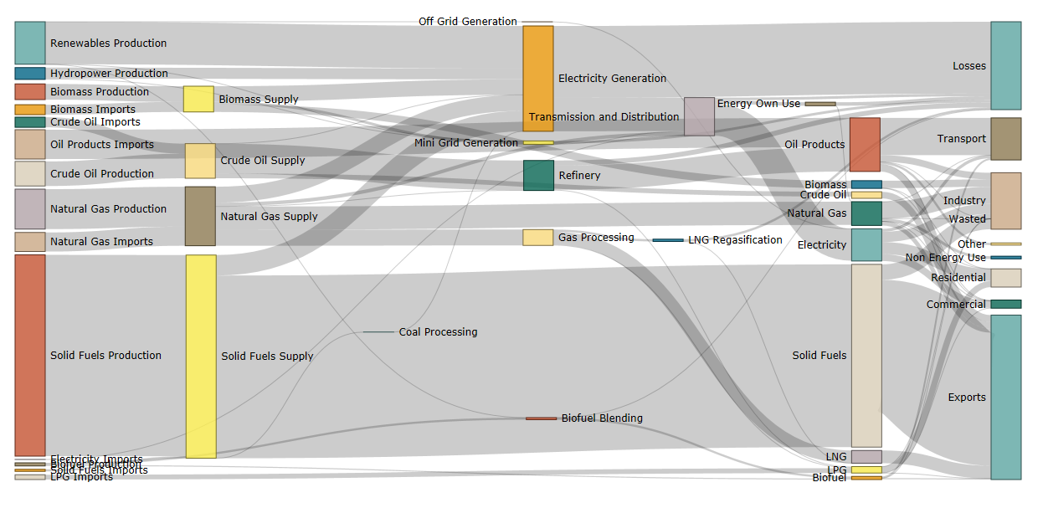

## Indonesia RUPTL 2019 – 2028 Planned Capacity Addition

|  |  |  |  |  |  |  |  |  |  |  |  |
| --- | --- | --- | --- | --- | --- | --- | --- | --- | --- | --- | --- |
| **RUPTL 2019 - 2028 Planned Capacity Addition** | | | | | | | | | | | |
| **Year** | **2019** | **2020** | **2021** | **2022** | **2023** | **2024** | **2025** | **2026** | **2027** | **2028** | **Total** |
| Hydro PP | 154 | 326 | 755 | 0 | 182 | 1,484 | 3,047 | 129 | 466 | 1,467 | **8,010** |
| Geothermal PP | 190 | 151 | 147 | 455 | 245 | 415 | 2,759 | 45 | 145 | 55 | **4,607** |
| Solar PP | 63 | 78 | 219 | 129 | 160 | 4 | 250 | 0 | 2 | 2 | **907** |
| Wind PP | 0 | 0 | 30 | 360 | 260 | 50 | 150 | 0 | 0 | 5 | **855** |
| Biomass PP | 12 | 139 | 60 | 357 | 50 | 103 | 19 | 5 | 15 | 35 | **795** |
| Steam PP | 1,569 | 6,047 | 3,641 | 2,780 | 4,590 | 3,090 | 1,184 | 1,695 | 1,375 | 1,093 | **27,064** |
| Gas PP | 890 | 797 | 536 | 485 | 355 | 95 | 40 | 50 | 0 | 35 | **3,283** |
| Combined Cycle PP | 702 | 2,276 | 475 | 2,670 | 1,180 | 750 | 0 | 230 | 400 | 450 | **9,133** |
| Diesel PP* | 138 | 8 | 2 | 3 | 47 | 3 | 0 | 0 | 0 | 0 | **201** |
| Gas Engine PP | 0 | 0 | 0 | 0 | 0 | 0 | 0 | 0 | 0 | 0 | **0** |
| Micro Hydro PP | 140 | 238 | 479 | 200 | 168 | 232 | 27 | 20 | 20 | 10 | **1,534** |
| Mini Hydro PP | 0 | 0 | 0 | 0 | 0 | 0 | 0 | 0 | 0 | 0 | **0** |
| Biogas PP | 0 | 0 | 0 | 0 | 0 | 0 | 0 | 0 | 0 | 0 | **0** |
| Marine Energy PP | 0 | 0 | 7 | 0 | 0 | 0 | 0 | 0 | 0 | 0 | **7** |
| **Total** | **3,858** | **10,060** | **6,351** | **7,439** | **7,237** | **6,226** | **7,476** | **2,174** | **2,423** | **3,152** | **56,396** |

1. One US dollar = 14,210 IDR, Bloomberg Data, 23 June 2020, <https://www.bloomberg.com/quote/USDIDR:CUR>.
2. GHG emission in this report refers to the emissions from three major gases – CO2, CH4 and N2O – and is calculated as CO2-e in line with the IPCC guidelines.
3. Energy elasticity of energy consumption measures the relative change of energy consumption to achieve 1 per cent change in GDP.
4. The NDC document target is based on old data. A revised target is important for Indonesia to be able to make informed decisions. Indonesia Energy Outlook 2019 (912 MTCO2e) and the NEXSTEP analysis (880 MTCO2e) BAU scenario results align with each other on projected energy sector emissions in 2030.
5. <http://documents.worldbank.org/curated/en/937711468320944879/pdf/88699-REVISED-LW16-Fin-Logo-OKR.pdf>.
6. This assumption has been based on expert advice on what could be practically possible in the next decade.
7. Ibid.
8. Improvement in energy efficiency has the potential to reduce total final energy consumption which, in turn, will reduce the overall energy supply and thus will save investments in the energy sector.
9. See <https://www.undp.org/content/undp/en/home/librarypage/environment-energy/low_emission_climateresilientdevelopment/derisking-renewable-energy-investment.html>.
10. This assumption has been based on expert advice on what could be practically possible in the next decade.
11. Ibid.
12. This assumption has been based on expert advice on what could be practically possible in the next decade.
13. Ibid.
14. This assumption has been based on expert advice on what could be practically possible in the next decade.
15. Ibid.
16. This assumption has been based on expert advice on what could be practically possible in the next decade.
17. Ibid.
18. This assumption has been based on expert advice on what could be practically possible in the next decade.
19. Ibid.